CHRONIC ADOLESCENT EXPOSURE TO CANNABINOIDS AND ENVIRONMENTAL FACTORS INTERACT TO CHANGE VULNERABILITY FOR LATER DEVELOPMENT OF PSYCHOPATHOLOGY

by

Amy L Furrow

A thesis submitted to the faculty of Radford University

in partial fulfillment of the requirements for the degree of

Master of Arts in the Department of Psychology



July, 2012

Copyright 2012, Amy L Furrow

**ABSTRACT**

Exposure to exogenous cannabinoids during adolescence has been shown to disrupt subsequent neuronal processes of development and functioning compared to chronic adult administration (e.g., Bambico et al., 2010). Age of first encounter with a psychoactive compound is critical due to the heightened sensitivity during this period. The current study examined the interaction of environmental conditions in rats exposed to a synthetic cannabinoid during puberty. Environmental enrichment (EE) mimics positive early life experiences by providing enhanced social and physical stimulation, whereas isolation environments mimic negative early life experiences and provide decreased physical and social stimulation. Rosenzweig, Krech, and Bennett (1961) were the first to provide evidence suggesting that EE could lead to structural changes in the brain. The present study investigates the influence of EE in rats chronically exposed to cannabinoids during adolescence by assessing symptomology of anxiety and depression in adulthood. Seventy-three naïve, male Long-Evans rats were divided into one of three environmental conditions: enriched environment (EE), social environment (SE) or isolation environment (IE) following weaning on postnatal day 22 (PND). Half of the rats in each environment received daily injections (i.p., .35 mg/kg) of CP 55, 940 from PND 35 to 48, while the other half received comparable vehicle injections. Behavioral testing began on PND 77, after a 28-day wash-out period. Subjects were tested in successive order on four behavioral tasks assessing symptoms of anxiety and depression: the elevated plus maze (EPM), a test of social interaction (SI), a sucrose preference task, and the forced swim test (FST). Behavioral alterations observed in adulthood resulting from chronic cannabinoid exposure during adolescence included, reduced weight gain, increased anxiety-related behaviors in the open-field (boli), and decreased sucrose consumption. The results supported the original hypothesis concerning increased emotionality among subjects housed in the isolation environment. Overall, the effects of chronic adolescent cannabinoid exposure were more severe and long-term for subjects that were housed in an impoverished environment growing up. Specifically, the IE animals displayed increased anxiety related behaviors in the open-field (boli), and in the forced swim test (boli). Exposure to the cannabinoid drug induced changes that persisted into adulthood including: reduced weight gain, increased anxiety-related behaviors on the EPM, in the open-field (boli), as well as some evidence of depression on the sucrose preference test. Environmental enrichment was found to reduce weight gain that persisted into late adulthood and decrease anxiety displayed by the drug rats on the FST. The EE and SE animals displayed similar behavioral characteristics such as, a decreased stress response and increased habituation to novelty, suggesting a beneficial effect of social housing. Although some protective effects of EE were found, the results of the study suggest an overall beneficial effect of social housing rather than a specific effect of enrichment on the EPM and social interaction task. Thus, EE may provide some protection against the effects of cannabinoid exposure, but the amount of social stimulation provided during early development is probably more important.

Amy L. Furrow, M.A.

Department of Psychology, 2012

Radford University

**ACKNOWLEDGEMENTS**

A special thanks to my thesis advisor, Dr. Pamela Jackson, and team of graduate and undergraduate researchers, Michael Curry, Lindsay Nolan, Bryce Lewis, Rina Schick, Andrew Bindewald, Victoria Scott, and Christopher Heartless, who devoted much of their time toward helping with the completion of this research.

**TABLE OF CONTENTS**

Page

Abstract……………………………………………………………………………………………ii

Acknowledgements……………………………………………………………………………….iv

Table of Contents………………………………………………………………………………….v

List of Tables or Figures………………………………………………………………………….vi

Chapter 1. Introduction……………………………………………………………………………1

Chapter 2. Methods………………………………………………………………………………21

Elevated Plus Maze…….....………………...……………………………………………24

Social Interaction………………………………………………………………………...25

Sucrose Preference Task…..……………………………………………………………..27

Forced Swim Test……...………………………………………………………………...28

Chapter 3. Results……..…………………………………………………………………………32

Body Weight……………………………………………………………………………..32

Elevated Plus Maze…………….………………………………………………………...45

Social Interaction………………………………………………………………………...50

Sucrose Preference Task…..……………………………………………………………..67

Forced Swim Test……...………………………………………………………………...73

Chapter 4. Discussion……………………………………………………………………………80

References……………………………………………………………………………..…....95-102

**LIST OF FIGURES**

Figure 1 – Average weight of the drug and vehicle animals in each of the three environment conditions on PND 22………………………..…….………...……………………....34

Figure 2 – Effect of CP 55, 940 and vehicle administration and environment condition on average body weight (g) at 5 day intervals during the 14 day exposure period…………………………………………………………….……......................37

Figure 3 – Effect of CP 55, 940 and vehicle administration and environment condition on average body weight (g) at 5 day intervals during the 14 day exposure period……………………………..………………………………………………….40

Figure 4 – The average weight of the drug and vehicle animals in the three environment conditions on PND block 73-77………………………………..…………………….42

Figure 5 – The average weight of the drug and vehicle animals in each environment condition on the first day of the forced swim task on PND 98……………………………….……44

Figure 6 – The mean percent (%) time the drug and vehicle rats housed in each of the three environment conditions spent on the enclosed arms of the plus-maze……………....47

Figure 7 – The average number of boli produced by drug and vehicle treated subjects in each of the three environment conditions on the plus-maze…………………………………49

Figure 8 – The average percent (%) of time spent in the periphery of the open arena by drug and vehicle treated subjects in each of the three environment conditions on habituation sessions 1 and 2 of the social interaction task………………………………………..51

Figure 9 – Mean percent of entries into peripheral cells of the open field as an average for both habituation trials by drug and vehicle-treated subjects in each environment condition.………………………………………………………………….………....53

Figure 10 – The mean percent (%) of entries into the peripheral cells relative to the center cells of the open-field by the drug and vehicle rats in each environment condition on habituation trials 1 and 2 of the social interaction task………………………….…...55

Figure 11 – Mean number of boli produced by drug and vehicle-treated subjects in each environment condition during habituation trials 1 and 2 of the social interaction task. ………………………………………………………………………………………..58

Figure 12 – The average amount of activity displayed by the drug and vehicle rats in each environment condition as a mean of habituation trials 1 and 2 on the social interaction task as measured by the length (m) of the path travelled.…………………………....61

Figure 13 – The average amount of time the drug and vehicle rats in each environment condition spent engaging in non-aggressive social interaction behaviors during the total 10-minute interaction session...………………………………………………………….64

Figure 14 – Average amount of time the rats housed in the three environment conditions spent engaging in aggressive interactions during the first and second five minute halves of the total 10 minute interaction session ……………………………………………....66

Figure 15 – Average amount of sucrose and plain water consumed (mL) by the drug and vehicle rats in each environment condition after the first 30 minutes of exposure to the novel sucrose solution ……...................................................................................................68

Figure 16 – Average amount of sucrose and plain water consumed (mL) by the drug and vehicle rats in each environment condition after the first hour of exposure to the novel sucrose solution.……………………………………………………………………...70

Figure 17 – Mean percent of sucrose consumed by the drug and vehicle animals across the last three days of the sucrose preference task...………………………….……………….72

Figure 18 – Mean latency (s) to the first bout of immobility during session 1 and session 2 of the forced swim test for the drug and vehicle animals in each environment condition.………………………………………………………………………….…74

Figure 19 – Mean percent time (s) the drug and vehicle animals in each environment conditions spent being immobile during the five-minute duration of the second test session of the forced swim test ……………………………………………………………….…….77

Figure 20 - Average amount of boli produced by drug and vehicle rats in each environment condition during session 1 and session 2 combined on the forced swim task………………………………………………………………………..………….79

**CHAPTER 1. INTRODUCTION**

Marijuana (Cannabis sativa) is the most commonly used and abused illicit drug among adolescents in the United States. The National Institute on Drug Abuse (NIDA, 2010) indicated a recent surge in the number of young Americans aged 12-17 reporting an increased use of the drug from that previously documented in 2008 and 2009. Currently, an ongoing debate is still in effect concerning the long-term effects associated with the use of the drug. However, one consistent finding among researchers has been that the long-term consequences of cannabinoids are dependent upon the age at which drug use began (Murray, 2007). Research with human subjects has provided evidence for an association between an earlier age at onset and increased rates of developing anxiety, depression, psychosis, and schizophrenia (Harley et al., 2010; Compton, & Ramsay, 2009; Konings et al., 2008; Ashtari et al., 2011). Thus, it has been suggested that the developmental stage of the adolescent brain may be especially vulnerable to the potentially toxic effects of cannabis (Cannon et al., 2006). Additionally, the National Institute of Mental Health (NIMH, 2012) has documented an increasing trend among prevalence rates of anxiety disorders (18.1%) and depression (9.5%) affecting the U.S. adult population annually. As a result of such findings, a growing body of research has been dedicated to investigating the long-term neurobiological effects of cannabis consumption at different stages of development in both human and animal subjects.

Research findings from both human and animal studies have provided important information regarding the effects of chronic marijuana exposure and have most consistently identified an age-dependent vulnerability of the brain. Specifically, the adolescent phase of neuronal development is characterized by various cellular and anatomical modifications taking place to refine the neural circuitry within frontal cortical regions of the brain (Schneider, Schomig, & Leweke, 2008). Maturational processes occurring during this time involve strong neuronal plasticity, myelination of nerve fibers, as well as the formation and pruning of synapses. Specifically, the marked overproduction of axons and synapses during early puberty is followed by rapid pruning during later adolescence (Crews, He, & Hodge, 2007). Neurotransmitter systems such as the glutamatergic, dopaminergic, serotonergic, and the endocannabinoid system are undergoing their final maturational processes (Schneider et al., 2008) and have been found to be influenced by drug use during this time (Crews et al., 2007). Crews et al. (2007) further suggested that such a period of high neuronal plasticity may make adolescents more vulnerable to external insults likely to result in psychiatric disorders. The endocannabinoid system has been suggested to play a functional role in the maturation of other neurotransmitter systems by its influence on early developmental processes such as cell proliferation and migration, axonal elongation, and later, synaptogenesis and myelogenesis (Trezza, Cuomo & Vanderschuren, 2008).

In contrast to endocannabinoids, exogenous cannabinoids such as ∆9-tetrahydrocannabinol (THC), the primary psychoactive ingredient found in marijuana, have been shown to markedly disrupt the circuitry dynamics and signaling of the endocannabinoid system. Chronic cannabis use during adolescence disrupts the endocannabinoid system by producing an overstimulation of system-wide CB1 receptors (Murray, 2007). As a result of this disruption, a series of stable reductions may be observed in CB1 receptor densities and CB1/G-protein coupling within certain brain structures. Brain structures that are mostly implicated are those containing high densities of CB receptors, which are mainly involved in emotional processing, motivation, motor activation and cognitive functioning such as the amygdala, ventral tegmental area, nucleus accumbens, and the hippocampus (Rubino et al., 2008). As a result of the change in CB1 receptor activity during this stage of development, alterations in the wiring and synaptic connections of other networks developing within the nervous system have been suggested to result in abnormal emotional and/or behavioral functioning in adulthood.

Thus, the adult brain is less susceptible to adverse cannabinoid-induced drug effects because it is practically fully developed when exposed to the psychoactive compound. For example, Schneider and Koch (2005) concluded that when administered to rats that were already matured into adulthood the effects of cannabinoid exposure were less severe and short-lived in comparison to adolescent subjects. Although only a few human studies have examined the effects of cannabis during adolescence, evidence suggests an increased vulnerability for subsequent development of adult psychopathology following chronic adolescent cannabis exposure. Specifically, Patton et al. (2002) found that daily chronic use of cannabis among teenage girls predicted more than a five-fold increase in the number of incidences of reported anxiety and depression in early adulthood.

In terms of animal studies, Bambico, Nguyen, Katz, and Gobbi (2010) found that chronic cannabinoid exposure during adolescence, but not adulthood, in rats led to increased symptoms of anxiety and depression when behavior was measured as adults. On the other hand, Rubino et al. (2008) found that chronic exposure during adolescence did not produce any differences in terms of anxiety, but female rats were found to exhibit an enhanced depressive-like profile when compared to males in adulthood. Realini, Rubino, and Parolaro (2009) chronically exposed adult female rats to the same THC paradigm as in the Rubino et al. 2008 study and did not find any significant increases in depressive-like behavior for adult females. Clearly adolescent cannabinoid exposure is likely to result in emotional changes in rats later in life, whereas adult exposure does not. What is less clear is the specific changes. For example, O’Shea, Singh, McGregor, and Mallet (2004) reported increased anxiety in both male and female adult rats after receiving chronic exposure during adolescence. Thus, although inconsistencies exist among research findings pertaining to the exact long-term consequences, the overall conclusion remains suggesting that the age of first encounter with a cannabinoid is critical due to the heightened sensitivity during adolescent neuronal development.

However, the fact is that only a minority of those individuals exposed to marijuana during human adolescence actually go on to further develop adult psychopathology. Clearly, the need for a better understanding of the precise factors contributing to the increased susceptibility for this group is critical. Previous research on marijuana use has traditionally focused on the acute and long-term effects while only speculating about potential causal factors. Few studies have examined the influence of environmental and social factors such as how the quality of the early environment may influence an individual’s sensitivity to cannabinoid drug effects and ultimate susceptibility to developing anxiety or depression. Numerous animal studies have suggested that early environmental stimulation may accelerate the development of the central nervous system and affect behavior in adulthood (Cirulli et al., 2010). Furthermore, because environmental complexity induces hippocampal growth (i.e., neurogenesis and dendritic complexity), it may provide a means for studying the role of environmental factors in reducing or preventing anxiety and depression-like responses. The physiological effects of anxiety and depression have both been associated with hippocampal function and morphology (Pittenger & Duman, 2008). Thus, the current study investigates the impact of the quality of the early environment on the vulnerability for the development of adult psychopathology following chronic adolescent exposure to cannabinoids in rats.

In animal studies, animals may be housed under environment conditions that reflect a continuum of early life experiences ranging from isolation (impoverished rearing), to social (standard rearing), to enrichment (enriched rearing). These early rearing conditions vary in the amount and quality of contact with other animals and other external environmental factors. Furthermore, these environment conditions are relevant to important issues that relate to the early life experiences of mammals and their subsequent neurodevelopment, behavior, and potential development of psychopathology in humans (Varty, Paulus, Braff, & Geyer, 2000). Additionally, the characteristics associated with each environment may be similar and relate to the conditions found in human society ranging from high, middle, and low socioeconomic status (SES).

Specifically, environments associated with enrichment mimic positive early life experiences by providing enhanced social and physical stimulation. In human society, enrichment would be associated with above-average level of education and income, enhanced reading opportunities, participating in club organizations, attending cultural events, and traveling (Rosenzweig & Bennett, 1995). Environments providing such enhanced stimulation have been suggested to be necessary for healthy brain development (Laviolaa et al., 2008). Studies implementing environmental enrichment house laboratory animals in group cages with increased floor space, a running wheel and an assortment of toys all of which promote exercise, play, exploration, and novelty (Simpson & Kelly, 2011).

Alternatively, isolation environments in animals may be associated with impoverished, low SES conditions mimicking negative early life experiences such as a general lack of social and physical stimulation. In human society, isolation would be associated with decreased stimulation by family and peers, below-average level of education and income, and poor nutrition. The quality of the early environment becomes important because childhood adversity has the potential to alter the development of systems that serve to regulate stress responses, such as the hippocampal glucocorticoid receptor expression. Isolation rearing may enhance the effects of stress in adulthood and increase vulnerability for mood disorders.

The effects of environmental enrichment were studied by Rosenzweig, Krech, and Bennett (1961) who provided the first evidence suggesting that environmental enrichment could lead to structural changes in the brain. They used the term “enriched condition” because it provided an increased opportunity for informal learning compared to the other housing conditions. Rosenzweig and his colleagues demonstrated that training or differential experience could produce measureable changes in the brain of both diseased and lesioned animals, and correlations were identified between measures of brain weight and cortical thickness (Bennett, Rosenzweig, & Diamond, 1969).

Over a series of subsequent experiments, measureable differences were also found between enriched and isolated housing conditions where the beneficial effects of enrichment included an increased size of neuronal cell bodies and nuclei, increased synaptic availability and connectivity, as well as increased branching of dendrites and dendritic spines compared to the isolated condition (Rosenzweig & Bennett, 1996). Additionally, Rosenzweig, Bennett, and Krech (1964) found evidence suggesting that the magnitude of the beneficial effects of enrichment did not differ between young and adult rats. This finding was especially important due to the high degree of neuronal plasticity associated with younger development. They concluded that the effect observed between the enriched and isolated conditions was the result of a differential opportunity to learn rather than alterations in the rate of early cerebral growth. In sum, this suggests that the beneficial effects associated with environmental enrichment can be experienced similarly at any age, regardless of when the exposure to enrichment began.

Rats reared in isolation show increased levels of anxiety, neophobia, hyperactivity of the hypothalamic-pituitary-adrenal (HPA) axis with subsequent increased blood corticosterone levels, poor performance on learning and spatial memory tasks, decreased habituation to novelty, and increased symptoms of depression compared to rats housed in an enriched environment (Hellemans, Benge, & Olmstead, 2004). Additionally, depressed human patients have been shown having a hyperactive HPA axis response to stress in addition to abnormalities found in brain regions associated with emotional disorders (Cirulli et al., 2010). Early-life stressful events have been shown to produce sustained changes in the HPA axis that are commonly associated with anxiety and depression disorders. Furthermore, Cirulli et al. (2010) mentioned that experiencing early negative environmental living conditions (e.g., chronic stress, childhood trauma, low SES) may ultimately jeopardize an individual’s intellectual development as well as increase the risk for future development of anxiety and/or depression disorders in adulthood.

Rats reared in an enriched environment have been shown to have decreased levels of anxiety and depression, increased learning and memory, increased habituation to novelty, reduced stress response of the HPA axis system with increased efficiency of corticosterone action, and increased hippocampal neurogenesis (Solinas et al., 2010; Chourbaji et al., 2005; Chourbaji, Brandwein, & Gass, 2011). More recent research on the neurobiological consequences of enrichment have identified additional and more complex beneficial effects on the brain including increased neurogenesis, heightened levels of neurotrophins, and alterations in neurotransmitter and receptor densities within specific brain regions (Amaral, Vargas, Hansel, Izquierdo, & Souza, 2008). Environmental enrichment has even been suggested to provide a mechanism of recovery from anxiety disorders because it has the ability to enhance an organisms coping style with stressors, allowing for faster recovery from severe trauma by enhancing their ability to operate more effectively under stress and/or novel situations (Hendriksen, Prins, Olivier, & Oosting, 2010).

Chronic stress, and a subsequent rise in plasma corticosteroid levels, has been suggested to be a major cause in the pathogenesis of depressive disorders (Chourbaji, 2011). Environmental enrichment then, may serve a protective function by increasing hippocampal neurogenesis and the number of glucocorticoid receptors in the hippocampus, thus increasing the sensitivity of the glucocorticoid negative feedback mechanism. This decrease in the stress response of the HPA axis enables the rat to terminate the secretion of glucocorticoids and return back to homeostasis more rapidly, and ultimately decreasing the amount of total exposure to glucocorticoids over the course of development. A faster return to homeostasis serves a protective mechanism against the potential harmful effects that could arise as a result of experiencing prolonged exposure to high levels of glucocorticoids in the blood. These harmful effects would include glucocorticoid hypersecretion, and negative-feedback insensitivity, which would subsequently increase the rate of hippocampal atrophy over time and increase the stress response by decreasing the number of available glucocorticoid receptors.

Research studies investigating the effects of stress on cannabinoid exposure have not explored the long-term effects of cannabis use or differences between age groups. Findings from animal research suggest that the acute effects appear to be contingent on the environmental conditions under which the drug is administered (MacLean & Littleton, 1977). MacLean and Littleton (1977) found that rats housed in social groups 24 hours prior to acute cannabinoid administration displaying only slight behavioral changes as a result from drug expose including minor sedation and hypothermia. Whereas, animals housed for 24 hours in social isolation displayed marked behavioral consequences including hyperactivity and immobility (MacLean & Littleton, 1977). Thus, variations of environmental stress may influence cannabinoid drug effects.

Surprisingly, the beneficial and protective effects associated with environmental enrichment have remained relatively unexplored in terms of their potential influence on adverse drug effects during adolescent development. However, the effects of environmental enrichment have been shown to alter drug effects and properties of addiction in a variety of different behavioral paradigms typically involving morphine, cocaine, amphetamine, nicotine, and alcohol. For example, some studies have shown a reduction in the rewarding effects of amphetamine and nicotine in rats reared in an enriched environment compared to rats reared in isolation (Bardo et al., 1995). In a similar study conducted by Solinas et al. (2009) environmental enrichment was shown to provide protection against the effects of addictive drugs by reducing the activating effects of repeated administrations of cocaine, while also reducing the expression of behavioral sensitization. Overall, the rewarding effects of cocaine were diminished in rats reared in an enriched environment from weaning to adulthood compared to those housed in isolation. Solinas et al. (2009) further concluded that the protective effect of environmental enrichment appeared to be mediated by neural adaptions inducing a compensatory response of the brain in response to repeated drug administrations. Thus, evidence supports the claim that positive life experiences or early environmental complexity during critical periods of high neuronal plasticity like that during adolescence may provide a mechanism for protection against adverse drug effects during this time.

The present study will be the first to investigate the impact of environmental enrichment in rats chronically exposed to cannabinoids during adolescence by examining behavioral measures assessing symptomology of anxiety and depression in adulthood. The goal of the study is to be able to provide a possible explanation as to why early cannabis use doesn’t always produce a subsequent increase in development of psychopathology. More specifically, whether the manipulation of the early environment influences the observation of symptoms of anxiety and depression differently when rats are measured in adulthood after having chronic exposure to a moderately high dose of the synthetic cannabinoid agonist CP 55, 940 during adolescence compared to control subjects.

For the manipulation of the early environment, subjects were semi-randomly assigned to one of three environmental conditions; enriched environment, social environment, or isolation environment immediately following post-weaning on post-natal day (PND) 22 until reaching PND 72. At PND 35, the age corresponding to early adolescence injections began. Half of the subjects within each environment received daily intraperitoneal (i.p.) injections of either the drug or vehicle for 14 days. Thus, the rats received chronic cannabinoid exposure throughout puberty, with drug injections ending on PND 48. After receiving their last daily injection, all of the rats remained in their appropriate environments most of a 28-day wash out period. Behavioral assessments measuring symptoms of anxiety and depression were conducted by testing rats in successive order on the following tasks; the elevated plus-maze (EPM), a test of social interaction, a sucrose preference task, and the forced swim test (FST).

The elevated plus-maze is a well-established procedure for measuring anxiety. Pellow and File (1986) validated this experimental apparatus as an excellent measure for evaluating anxiety-related drug effects in the rat after the administration of compounds shown to produce anxiolytic and anxiogenic drug effects in humans. The plus-maze consists of four arms in the shape of a plus sign that are elevated from the ground with two of the arms enclosed by walls. Symptoms of anxiety are determined by rats showing fewer open-arm entries, decreased time spent on the open versus enclosed arms, and also by an increased number of boli (feces).

The social interaction task is another common measure of anxiety that was validated by File (1985) as a useful test for research into the effects of psychoactive compounds on anxiety. Levels of anxiety are determined by the amount of time a rat spends in active social interaction with a naïve conspecific of similar size over the duration of a 10 minute session. Increased anxiety is indicated by a decrease in the overall amount of time spent in active social interaction.

The sucrose preference task is another that can be used to measure both symptoms of anxiety and depression. Symptoms of anxiety are determined using a measure of neophobia (fear of novelty) by measuring the amount of a novel liquid consumed compared to plain water over the duration of one hour. Neophobia is indicated by rats displaying decreased sucrose consumption relative to that of plain water. Symptoms of depression are determined using a measure of anhedonia (a lack of interest or ability to experience pleasure). Specifically, after the first hour, the amount of the two solutions consumed over three periods of 24-hours each is measured. Anhedonia is indicated by rats displaying a decrease in sucrose consumption over the three day period compared to the control animals.

The forced swim test (FST) is a well-established procedure commonly used to evaluate the potential effectiveness of antidepressant medications and for measuring symptoms of depression in rodents. Porsolt, Le Pichon, and Jalfre (1977) validated the forced swim test as a reliable measure of depression in rats after showing antidepressant drug treatment to reduce immobility time. The task is a two day procedure with a 15-minute habituation session on day one followed by a five minute test session on day two. Assessment of behaviors during the second test session measures the dynamics of the rats’ transition from an active (swimming and climbing) to a passive (immobility) coping style when forced to swim in a situation from which there is no escape. Specifically, after an initial period of vigorous activity, the rat eventually develops an immobile floating posture making only those movements necessary to keep its head above water. This immobility behavior was interpreted by Porsolt, Pichon, and Jalfre (1977) to reflect a state of despair, in which the rat has learned that escape is impossible and thus is able to perceive the hopelessness of the situation learned during the first habituation session. On day two, measurements are recorded for the amount of time spent swimming, climbing, or being immobile during the five minute test session. Symptoms of depression are indicated by the rat displaying increased time spent immobile, or a shorter latency to become immobile, and decreased time spent swimming or climbing.

Environmental enrichment may demonstrate protective effects by reducing symptoms of anxiety and depression in drug rats reared in an enriched environment compared to those reared in isolation or a social environment. Cannabinoid treated subjects reared in isolation are expected to behave in a manner that is consistent with the presence of an anxiogenic drug effect by displaying the highest levels of anxiety and depression compared to all other subjects. Because the same dose of the synthetic cannabinoid receptor agonist CP 55,940 will be administered to all subjects receiving drug treatment differences observed in the levels of anxiety and depression present in adulthood may be attributed to the quality of the early rearing environment.

If the results indicate higher levels of anxiety and depression in cannabinoid treated rats housed in the isolation environment compared to those housed in enrichment, it may suggest that adolescents living under stressful or low-SES conditions are at higher risk. Such a finding would be particularly important in terms of increasing the effectiveness of prevention strategies implemented to decrease marijuana use among this at-risk group of adolescents. A decrease in marijuana use among this group may potentially help reduce the increasing trend of prevalence rates for anxiety and depression that continue affect our adult U. S. population today.

**CHAPTER 2. METHODS**

*Subjects*

Seventy-three naive, male Long-Evans rats were bred in the small animal laboratory located at Radford University to serve as subjects for the study. Subjects were direct offspring of male and female breeder rats obtained from the Charles River Laboratories. Female rats were mated one-on-one with male rats in plastic cages (44 cm L x 22 cm H x 20.5 cm W) and left together for approximately 21 days. After 21 days, males were removed from the tubs and the female remained until weaning of the pups. Litters were sex-balanced and culled to 12 pups within 48 hours following birth, on PND 1 or 2, based on body-weight. Maternal rats were then left with pups until weaning on PND 22.

At weaning on PND 22, each litter was separated by gender and the male pups were randomly assigned to one of three environmental housing conditions: enriched environment (EE), social environment (SE), or isolation environment (IE) until PND 72. Each experimental group contained 10 subjects, across six groups which satisfied the requirements for power (β) of .80. However, given the small effect sizes associated with each behavioral task, an additional 13 animals were included in the study. Each cohort of 6 subjects was drawn from one or two litters of pups (as needed). If the litter did not contain 6 male pups, then additional pups were drawn from a second age-matched litter to make up a cohort of six subjects. Every cohort was bred from a pair of animals unrelated to each other (all cohorts were bred from non-litter mates obtained from Charles River Laboratories).

On PND 34, two subjects from each environment condition was selected from each cohort and semi-randomly assigned (by weight) to one of two drug-treatment conditions: cannabinoid drug or vehicle (see drug conditions described below). The enriched environment condition contained 24 subjects (12 drug, 12 vehicle), the social environment also contained 24 subjects (12 drug, 12 vehicle) and the isolated environment contained 25 subjects (13 drug, 12 vehicle). Thus, 36 subjects received cannabinoid drug treatment and 37 subjects received vehicle treatment.

The subjects were weighed for 14 consecutive days over the duration of drug or vehicle treatment and every 5 days otherwise until behavioral data collection began on PND 77. Subjects were maintained on a 12:12 light/dark cycle in a temperature and humidity controlled vivarium and were provided with access to food and water ad libitum. All treatment and testing procedures were conducted during the light portion of the cycle. This project was IACUC approved and all animals were treated in accordance with the NIH *Guide for the Care and Use of Laboratory Animals.*

**Environment Conditions**

The enriched environment (EE) consisted of rats housed in groups of 4-6 in a large plastic cage (74 cm L x 57 cm W x 25 cm D). The cage contained a running-wheel (20 cm), a wooden shelter containing bedding inside for nesting, a ladder, tunnels, and 5 toys of differing textures, shapes and colors. The toys were replaced with new and different toys after every 5 days. All cages were exchanged for a clean one after every 10 days and all animals were weighed every 5 days. Toy changes always coincided with the day the cages were exchanged or the day the rats were weighed to ensure that the EE group were not handled more than the other two groups. The social environment (SE) consisted of rats housed in groups of 4-6 in the same type of plastic hanging cage (74 cm L x 57 cm W x 25 cm D) with no enrichment. The isolation environment (IE) consisted of individually-housed rats in a standard stainless-steel hanging cage (25 cm L x 18 cm H x 18 cm W) with three solid metal sides. The inclusion of the social environment condition for comparison ensures the proper control concerning the degree of severity between the two extremes, isolation and enrichment. Simpson and Kelly (2011) provided a review of animal enrichment and suggested that future enrichment studies employ this control method due to the possible negative consequences associated with the isolation environment as a potential stressor. Animals were placed in their assigned environmental conditions beginning at weaning (PND 22) until five days before beginning behavioral testing (PND 72). All rats were switched to single, standard-hanging cages on PND 72. During the 28-day wash-out period all subjects were weighed once every 5 days.

**Drug Condition**

Half of the rats in each environmental condition received daily intraperitoneal (i.p.) injections of either a high dose of the synthetic cannabinoid agonist, CP 55, 940 or the vehicle solution, for 14 days. The drug was mixed using 3.5 mg of the synthetic cannabinoid, CP 55,940 ((-)-*cis*-3-[2-Hydroxy-4-(1,1-dimethylheptyl)phenyl]-*trans*-4-(3-hydroxypropyl)cyclohexanol), Tocris Bioscience, Ellisville, MO), and dissolving it in 0.5 mL of ethanol, combined with 75.0 µL Tween 80 (polyoxyethylene sorbitan monoleate, Sigma-Aldrich, Inc.). After the solution was thoroughly mixed, the ethanol was completely evaporated using a stream of compressed oxygen. The resulting mixture was combined with 9.925 mL of physiological saline to produce a final solution of 10.0 mL (O’Shea et al., 2004). The final preparation was administered by an i.p. injection at a dose of 0.35 mg/kg (body weight) equivalent to a volume of 1 mL/kg (body weight). The vehicle solution was mixed exactly the same, minus the CP 55,940, and was administered by an i.p. injection of similar volume based on body weight. All subjects were naïve to treatment prior to the beginning of injections. After receiving their last daily injection, the rats remained in their appropriate environments until they were single-housed on PND 72.

**Behavioral Measures**

Behavioral tasks were selected to provide a reliable assessment of animal behaviors related to symptoms of anxiety and depression. Rats were tested in successive order on the following tasks: the elevated plus-maze (EPM), a social interaction test, a sucrose preference task, and the forced swim test (FST). Animals were permitted at least four full days of rest between each behavioral task. All experimental apparati were thoroughly cleansed between subjects with a solution of vinegar and water (1:10 ratio) to remove all olfactory cues. Measurements of behavior on individual tasks were conducted in separate rooms containing overhead lights and white noise (used to mask extraneous sounds) with the exception of the sucrose preference test which was conducted in their home cages.

**Elevated-Plus Maze (EPM)**

The elevated plus-maze is a well-established procedure for measuring anxiety. All subjects were behaviorally assessed on this measure first, beginning twenty-eight days after their last injection, on PND 77.

*Apparatus*

The plus-maze, constructed of wood and painted flat white, was elevated 50 cm above the ground and consisted of 4 arms, each measuring 61.0 cm long and 11.5 cm wide. The four arms extended from the square center of the maze (measuring 12.5 cm x 12.5 cm) in directions similar to a plus sign. A 2.4 cm safety lip surrounded the entire maze. Two arms, opposite each other, were enclosed by walls measuring 40 cm high. The apparatus was positioned in the corner of the running room and enclosed on 2 sides by wall to wall curtains. Each of the other 2 walls had a different poster on each. A wireless video camera was mounted directly above the plus-maze and was connected to a TV monitor and VCR that recorded each trial for later coding and analysis. The experimenter stayed in the room and sat at a table facing the TV monitor, approximately 41 in. from the curtain during all testing sessions. The room contained overhead lights to completely illuminate the maze and a radio to provide white noise was used to mask extraneous sounds.

*Procedure*

Experimental subjects were brought to the running room on a cart inside of their home cages with a wooden cover used to keep the rat contained inside, and left there for at least 3 minutes prior to the start of testing. At the start of the session the subject was placed on the center platform of the maze facing the back wall while the experimenter quickly stepped away from the maze and closed the curtains. All sessions were recorded during the 10-minute testing session. The number of arm entries and the amount of time spent on each arm was later coded by researchers blind to experimental conditions. The criteria for determining a complete arm entry was defined as when half of the subject’s body (head, front paws, and shoulders) had crossed the threshold of an arm. The total number of arm entries provided a measure of activity, while the amount of time spent on, and the number of entries into, open versus enclosed arms, provided the measures of anxiety. More specifically, symptoms of anxiety were determined by fewer open-arm entries, decreased time spent on open versus enclosed arms, and also by an increased number of boli (feces).

**Social Interaction Test**

The social interaction test is another commonly used procedure for measuring symptoms of anxiety. The test is a three-day procedure and was the second behavioral measure for all subjects. At the same time on days 1-2, the rat was habituated to the open-field for 10 minutes and activity levels were recorded. On the third day, anxiety was measured by recording the amount of time the experimental rat spent socially interacting with an unfamiliar naïve male conspecific rat of similar size over the duration of the 10-minute testing session.

*Apparatus*

The social interaction arena (61 cm square) was an open-field with 36 cm tall walls. It was constructed of wood and painted white. The box was positioned on top of a table in a room with the lights set moderately low and with white noise playing in the background. A wireless video camera was suspended above the arena and linked to a TV monitor, VHS recorder, and an HVS tracking system provided on a laptop within the same room. At least one experimenter was present during each session. Recordings of aggression and total social interaction time were later coded by researchers blind to experimental conditions using electronic stop watches. Total activity levels during the first two habituation sessions were measured using path length and number of entries into cells (obtained by dividing the floor space into a 4 x 4 grid) via the HVS tracking system. Anxiety during these sessions was measured based on the amount of time spent in, and number of entries into, the center cells of the 4 x 4 grid compared to the peripheral cells of the grid using the HVS tracking system.

*Procedure*

Experimental subjects were brought to the running room on a cart inside of their home cages with a wooden top used to keep the rat contained and left inside the room for at least 3 minutes prior to the start of testing. Subjects were habituated to the arena alone for a 10-minute session on the first two consecutive days prior to social interaction testing. On the third day, both drug and vehicle rats were independently paired with a naïve male conspecific rat and placed inside of the arena together for a 10-minute session. Experimental rats were paired with conspecific rats by weight (within 10 g of each other). Conspecific rats were also habituated to the arena for at least two days prior to the interaction day. Some rats served twice as a conspecific, although not within a period of 7 days of the last interaction session. If they had previously engaged in an interaction session they were only given one additional habituation session in the arena before the interaction. As a means of controlling familiarity, experimental rats could not be paired with naïve siblings as conspecifics. On the interaction day, both rats were brought to the social interaction room on a cart inside of their home cages with wooden covers and left there for at least 3 minutes prior to the start of testing. The experimental rat was placed inside of the arena first and the conspecific rat was introduced immediately afterwards. The 10-minute session was divided into two 5-minute intervals for analysis purposes. Active social interaction was defined as the amount of time the experimental rat spent engaging in six different non-aggressive behaviors (sniffing, genital investigation, following, mounting, climbing over, and/or climbing under) and/or 6 different aggressive behaviors (kicking, punching, and/or boxing, aggressive mounting, wrestling, and full submissive posture). The recorded videotapes for each 10-minute interaction session were later coded by researchers blind to experimental conditions and the total amount of time the experimental rat initiated or engaged in any of the six non-aggressive behaviors was measured for each half of the session. The amount of aggression was determined by recording the amount of time the experimental rat initiated or reciprocated any of the six aggressive-behaviors while interacting with the conspecific rat. The presence of social anxiety was determined by the rat displaying decreased social interaction behaviors such as sniffing, following, and/or grooming of the social partner (File, 1985). In the presence of anxiety, decreased social interaction behaviors have also been associated with an increase in other behaviors related to emotionality such as: freezing, self-grooming, and defection.

**Sucrose Preference Task**

The sucrose preference task is an animal model used to measure both symptoms of anxiety and depression. Symptoms of anxiety are determined by a measure of neophobia (fear of novelty) and symptoms of depression are determined using a measure of anhedonia (a lack of interest in or ability to experience pleasure). The sucrose preference task is a four-day procedure and was the third behavioral test for all subjects.

*Apparatus*

The sucrose preference task was conducted in the animals’ home cage and involved a two-bottle preference test of a novel stimulus (2% sucrose solution) and a control stimulus (plain water). Both solutions were kept in the same type of glass container and stored in the refrigerator. For the measure of neophobia, two plastic water tubes (13.5 cm L x 2.5 cm diameter) were filled with approximately 30.0 mL of the two solutions and sealed with rubber stoppers. Two larger glass bottles (236 mL) were filled with ~150 mL of the two solutions and sealed with rubber stoppers and were provided over an extended duration for the measure of anhedonia.

*Procedure*

Measurements were recorded across a four-day test period at five different time intervals for the amount of the novel sucrose solution consumed relative to that of plain water. For the measure of neophobia, measurements were recorded for the amount of each solution consumed in mL over the duration of the first hour at two time intervals (after 30 minutes, and 1 hour). Neophobia was assessed using two plastic water tubes that were filled with approximately 30.0 mL of each solution and sealed with rubber stoppers. Prior to attaching the two water tubes to the front of the rats’ home cage, measurements were recorded for the weight (in grams) of each test tube filled with the appropriate solution. For the measure of neophobia, measurements were recorded for the amount of each solution consumed in mL over the duration of the first 30 minutes without removing the tube from the home cage and again at one hour). The presence of neophobia was indicated by the rats consuming less sucrose relative to plain water during the first hour. At completion of the first hour, the smaller water tubes were removed and weighed, then replaced with larger glass bottles allowing for higher amounts (~150mL) of the two solutions to be supplied over the 24 hours. The glass bottles were filled with each appropriate solution and weighed prior to being attached to the home cage. Measurements were recorded 24 hours later and again at the same time (after 24 hours) over the next two days. After measurements were recorded each day, the placement of the bottles was counterbalanced by side (left or right) when being reattached to the front of the rats home cage after the fluids were replaced. At the completion of the task, anhedonia was determined by decreased sucrose consumption relative to plain water over the three day period, indicating the presence of depressive-like symptoms.

**The Forced Swim Test (FST)**

The forced swim test (FST) is a well-established procedure for measuring symptoms of depression. The test is a two-day procedure and was the last behavioral measure for all subjects.

*Apparatus*

A cylindrical Plexiglas tank (28 cm in diameter x 51 cm H) was filled to a depth of approximately 30 cm with water. The water depth was enough to prevent the subject from touching the bottom of the tank, and thus ensuring swimming behavior. The temperature of the water was 27 degrees, +/-2 degrees Celsius for each rat.

*Procedure*

Experimental subjects were brought to the running room on a cart inside of their home cages with a wooden cover to keep the rat contained inside and left there for at least 3 minutes prior to the start of testing. Day one consisted of a 15-minute habituation period. The purpose of the habituation day was to instill a feeling of learned helplessness in the rats that could then be measured on the second test day. On the test day (day 2) all procedures were kept constant except the duration of the swimming session which lasted only five minutes. A wireless video camera was mounted directly above the tank and connected to a TV monitor and VCR that recorded each trial for later coding and analysis. Behaviors during the second test day were analyzed and recorded in categories as either swimming, climbing, or immobile. Climbing behaviors were considered those during which the rat made vigorous movements with its forepaws in and out of the water, usually in contact with the wall (escape behaviors). Swimming behaviors were classified as those during which the rat was actively moving around the cylinder (e.g., moving to the side, circling, or swimming down). Immobility was identified when the rat only used those movements necessary to keep the head above water or to stay afloat (including head bobbing and/or pushing off the wall with paws). An increased amount of time spent immobile was indicative of depressive-like symptoms. A measure of the latency to the first bout of immobility (lasting at least 2 sec.) was recorded on both days and a shorter latency on day 2 compared to control animals indicated depressive tendencies. Specifically, shorter latencies to immobility indicated symptoms of depression in that the rat displayed “learned helplessness” by giving up more quickly. Conversely, longer latencies to immobility indicated an increased attempt to escape the stressful situation (swimming and climbing). At the completion of each swimming session, all rats were hand-dried using a towel and placed under a warming lamp for 30 minutes before being returned back to the home cage. The tank was cleaned using a sponge and vinegar solution in order to remove all traces of the previous rat prior to being refilled for the next session.

**CHAPTER 3. RESULTS**

The effects of rearing in enriched, social, and isolated environment conditions as well as the vehicle and CP 55,940 cannabinoid treatment were assessed using two-way and repeated measures Analyses of Variance (ANOVAs). Post hoc analyses were conducted using Tukey’s "honestly significant difference (HSD)" test of comparisons. Independent samples *t*-tests were also conducted to analyze simple effects. Data was analyzed and graphs were produced using PASW 18 and Microsoft Excel. The results presented will generally only include the significant findings from each analysis using an alpha of .05.

**Body Weight**

Subjects were weighed once every five days beginning on the day they were weaned (PND 22). Weights were collected every day for the 14 consecutive days of drug or vehicle exposure. After exposure, the rats remained in their environments and continued to be weighed once in every block of five days during the 28-day wash-out period before behavioral testing began on PND 77. Body weights were analyzed for alterations in normal weight gain as a result of the drug or environment treatment. All rats were weighed using an electronic scale. Subjects were provided access to food and water ad libitum throughout the duration of the study.

A 2 (drug group) x 3 (environment condition) ANOVA was conducted to assess the weight of the animals on the day of weaning (PND 22) and on the first day of injections (PND 35) before the first drug or vehicle exposure. No significant differences were found between experimental groups in the average body weight on PND 22. On average, the rats weighed 63.54 g before they were assigned to experimental conditions. The analysis of body weight on PND 35 resulted in a significant main effect of environment condition, *F*(2, 67)=4.51, *p*=.015. Group means revealed that the average weight of the EE rats (=153.38) was less than the average weight of the SE rats (=165.17) and IE rats (=163.03) at the start of exposure. Tukey’s post hoc tests revealed that the EE rats were significantly different from the SE rats (*p*=.017), and almost different from the IE rats (*p*=.057), but no difference was found between the SE rats and IE rats (*p*=.870). The data are graphed in Figure 1. These results suggest an overall environmental enrichment effect in that the weight gain for these animals was significantly decreased compared to the SE and IE environment conditions, probably due to the increased opportunity for exercise. The average weight of the drug and vehicle rats in each environment condition was not different at the start of exposure.

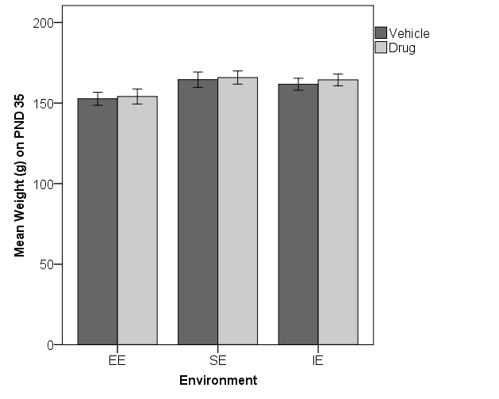

Figure 1 – The average weight of the drug and vehicle animals in each environment condition at the start of injections which began on PND 35 is graphed, along with the standard error of the means (SEM) for each. The average weight of the EE rats was less than the average weight of the SE rats, and almost significantly less than the IE rats, at the start of exposure. The SE and IE groups did not differ.

The rats were weighed each day before receiving injections during the 14-day exposure period, and the average weight for each 2-day block was analyzed to assess the effects of environment and drug exposure on weight gain. A 7 (block) x 2 (drug group) x 3 (environment condition) repeated measures ANOVA was conducted. As expected, the main effect of block was significant, *F*(6, 402)=2514.94, *p*<.001 because all subjects gained weight. The main effect of drug group was significant, *F*(1, 67)=10.83, *p=*.002. Means for this finding indicated that the drug animals weighed less overall (=208.64) compared to the average weight of the vehicle rats during exposure (=221.97). A significant interaction was produced between block and drug group, *F*(6, 402)=36.80, *p*<.001. Comparing the drug group to the vehicle animals with a *t*-test for each block of 2 days confirmed that the groups were not significantly different on blocks 1 and 2 (*p*=.817 and *p*=.182 respectively). However, the drug rats weighed significantly less than the vehicle rats beginning on block 3 (*p*=.020) and continued to weigh less throughout the exposure period (*p*=.003, *p*<.001, *p*<.001, and *p*<.001, for blocks 4 through 7 respectively). These data are displayed in the top graph of Figure 2.

The main effect of environment condition was also significant, *F*(2, 67)=8.15, *p*=.001 (see the bottom graph in Figure 2). The group means for this result indicated that the EE rats weighed significantly less (=205.00) on average during the exposure period compared to the SE rats (=225.15) and the IE rats (=215.77). Tukey’s post hoc tests revealed that the EE rats weighed significantly less than the SE rats (*p*<.001), but did not weigh less than the IE rats (*p*=.090), and no difference was found between the SE and IE rats (*p*=.136). It is clear that the drug slowed down normal weight gain during puberty, as did living in an enriched environment.

A significant interaction was also found between block and environment condition, *F*(12, 402)=5.30, *p*<.001. This finding, displayed in the bottom graph of Figure 2, indicated that the SE rats gained weight faster than the other two groups. The three-way interaction between block, drug group, and environment condition was not significant. A univariate ANOVA with just environment condition as a factor was used to analyze each 2-day block of body weights during the exposure period to further evaluate the two-way interaction of environment condition across blocks. The effect of environment was significant on every block, and Tukey’s post hoc tests were conducted to compare differences between group means. On the first three blocks, the EE rats weighed significantly less than both the IE and the SE rats, and the IE and SE rats did not differ (see the bottom graph in Figure 2). Beginning on block 4, and continuing through blocks 5 and 6, the only significant group difference was between the EE and the SE rats. The IE rats did not differ from the SE or the EE rats. On block 7, the last two days of injections, the SE rats weighed significantly more than both the EE and the IE rats, who weighed the same. Living in an enriched environment resulted in smaller rats that gained less weight during puberty compared to the animals that were socially housed in the same type of cage but minus the toys and exercise opportunities. Socially isolated rats in an impoverished environment fell in the middle of these two extremes, suggesting that lack of social stimulation was detrimental.

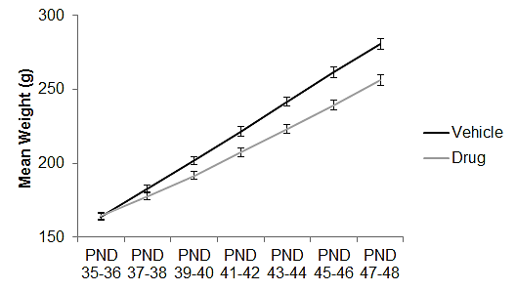

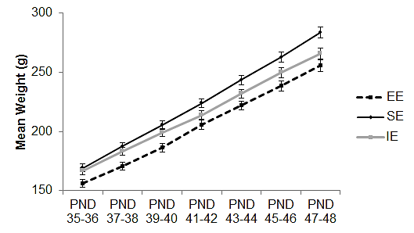

Figure 2 – The average body weight (g) during the 14-day exposure period as a function of drug and environment group. The effects of CP 55, 940 and vehicle administration are graphed in the top graph, and the effects of environment condition in the bottom graph. Means are illustrated with standard error of the means (SEM) and show that the drug rats weighed significantly less overall compared to the vehicle rats during the injection period and the interaction was significant across days. The EE rats weighed the least and were significantly lighter than the SE rats on every block. The IE rats’ weight gain tapered off and began to match the EE rats on block 4.

A second 4 (block) x 2 (drug group) x 3 (environment condition) repeated measures ANOVA was conducted to assess the effects of the environment and drug treatment on average weight gain across the four blocks immediately following the exposure period. During this wash-out period the rats were weighed once every five days. The analysis produced another significant main effect of block, *F*(3, 183)=861.72, *p*<.001, because once again all subjects were gaining weight. The main effect of drug group was significant, *F*(1, 61)=5.59, *p=*.021. Means for this finding indicated that the drug animals weighed less overall (=390.86) compared to the average weight of the vehicle rats during exposure (=412.17). A significant interaction was produced between block and drug group, *F*(3, 183)=2.82, *p*=.040. This finding indicated that the drug rats gained weight at a faster rate than the vehicle groups across the post-exposure period (see the top graph in Figure 3). Comparing the drug group to the vehicle animals with *t*-tests for each of the 4 blocks of 5-day intervals after the exposure period confirmed that the groups were significantly different on blocks 1 and 2 (*p*=.004 and *p*=.025 respectively). However, the increased weight gain in the drug rats resulted in an average body weight similar to that of the vehicle rats on block 3 and block 4 (*p*=.107 and *p*=.200 respectively).

The main effect of environment condition was also significant, *F*(2, 61)=9.12, *p*<.001 (see the bottom graph in Figure 3). The group means for this result indicated that the EE rats weighed significantly less (=378.01) on average during the post-exposure period compared to the SE rats (=425.44) and the IE rats (=401.09). Tukey’s post hoc tests revealed that the EE rats weighed significantly less than the SE rats (*p*<.001), but the EE rats weighed the same as the IE rats (*p*=.106), whereas the SE rats almost weighed more than the IE rats (*p*=.071). No significant interaction was found between block and environment condition. The three-way interaction between block, drug group, and environment condition, was also not significant. It is clear that environmental enrichment slowed down normal weight gain into adulthood.

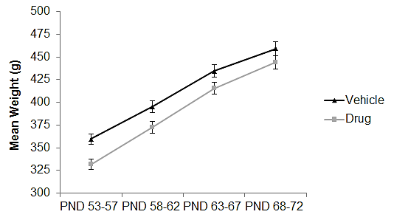

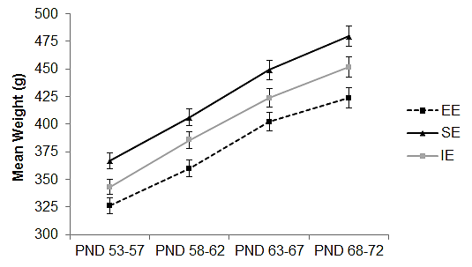

Figure 3 – The average body weight (g) across four blocks of 5-day intervals post exposure, as a function of drug and environment group. The effects of CP 55, 940 and vehicle administration are graphed in the top graph, and the effects of environment condition in the bottom graph. Means are illustrated with standard error of the means (SEM) and show that the drug rats weighed significantly less than the vehicle rats only on the first two blocks but gained weight faster such that the difference was no longer significant in the last two blocks. The EE and the IE rats weighed the same and both weighed significantly less than the SE rats overall. The rate of weight gain was not affected by environmental condition in the first 20 days of the wash-out period.

A 2 (drug group) x 3 (environment condition) ANOVA was conducted to assess the weight of the animals on the first day of behavioral testing in adulthood (PND 77). No significant differences were found between the average body weight of the drug and vehicle animals before they began the first behavioral test. The drug animals increased their rate of weight gain during the wash-out period such that there was no longer any difference in the average body weight compared to that of the vehicle animals 28 days after drug exposure. However, there was a significant main effect of environment condition, *F*(2, 67)=6.43, *p*=.003. Group means revealed that the average weight of the EE rats (=453.00) was still less than the average weight of the SE rats (=497.17) and IE rats (=478.16) at the start of behavioral testing. Tukey’s post hoc tests revealed that the EE rats were significantly different from the SE rats (*p*=.002), while the difference between the EE and IE rats (*p*=.110) and between the SE rats and IE rats (*p*=.267) was not significant. The data are graphed in Figure 4. In sum, environmental enrichment significantly slowed down normal weight gain during puberty and into adulthood.

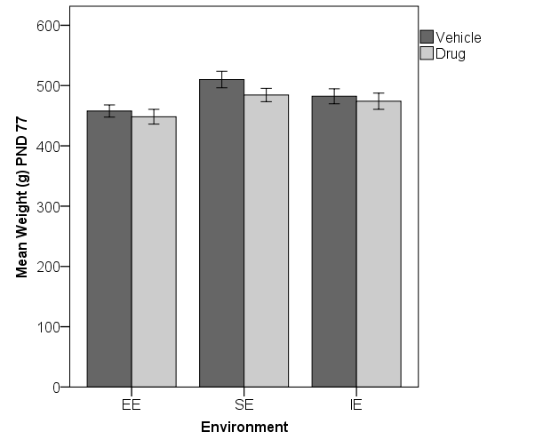

Figure 4 – The average weight of the drug and vehicle animals in each environment condition on PND 77 before starting behavioral testing. Means are illustrated with standard error of the means (SEM) and show that the average weight of the EE rats was less than the average weight of the SE rats. The EE rats were not different from the IE rats, and the SE and IE groups also did not differ.

An additional 2 (drug group) x 3 (environment condition) ANOVA was conducted to assess the weight of the animals on the first day of the forced swim task on PND 98 in adulthood. No significant differences were found between the average body weight of the drug and vehicle animals on PND 98. The weight-suppressing effects of CP55,940 not only wore off following the cessation of drug administration, but the drug rats gained weight in such a way as to catch up with the vehicle rats as well. The significant main effect of environment condition was still present on PND 98, *F*(2, 67)=4.92, *p*=.010. Group means revealed that the average weight of the EE rats (=531.25) was still less than the average weight of the SE rats (=576.17) and IE rats (=570.77) on the first day of the FST in adulthood. Tukey’s post hoc tests revealed that the EE rats were significantly different from the SE rats (*p*=.015), and also from the IE rats (*p*=.036), but no difference was found between the SE rats and IE rats (*p*=.931). The data are graphed in Figure 5. In sum, environmental enrichment significantly slowed down normal weight gain that resulted in a reduced average body weight that persisted into late adulthood, four weeks after the rats had been switched to isolation housing.

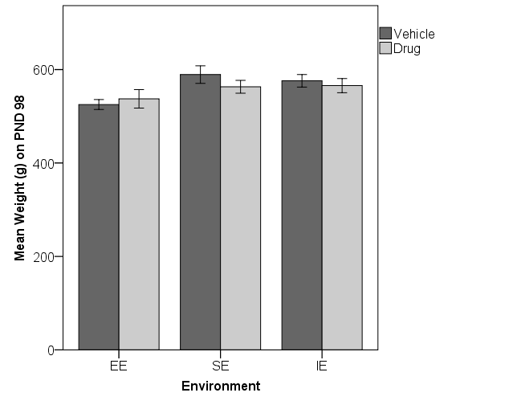

Figure 5 – The average weight of the drug and vehicle animals in each environment condition on the first day of the forced swim task on PND 98. Means are illustrated with standard error of the means (SEM) and show that the average weight of the EE rats was less than the average weight of the SE rats. The EE rats were also different from IE rats, but the SE and IE groups did not differ.

**Elevated Plus-Maze**

A 2 (drug group) x 3 (environment condition) ANOVA was conducted to assess the effect of drug treatment and environment condition on the activity levels displayed by subjects on the elevated plus-maze as determined by the total number of arm entries. The analysis revealed no significant main effects of drug group or environment condition, and the interaction between the two was also not significant. Based on these results the rats were equally active on the maze regardless of drug treatment or environment condition. The average number of total arm entries was 22.19 during the 10-min session.

In order to assess arm entries as a measure of anxiety, a 2 (arm type) x 2 (drug group) x 3 (environment condition) repeated measures ANOVA was conducted on the total number of entries made into the open versus the enclosed arms of the maze. Results for the main effects of drug group and environment condition, as well as the interaction between drug group and environment condition were not significant. A significant main effect of arm type was produced, *F*(1, 66)=519.78, *p*<.001. All subjects entered the enclosed arms (=14.82) more frequently than the open arms (=7.38). However, arm type was not found to interact significantly with drug group, or environment condition. The three-way interaction between arm type, drug group, and environment condition, was also not significant. These results indicated that all animals, regardless of drug group and environment condition made fewer entries into the open arms compared to the more highly preferred enclosed arms on the plus-maze.

The total number of entries into the open- versus enclosed- arms is not as sensitive as the percentage of entries into the open arms for each individual rat (open-arm entries divided by total arm entries). A 2 (drug group) x 3 (environment condition) ANOVA was conducted on this data to more accurately assess the presence of anxiety in our rats. The analysis revealed that the main effect of drug group approached significance for the percentage of open-arm entries *F*(1, 66)=3.40, *p*=.070. The means suggested that the vehicle rats made a higher percentage of entries into the open arms (=33.62%) compared to the drug rats (=30.46%), but the effect was not quite significant (see Figure 6). The main effect of environment condition was also not significant. However, environment condition was found to interact significantly with drug group, *F*(2, 66)=3.40, *p*=.039. As can be seen in Figure 6, the vehicle rats in the social and isolation environment groups made a greater percentage of entries into the open arms of the maze compared to the drug rats in the social and isolation environment groups, whereas the opposite occurred in the EE rats. Given the significant interaction, additional *t*-tests were conducted to analyze the difference between the drug and vehicle animals for each environment condition. The drug group did not differ from the vehicle group in the EE condition (*p* = .442), nor in the SE condition (*p* = .341). However, the drug rats entered the open arms relative to the enclosed arms significantly less than the vehicle rats in the IE condition (*p* = .026). This finding suggests that the drug rats housed in the social isolation environments displayed increased anxiety as compared to the vehicle rats. Enrichment did not offer more protection from the drug-induced anxiety than social housing alone.

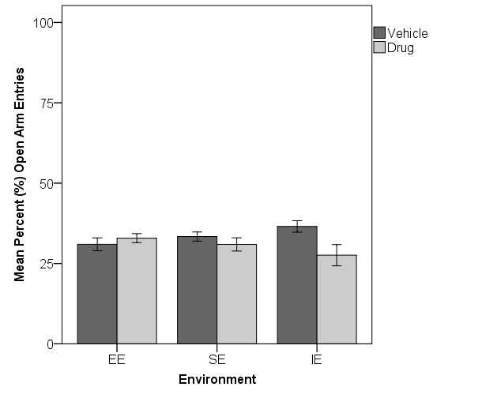

Figure 6 - The mean percent (%) of entries made into the open arms of the maze as a function of drug group and environment condition. Means are illustrated with standard error of the means (SEM) and indicate increased anxiety in the IE drug rats, but not in the EE or SE drug rats.

An additional 2 (arm type) x 2 (drug group) x 3 (environment condition) repeated measures ANOVA was conducted to assess the effects of drug treatment and environment condition on the total amount of time spent on the open and enclosed arms of the maze. Only one significant effect was found, which was the main effect of arm type, *F*(1, 66)=446.98, *p*<.001. All subjects displayed a preference for enclosed arms (=420.82 s) compared to the opens arms (=110.18 s) as indicated by the total amount of time spent on each. Basically all subjects displayed the typical behavior of rats by showing a strong preference for enclosed arms and avoidance of the open arms on the plus-maze.

To provide the more sensitive measure for assessing anxiety, a 2 (drug group) x 3 (environment condition) ANOVA was conducted on the percentage of time spent on the open arms of the maze relative to the time spent on both open and enclosed arms. Although the graph in Figure 6 shows a similar pattern of data as that seen for the percentage of entries into the open arms, the results for the main effects of drug group and environment condition, as well as the interaction between drug group and environment condition were not significant. The drug and vehicle-treated subjects within each environment condition did not differ in terms of the average percent of time spent on the open arms of the plus-maze (see Figure 7).

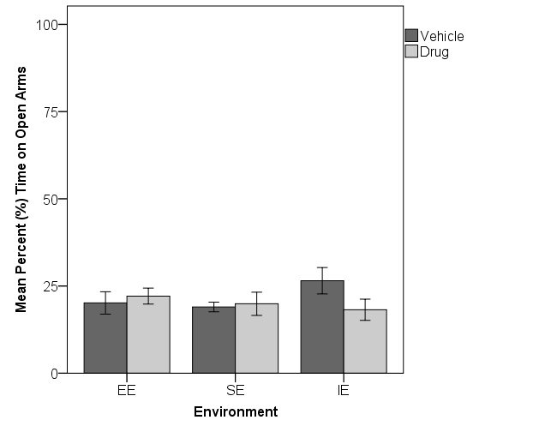

Figure 7 – The mean percent time spent on the open arms relative to both open and enclosed arms of the maze (%) by the drug and vehicle rats in each environment condition. Means are illustrated with standard error of the means (SEM) and indicate no difference in the percent of time spent on the open arms of the maze between experimental groups.

**Social Interaction**

*Habituation.* The first two days of the social interaction task consisted of two 10-minute habituation sessions where experimental rats were introduced to the open-field and activity was recorded. Measurements were obtained for overall activity (path length), and several measures to determine the presence of anxiety, including mean percent time spent in the periphery of the open field versus the center, as well as mean percent of entries into the periphery versus the center. In addition, the number of rears and the amount of boli produced by subjects on habituation sessions 1 and 2 were recorded.

A 2 (trial) x 2 (drug group) x 3 (environment condition) repeated measures ANOVA was conducted to assess differences in the mean percent time spent in the periphery compared to the center of the open-field. The main effects of drug group and environment condition, as well as the interaction between drug group and environment condition, were not significant. This finding indicated that all subjects, regardless of drug group and environment condition spent the same percentage of time in the periphery, while also avoiding the center of the open-field (see Figure 8). The main effect of trial was also not significant, and neither were any of the two and three-way interactions with trial. These results indicate that all animals, regardless of drug group and environment condition, spent the same percentage of time in the periphery as a function of time in the center of the open field on habituation trials 1 and 2 of the social interaction task. All subjects displayed a large overall preference for the periphery and avoidance of the center of the open field (see Figure 8).

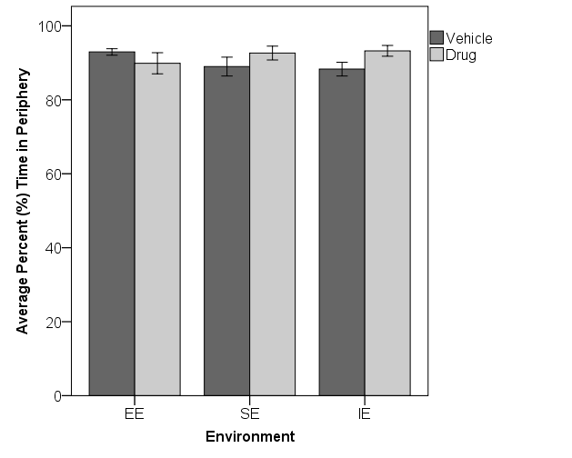

Figure 8 - The average percent (%) of time spent in the periphery of the open field relative to time in the center by drug and vehicle treated subjects in each environment condition on habituation sessions 1 and 2 of the social interaction task. Means are illustrated with standard error of the means (SEM) and show that all animals, regardless of drug group and environment condition, displayed a preference for the periphery and avoided the center of the open field.

Another 2 (trial) x 2 (drug group) x 3 (environment condition) repeated measures ANOVA was conducted to assess differences in the mean percent of entries made into the peripheral cells of the open field relative to the center. No significant main effects were found for drug group or environment condition. However, the analysis revealed that the interaction between the two approached significance, *F*(2, 62)=2.77, *p*=.070. This data is graphed in Figure 9. The remainder of the analysis did not reveal other significant main effects or two-way interactions. However, the three-way interaction between trial, drug group, and environment condition was significant, *F*(2, 62)=3.27, *p*=.045. This finding suggests that the average percentage of entries made into the peripheral cells of the open-field were different for the drug and vehicle-treated subjects within each environment condition on habituation trial 1 versus trial 2.

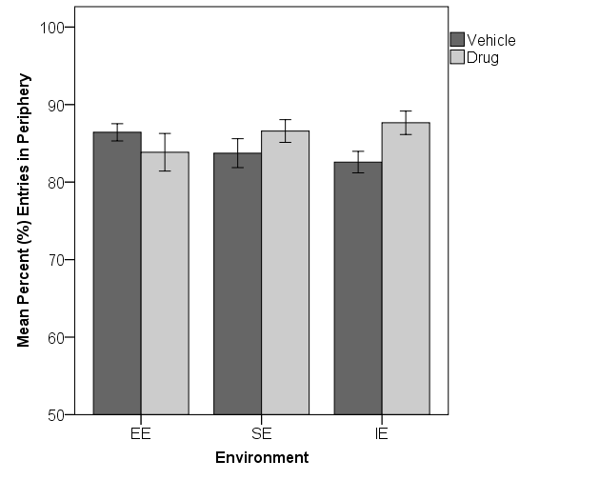

Figure 9- Mean percent of entries into peripheral cells of the open field as an average for both habituation trials by drug and vehicle-treated subjects in each environment condition. Means are illustrated with standard error of the means (SEM) and show that the average percent of entries made into the peripheral cells of the open-field was slightly different between the drug and vehicle animals in each environment condition overall.

To better interpret the significant three-way interaction, tests of the simple effects were conducted using a 2 (trial) x 2 (drug group) repeated measures ANOVA for each environment condition separately, followed by independent samples *t*-tests comparing the drug to the vehicle group if needed. The first analysis was conducted to assess the mean percentage of entries into the peripheral cells of the open-field for the enriched environment condition. The analysis did not produce significant main effects. However, the interaction between trial and drug group was significant, *F*(1, 19)=5.42, *p*=.031. The means are graphed in the top panel of Figure 10 and indicate that the vehicle rats made fewer entries into the peripheral cells on trial 2 (=85.35) compared to trial 1 (=87.50), whereas, the drug rats made fewer entries into the periphery on trial 1 (=82.53) compared to trial 2 (=85.17). This finding suggests that the drug rats in the enriched environment condition displayed increased anxiety on habituation trial 2 whereas the vehicle rats displayed increased anxiety on trial 1. An independent samples *t*-test was conducted for each trial to assess the percent of entries made into the peripheral cells between the drug and vehicle rats. The drug and vehicle rats were not significantly different on trial 1 (*t*(20)=1.50, *p*=.149), or trial 2 (*t*(21)=-.035, *p*=.972). These data are graphed in Figure 10.

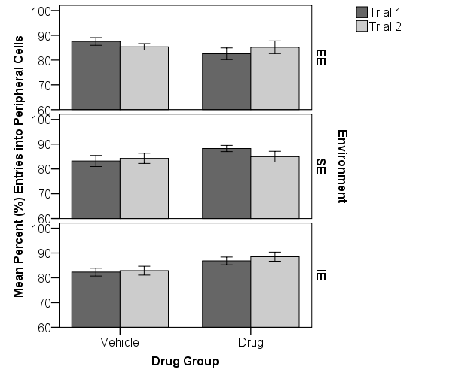

Figure 10 – The mean percent (%) of entries into the peripheral cells relative to the center cells of the open-field by the drug and vehicle rats in each environment condition on habituation trials 1 and 2 on the open field. Means are illustrated with standard error of the means (SEM) and show subtle effects of the drug within the environment conditions.. The interaction was significant for the EE drug rats, but planned comparisons revealed no differences between drug and vehicle rats on each trial separately. Nor were there differences for the SE group. The IE drug rats exhibited a significant increase in % entries into the periphery, indicating fewer into the center, suggesting increased anxiety overall.

The second 2 x 2 repeated measures ANOVA was conducted to assess the mean percentage of entries into the peripheral cells of the open-field on habituation trials 1 and 2 by the drug and vehicle rats for the social environment condition. The main effects of trial and drug group, as well as the interaction between trial and drug group, were not significant. The social environment drug rats did not differ from the vehicle rats in terms of percent entries into the center of the open field, therefore they did not exhibit increased anxiety. A third 2 x 2 repeated measures ANOVA was conducted to assess the mean percentage of entries into the peripheral cells of the open-field for the isolated environment condition (see the bottom panel in Figure 10). The main effect of trial was not significant, nor was the interaction between trial and drug group significant. However, a significant main effect of drug group was produced, *F*(1, 22)=5.93, *p*=.023. The means indicated that overall, the drug rats made a greater percentage of entries into the peripheral cells (=87.65) compared to the vehicle rats (=82.58). This finding suggests that the drug rats in the isolated environment condition showed increased anxiety.

Two independent samples *t*-tests were conducted to assess the percent of entries made into the peripheral cells on trial 1, and the percent on trial 2 between the drug and vehicle isolated rats. The analysis of trial 1 suggested that although the drug rats made a higher percentage of entries into the peripheral cells (=86.81) than the vehicle rats (=82.30), the effect was not quite significant (*t*(22)=-2.01, *p*=.056). However, on trial 2, the drug rats made a significantly higher percentage of entries (*t*(23)=-2.38, *p*=.026) into the peripheral cells of the open-field (=88.50) compared to the vehicle rats (=82.59). These results indicate that the drug rats in the isolated environment condition displayed increased anxiety in the open field, but especially on habituation trial 2 (see Figure 10).

To further investigate the possibility of altered emotionality, a 2 (trial) x 2 (drug group) x 3 (environment condition) repeated measures ANOVA was conducted for the number of boli produced by subjects during each session of habituation to the open field. The analysis did not produce a significant main effect of trial, or environment; nor were significant interactions found between trial and drug group,or between trial and environment condition, or between drug group and environment. The three-way interaction between trial, drug group, and environment condition, was also not significant. However, a significant main effect of drug group was produced, *F*(1, 67)=4.80, *p*=.032. The data are graphed in Figure 11. Group means for this finding indicated that the drug rats produced more boli overall (=2.64) compared to the vehicle rats (=1.67). These results suggest that drug rats in general were more anxious on the open field than the vehicle subjects regardless of their environment condition.

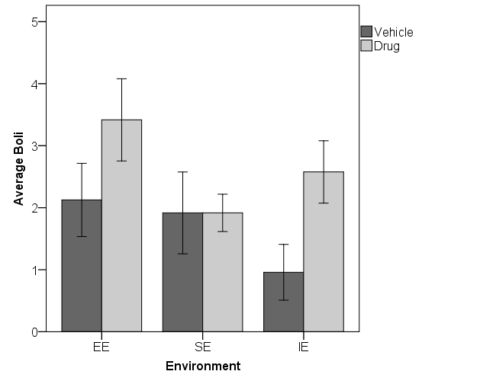

Figure 11 – Mean number of boli produced by drug and vehicle-treated subjects in each environment condition during habituation trials 1 and 2 of the social interaction task. Means are illustrated with standard error of the means (SEM) and show that the drug rats produced the most boli overall compared to the vehicle rats.

Given the data graphed in Figure 11, independent samples *t*-tests were conducted to assess the average amount of boli produced by the drug and vehicle subjects in each environment condition. The first analysis examined the enriched environment condition and no difference was found, *t*(22)=-1.46, *p*=.160. This finding indicated that the drug and vehicle animals did not differ in the average amount of boli produced across the two habituation trials for the EE animals. A second independent samples *t*-test revealed no significant difference in the average amount of boli produced by the drug and vehicle rats in the social environment condition, as well, *t*(22)=.000, *p*=1.0. The third independent samples *t*-test revealed a significant difference in the average amount of boli produced by the drug and vehicle rats in the isolation environment condition, *t*(23)=-2.38, *p*=.026. The IE drug rats produced more boli (=2.58) on average compared to the vehicle rats (=0.96). In conclusion, the drug rats in the isolated environment condition displayed increased anxiety compared to the vehicle rats across the two trials of habituation to the open-field, but the drug rats in the enriched and social conditions did not.

In terms of examining differences in activity levels, a 2 (trial) x 2 (drug group) x 3 (environment condition) repeated measures ANOVA was conducted on the length (m) of the path travelled during habituation trial 1 and 2. The main effect of trial was significant, *F*(1,62)=9.08, *p*=.004. The means for this finding indicated that all animals were less active on trial 2 (=24.27) than on trial 1(=25.78). No significant interactions were found between trial and drug group, or between trial and environment condition. The three-way interaction between trial, drug group, and environment condition, was also not significant. The main effect of drug group approached significance, *F*(1, 62)=3.42, *p*=.069. This finding suggested that the drug rats were slightly less active overall (=23.64) compared to the vehicle rats (=26.40), across the two habituation trials.

The main effect of environment condition was also significant, *F*(2,62)=5.82, *p*=.005. This finding indicated a difference in the average amount of activity for the two habituation trials between the three environment conditions. The animals housed in the enriched environment were the least active (=23.07) during the two habituation trials compared to the animals housed in the social (=23.43) and isolated environment conditions (=28.57). These data are graphed in Figure 12. Tukey’s post hoc tests revealed a significant difference between the enriched and isolated environment conditions (*p*=.014), and also between the social and isolated environments (*p*=.019), but not between the social and enriched environment conditions (*p*=.985). The two-way interaction between drug group and environment condition was not significant, *F*(2, 62)=1.98, *p*=.147. The pattern of results suggests that isolation housing, in comparison to social housing, results in an increased level of activity in an open-field regardless of drug condition or enrichment.

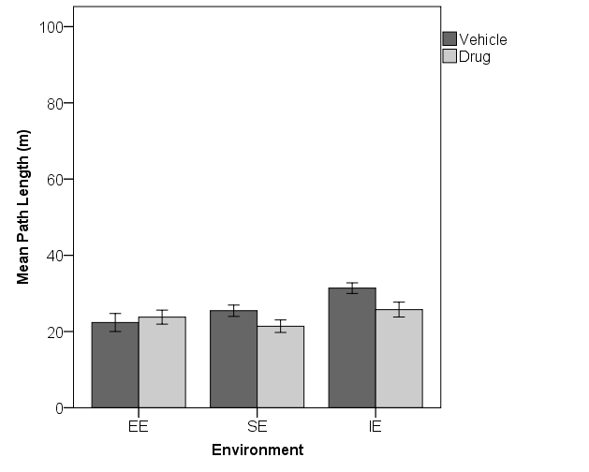

Figure 12– The average amount of activity displayed by the drug and vehicle rats in each environment condition as a mean of habituation trials 1 and 2 on the social interaction task as measured by the length (m) of the path travelled. Means are illustrated with standard error of the means (SEM) and show that the animals in the two social environments were less active overall compared to the animals in the isolation environment.

On the third day of the social interaction task, experimental rats were paired with a naïve male conspecific and the 10-minute social interaction session was videotaped and later coded by researchers blind to the experimental conditions. It is known that the weight of adult male rats influences their behavior when allowed to interact with one another. Due to the large number of rats needed to serve as conspecifics throughout the study, not all pairs fell within the preferred +/-10 g weight range. Therefore, the weight difference between experimental subjects and paired conspecifics were entered into each overall analysis as a covariate when analyzing the amount of time the experimental rats spent in social interactions. Total time spent engaging in active social interaction and aggressive behaviors were recorded and analyzed separately for the first 5-minute and second 5-minute halves of the total 10-minute social interaction session.

A 2 (drug group) x 3 (environment condition) ANOVA assessing the weight difference between the experimental rat and the conspecific for all groups revealed a significant main effect of drug group, *F*(1,67)=4.68, *p*=.034. Means for this finding indicated that the average weight difference was significantly greater between the vehicle-treated subjects and paired conspecifics (=2.86) than the drug-treated subjects and paired conspecifics (=-1.19). The main effect of environment condition was not significant, and the interaction between drug group and environment condition was also not significant.

A 2 (half) x 2 (drug group) x 3 (environment condition) repeated measures ANOVA with weight difference entered as a covariate was conducted to assess the effect of drug treatment and environment condition on the amount of time spent engaging in non-aggressive social interaction during the first and second five-minute halves of the total 10-minute social interaction session. The analysis produced a significant main effect of half, *F*(1, 66)=215.54, *p*<.001. The means for this finding indicated that all subjects spent significantly more time engaging in active social interaction during the first 5 minutes (=103.36) compared to the second 5 minutes (=61.18) of the social interaction session. The only other significant effect was the main effect of environment condition, *F*(2, 66)=7.14, *p*=.002. Means for this finding indicated that the IE rats spent significantly more time engaging in active social interactions (=97.49) compared to the SE rats (=77.42) and EE rats (=68.90). Tukey’s post hoc tests were conducted and revealed that the IE rats were significantly more socially active than the EE rats (*p*=.001), and the IE rats also more socially active than the SE rats (*p*=.033), while no difference was found between the EE and SE rats (*p*=.515). Concluding from these findings, isolation housing increased the overall amount of time spent engaging in active social interactions compared to the social housing groups (EE and SE), regardless of drug group (see Figure 13).

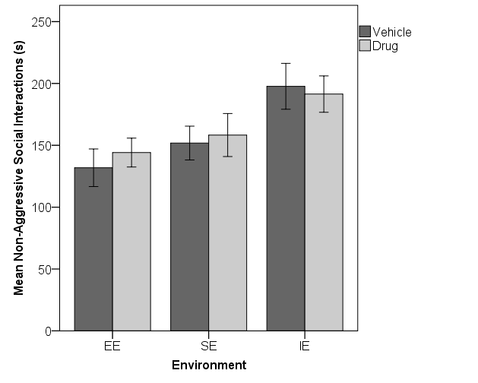

Figure 13– The average amount of time the drug and vehicle rats in each environment condition spent engaging in non-aggressive social interaction behaviors during the total 10-minute interaction session. Means are illustrated with standard error of the means (SEM) and show that the subjects housed in isolation spent the most time overall engaging in social activity compared to the subjects that were socially housed (both the enriched and social environment conditions).

A 2 (session half) x 2 (drug group) x 3 (environment condition) repeated measures ANOVA with weight difference entered as a covariate was conducted to assess the effects of treatment and environment condition on the amount of time spent engaging in aggressive behaviors during the first and second five-minute halves of the total-10 minute social interaction session. The analysis revealed no significant main effects of half, drug group, or environment condition. Also, no significant interactions were produced. These findings indicate no effect of the environment or drug treatment on aggressive interactions. As can be seen in Figure 14, there was a great deal of variability in the data.

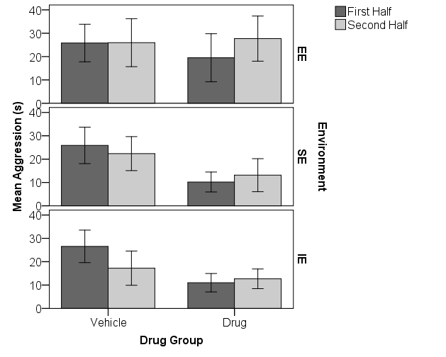

Figure 14 – Average amount of time the vehicle and drug rats housed in the three environment conditions spent engaging in aggressive interactions during the first and second five-minute halves of the total 10-minute interaction session. Means are illustrated with standard error of the means (SEM) and show that the animals did not differ in terms of the amount of aggression displayed during the social interaction session.

**Sucrose Preference Task**

The sucrose preference task measures symptoms of anxiety via a measure of neophobia (fear of novelty) by assessing the amount of sucrose versus plain water consumed during the first 30 minutes and the first hour of exposure. Less sucrose consumption after 30 minutes or 1 hour indicates increased anxiety. Symptoms of depression are determined by the presence of anhedonia (a lack of interest in or ability to experience pleasure) by assessing sucrose consumption across days. Decreased sucrose consumption across days indicates increased symptoms of depression.

*Neophobia.* To assess the presence of neophobia, two 2 (fluid) x 2 (drug group) x 3 (environment group) repeated measures ANOVA’s were conducted on the total amount of sucrose versus plain water consumed at 30 minutes and 1 hour. Results for the first ANOVA assessing differences after 30 minutes of exposure to the novel sucrose solution revealed a significant main effect of fluid, *F*(1, 67)=32.00, *p*<.001. Means for this result indicated that significantly more sucrose was consumed (=3.06) compared to plain water (=0.82) by all subjects during the first 30 minutes of exposure. No significant interactions were found between type of fluid and drug group, or between fluid and environment condition. Nor were any other effects or interactions significant. There was no sign of neophobia after the first 30 minutes of exposure to the novel sucrose solution as all animals displayed an increase in sucrose consumption, regardless of drug group and environment condition (see Figure 15).

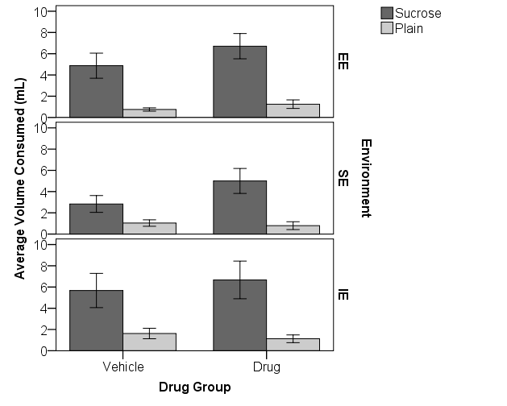

Figure 15 - Average amount of sucrose and plain water consumed (mL) by the drug and vehicle rats in each environment condition after the first 30 minutes of exposure to the novel sucrose solution. Means are illustrated with standard error of the means (SEM) and show no presence of neophobia: all subjects, regardless of drug group and environment condition, drank more sucrose at 30 minutes of exposure.

The second 2 (fluid) x 2 (drug group) x 3 (environment group) repeated measures ANOVA assessing differences in the total amount of sucrose versus plain water consumed after the first hour of exposure, revealed a significant main effect of type of fluid, *F*(1, 66)=49.35, *p*<.001. Overall significantly more sucrose was consumed (=5.29) than plain water (=1.10) during the first hour of exposure to the novel sucrose solution. The main effect of sucrose versus plain water was the only significant finding for this data. These results indicated no sign of neophobia after the first hour of exposure to the novel sucrose solution as all animals consumed significantly more sucrose than water across all groups (see Figure 16).



Figure 16 – Average amount of sucrose and plain water consumed (mL) by the drug and vehicle rats in each environment condition after the first hour of exposure to the novel sucrose solution. Means are illustrated with standard error of the means (SEM) and show no presence of neophobia in that all subjects, regardless of drug group and environment condition, drank significantly more sucrose at the end of the first hour of exposure.

*Anhedonia.* To assess the presence of anhedonia, a 3 (day) x 2 (drug group) x 3 (environment condition) repeated measures ANOVA was conducted to assess differences in the percentage of sucrose consumed across three days. A graph of the data for this analysis is presented in Figure 16; note that the majority of fluid consumed by the rats each day was sucrose (85.22%) rather than plain water (14.78%). The analysis did not reveal a significant main effect of day, *F*(2, 132)=1.60, *p*=.205. This finding indicated no increase in the overall mean percent of sucrose consumed on consecutive days. There were no significant effects, although the main effect of drug group approached significance, *F*(1, 66)=3.72, *p*=.058. This finding suggested that the average percent of sucrose consumed was less for the drug rats overall (=82.83) compared to the vehicle rats (=87.60). This finding may indicate some anhedonia in the drug rats because they were less interested in the sweet sucrose solution compared to the vehicle rats (see Figure 16). Closer examination of the graph made it clear that analysis of the data on each day was necessary.

Independent samples *t*-tests were conducted to assess differences between the drug and vehicle rats in average percent of sucrose consumed on each day. Significant differences were not found on day 1 (*t*(71)=.50, *p*=.621), or day 3 (*t*(70)=1.23, *p*=.222), but the drug and vehicle rats did differ in the amount of sucrose consumed on day 2 (*t*(71)=2.45, *p*=.017). Means for this finding indicated that the drug rats consumed significantly less sucrose (=81.27%) on day 2 compared to the amount consumed by the vehicle rats (=89.34%), suggesting that the drug rats displayed signs of anhedonia, but only on the second day of exposure (see Figure 17).

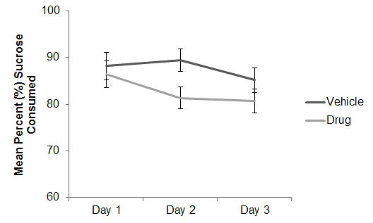

Figure 17 - Mean percent of sucrose consumed by the drug and vehicle animals across the three days of the sucrose preference task. Means are illustrated with standard error of the means (SEM) and show that the drug rats drank somewhat less sucrose overall and drank significantly less sucrose on day 2, indicating that the drug animals displayed signs of anhedonia on day 2 of exposure.

**Forced Swim Test**

The FST procedure measures the dynamics of the rats’ transition from an active (swimming and climbing) to a passive (immobility) coping style when forced to swim in a tank filled with water. Day 1 consisted of a 15-minute habituation session followed by a five-minute test session on day 2. On day two, measurements were recorded for the amount of time spent swimming, climbing, or immobile. Symptoms of depression would be indicated by the rat displaying shorter latencies to immobility, increased time spent immobile, and decreased time spent swimming or climbing.

It was assumed that the temperature of the water may influence the rats’ behavior in the forced swim test. While the temperature of the water remained within the preferred range of 27 degrees Celsius, +/-2 degrees, on both days of the task, the temperature difference was calculated between day 1 and 2 of the task for each rat and entered into the analyses as a covariate.

A 2 (session) x 2 (drug group) x 3 (environment condition) repeated measures ANOVA was conducted to assess differences in the latency to the first bout of immobility on the first versus the second session of the task, with temperature difference included as a covariate. Temperature difference did not account for a significant amount of variability in the latency to immobility during the first and second test session. The analysis revealed a significant main effect of session, *F*(1, 63)=6.52, *p*=.013. Means for this result indicated that subjects in general had shorter latencies to the first bout of immobility on the second test session (=57.12) compared to the first swim session (=75.94). These data are graphed in Figure 18.

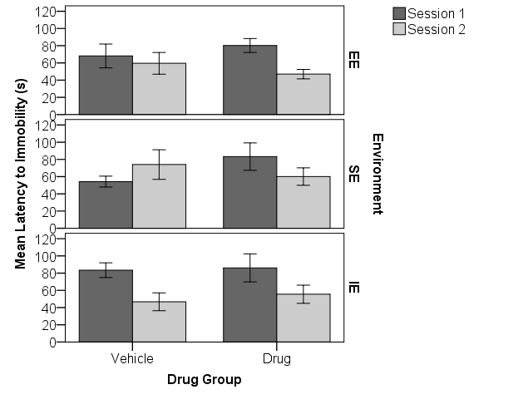

Figure 18 – Mean latency (s) to the first bout of immobility during session 1 and session 2 of the forced swim test for the drug and vehicle animals in each environment condition. Means are illustrated with standard error of the means (SEM) and show that subjects in general, regardless of drug group and environment condition had shorter latencies to immobility overall on session 2 compared to the average latency to immobility on session 1.

No significant interactions were found between session and temperature difference, session and drug group, or between session and environment condition. Also, the three-way interaction between session, drug group, and environment condition, was not significant. Results for the main effects of drug group and environment condition, as well as the interaction between drug group and environment condition were also not significant. The results from this analysis indicated that most subjects, regardless of drug group and environment condition, gave up trying to escape on session 2 quicker than they had on session 1, which could be interpreted to mean that they displayed learned helplessness on session 2.

Three separate 2 (drug group) x 3 (environment condition) ANOVAs were conducted to assess differences in the average amount of time rats spent engaging in one of the three behaviors, climbing, swimming and being immobile during session 2, with temperature difference entered as a covariate. None of the three 2 x 3 ANOVAs revealed any significant differences as a function of the temperature covariate, the drug group, or the environment condition on the average amount of time the subjects spent engaging in any of the three behaviors. The interactions between drug group and environment condition were not significant on the swimming, climbing, or immobility analyses either. These results indicated that all animals, regardless of drug group and environment condition did not differ in the amount of time spent climbing, swimming, or maintaining immobility during the five-minute duration of the second test session.

A 2 (drug group) x 3 (environment condition) ANOVA was conducted to assess differences in the average percent of time the drug and vehicle subjects in each environment condition spent being immobile during the test session, with temperature difference as a covariate. The analysis revealed no significant effects or interactions. The average percent of time the rats spent immobile during the second test session did not differ as a function of drug group or environment condition (see Figure 19). The overall conclusion from this analysis indicated that all subjects spent the same amount of time immobile during the second test session of the forced swim task.

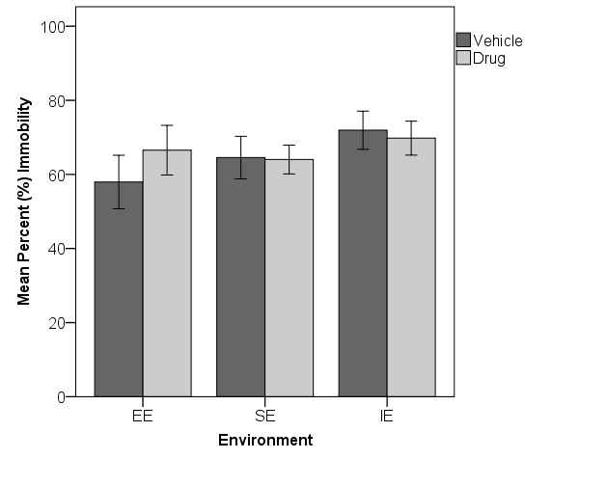

Figure 19 – Mean percent time (%) the drug and vehicle animals in each environment condition spent being immobile during the five-minute duration of the second test session of the forced swim test. Means are illustrated with standard error of the means (SEM) and show that all animals, regardless of drug group and environment condition spent the same amount of time maintaining immobility during the second test session.

To further examine potential altered emotionality on the forced swim test a 2 (session) x 2 (drug group) x 3 (environment condition) repeated measures ANOVA was conducted to assess the average amount of boli produced by subjects on session 1 and session 2 with temperature difference entered as a covariate. Temperature difference did not account for a significant amount of variability in the amount of boli produced by subjects on session 1 and session 2. The analysis revealed a significant main effect of session, *F*(1, 64)=27.32, *p*<.001. Means for this result indicated that all subjects produced more boli overall on session 1 (=6.40) compared to the average amount produced on session 2 (=4.59), indicating habituation to the swimming tank and less anxiety on session 2. No significant interactions were found between session and temperature difference, session and drug group, or between session and environment condition. Also, the three-way interaction between session, drug group, and environment condition, was not significant.

Results for the main effects of drug group, as well as the interaction between drug group and environment condition also were not significant. However, a significant main effect of environment condition was produced, *F*(2, 64)=3.14, *p*=.050. Group means for this finding indicated that the IE rats produced the most boli overall (=6.00) compared to the average amount of boli produced by subjects in the social (=5.68) and enriched environment conditions (=4.80). The data are graphed in Figure 20. Tukey’s post hoc tests were conducted and revealed a significant difference between the enriched and isolation environment groups (*p*=.045), whereas no significant differences were found between the enriched and social environments (*p*=.215), or between the social and isolation environments (*p*=.758). These results suggest that the EE rats were significantly less anxious on the FST overall than the IE rats as measured by increased boli (see Figure 20).

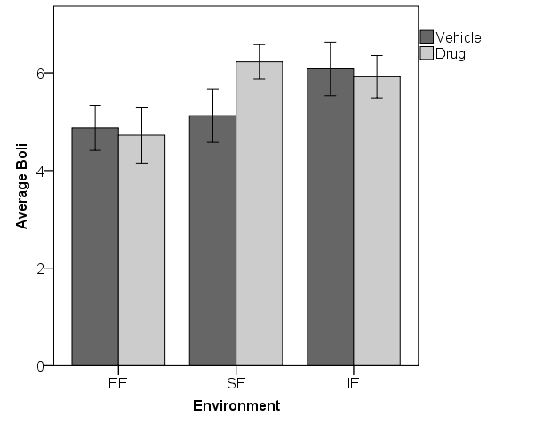

Figure 20 - Average amount of boli produced by drug and vehicle rats in each environment condition during session 1 and session 2 combined on the forced swim task. Means are illustrated with standard error of the means (SEM) and show that overall the enriched environment rats produced significantly less than the average boli produced by the isolation environment rats.

**CHAPTER 4. DISCUSSION**

It was originally hypothesized that chronic cannabinoid exposure during adolescence would increase symptoms of anxiety and depression relative to the vehicle-treated controls. Additionally, it was hypothesized that the early rearing environment would influence the observation of adverse cannabinoid drug effects differently for the subjects housed in the enriched, social, and isolation environment conditions. Specifically, the IE rats were predicted to show the highest levels of anxiety and depression compared to all other subjects. Whereas, the protective effects of environmental enrichment were predicted to reduce symptoms of anxiety and depression displayed by the EE drug rats compared to the other drug-treated subjects housed in the social and isolation environments. The results were found to partially support the original hypothesis in that the cannabinoid treated subjects displayed increased symptoms of anxiety compared to the subjects that received vehicle treatment, but very few depressive symptoms. The results also supported the hypothesis concerning increased emotionality displayed by subjects housed in the isolation environment, and cannabinoid exposure was found to exacerbate this effect. Additionally, there was some evidence to suggest that enrichment provided a protective effect in that the drug and vehicle rats in the EE condition displayed similar levels of anxiety and depression, even when the IE drug rats exhibited impairment.

Experimental subjects were assigned to environment conditions at weaning (PND 22) and began exposure to the injections commencing at 35 days of age. It was expected that all subjects would gain weight as they matured. Statistical analyses revealed that all subjects did in fact gain weight during the exposure period and for the duration of the study. However, drug condition affected body weight, as did environmental condition.

There were no group differences in weight when the animals were weaned and assigned to environment conditions on PND 22, and the average weight of the drug and vehicle animals did not differ before beginning exposure on PND 35. However, living in an enriched environment resulted in a smaller average body weight after just 13 days. The EE rats weighed less consistently, throughout the exposure and washout periods, as well as the behavioral testing period. During exposure the EE rats weighed significantly less than the SE rats overall, and the interaction showed that the EE and the IE rats gained weight slower than the SE rats. The EE rats weighed less than the SE group of rats during the washout period, but their rate of weight gain was the same. This effect did not interact with drug condition. These findings indicate an overall environmental enrichment effect in that the weight gain for these animals was significantly decreased compared to the rats in the SE environment.

Overall, the SE rats weighed the most and the IE rats were intermediate between the EE and SE groups. It has been suggested that housing rats under standard laboratory social environment conditions may increase body weight as a result of competition among social cage-mates regarding food intake. Thus, if body weight is increased by social factors and decreased by physical stimulation then it is not surprising that the average body weight of the IE rats was intermediate between the heavier, socially stressed SE rats and the healthier, more physically active EE rats. Although all rats housed in the IE and SE conditions lacked physical stimulation, the IE rats probably weighed less than the SE rats due to the absence of competition for food allocation and intake when housed in isolation.

The reduced weight gain in the EE rats after only 13 days of housing was probably due to the increased opportunity for exercise provided by enrichment, which previous studies have suggested. In particular, Zaias, Queeney, Kelley, Zakharova, and Izenwasser (2008) housed male Sprague-Dawley rats in the same environment conditions from weaning (PND 23) through adolescence (PND 45). Their results revealed that the EE rats weighed significantly less after only eight days of environmental housing (PND 31) compared to rats housed in the social and isolation environment conditions (Zaias et al., 2008).

There was no difference in body weight between the CP 55,940 rats and the vehicle rats on the first day of injections on PND 35, although both EE groups weighed less. However, cannabinoid exposure resulted in a smaller average body weight compared to the vehicle rats after just 4 days of injections, and the drug rats continued to weigh less throughout the exposure period. In addition, the rate of weight gain was significantly slower across days in those rats receiving the drug versus those receiving vehicle injections. Both cannabinoid drug exposure and environmental enrichment slowed down normal weight gain during puberty, but there was no interaction between the two, suggesting that the housing environment did not protect from or exacerbate the detrimental effects of the drug. The drug rats continued to weigh less overall compared to the vehicle rats during the post-exposure period, but the drug rats gained weight significantly faster and weighed similar to the vehicle rats after 15 days following exposure to injections. Statistical analysis of the data for body weights on the first day of behavioral testing (PND 77) revealed no effect of cannabinoid exposure on body weight. Thus, effect of the drug did not persist into adulthood, it tapered off over time and resulted in an average body weight similar to that of controls.

Similar results were found in the study conducted by Biscaia et al. (2003) in which subjects that received a high dose (.40 mg/kg) of CP 55, 940 from PND 35-45 had reduced body weight over the duration of treatment that later returned to normal and matched the vehicle controls. Biscaia et al. (2003) concluded that the reduced weight gain in the drug rats resulted from decreased food intake which remained significant throughout the entire exposure period. This is consistent with results from previous studies in which chronic THC administration and acute exposure to CP 55, 940 were found to inhibit food intake and reduce body weight gain in rats (Miczek, & Dixit, 1980; McGregor, Issakidis, & Prior, 1996). One possible explanation for the decreased food intake and body weight following acute exposure to CP 55, 940 could be attributed, at least in part, to the decreased level of activity observed following acute administration of the drug. The current results are in agreement with these findings and indicate that chronic exposure to the synthetic cannabinoid agonist, CP 55, 940 during adolescence may diminish food intake (Biscaia et al., 2003) and body weight during the exposure period. However, because the drug rats’ body weight returned to normal within 15 days following the exposure period suggests that the long-term behavioral effects of cannabinoid exposure do not produce persistent impairments in the nutritional state or somatic growth in the rat that persisted into adulthood.

Although all animals had been removed from their previous environment conditions and single-housed on PND 72, the EE rats continued to weigh less overall, and significantly less than the SE rats. Additionally, the EE rats were also found weighing significantly less than the SE and IE rats on the first day of the social interaction task (PND 82), the first day of the sucrose preference task (PND 89), and also on the first day of the forced swim task (PND 98). This finding is consistent with previous research suggesting that the increased opportunity to interact with an array of stimuli in the enriched environment enhances activity, exploration, and exercise. Specifically, Pena et al. (2009) found persistent reduced weight gain in adult male Sprague-Dawley rats during the EE post-exposure period compared to the SE control rats after 8 weeks of environmental housing starting two days after weaning on PND 23. Whereas, weight gain normalized during the post-EE exposure period among adult female rats resulting in an average body weight similar to the SE control rats (Pena et al. (2009). These results are quite interesting considering that they suggest a beneficial effect of enrichment on reduced weight gain that persists into late adulthood.

This effect is beneficial because previous studies have shown regular voluntary exercise (i.e., in-cage running wheel) and dietary restriction to significantly reduce body weight in rats (Oscai, & Holloszy, 1969). Furthermore, dietary restriction has been shown to improve regulation of energy balance and cardiovascular health in laboratory rats (Martin, Ji, Maudsley, & Mattson, 2010). Specifically, one study found that reducing daily food intake by 20-40 % significantly decreased the risk of developing diseases such as cancer, type II diabetes, and renal failure in addition to expanding the rats’ lifespan up to 40 % (Weindruch, 1996). Thus, if the reduced body weight observed in the EE rats resulted from decreased food intake then the current results fit with previous research findings on food restriction. However, it has also been suggested that environmental enrichment may increase food intake (Mainardi, Scabia, Vottari, Santini, Pinchera, Maffei, Pizzorusso & Maffei, 2010). Since food intake was not measured in the current study, another possible explanation for the decreased body weight observed in the EE rats should be addressed. Specifically, in the same study where EE increased food intake, exposure to EE during early development was enhanced the functioning of the leptin-hypothalamic axis. Leptin is a hormone responsible for signaling the status of energy stored in the body, down-regulating feeding behavior, and promoting energy expenditure (Mainardi et al., 2010). Thus, enhanced functioning of this axis suggests improved appetite, feeding behavior, and metabolism and better regulation of energy intake and expenditure.

Additionally, the beneficial effect of EE on increasing adult hippocampal cell proliferation and neurogenesis has also been shown to be increased by physical exercise. Physical exercise has also been shown to increase cell proliferation in the hypothalamus, hence its influence on improving energy balance and metabolism (Rivera, Romero-Zerbo, Pavon, Serrano, Lopez-Avalos, Cifuentes, Grondona, Bermudez-Silva, Fernandez-Llebrez, de Fonseca, Suarez, & Perez-Martin, 2011). Therefore, the increased amount of physical activity associated with environmental enrichment may have also increased cell proliferation in the hypothalamus which would suggest improved energy metabolism in these animals as a possible explanation for the reduced body weight observed in the EE rats.

Results from the elevated-plus maze revealed that the environment and cannabinoid exposure altered anxiety levels displayed by subjects on the maze. Specifically, analysis of the percentage of entries made into the open arms of the maze revealed that the IE drug rats displayed increased anxiety while the EE and SE rats did not. The IE drug rats entered the open arms relative to the enclosed arms significantly less than the IE vehicle rats. The SE pattern of behavior was similar to that of the IE rats, but was not significant. However, the EE drug rats showed no evidence of anxiety and the average percent of entries into the open arms were actually slightly higher than their vehicle counterparts. No differences in activity were found between experimental groups on: total entries, entries into the open versus enclosed arms, time spent on the open versus enclosed arms, or percent time on open versus enclosed arms. All rats displayed a strong preference for the enclosed arms and avoidance of the open arms on the plus-maze. Overall, the current results on the EPM suggest a protective effect of social housing rather than of environmental enrichment. The only drug group showing significantly higher levels of anxiety was the IE rats who were housed singly from the age of weaning.

Research findings from the animal literature investigating the effects of chronic cannabinoid exposure in adolescence on levels of anxiety on the EPM have been largely inconsistent. For example, in a study conducted by Biscaia et al. (2003), 10 days of exposure (PND 35- 45) to a high dose (.40mg/kg) of CP 55, 940 decreased levels of anxiety displayed by male Wistar albino rats on the elevated-plus maze when tested in adulthood (PND 75). Decreased levels of anxiety was determined by an increased percentage of time spent on the open arms of the plus maze by rats chronically exposed to CP 55, 940 during adolescence. However, no effect of cannabinoid exposure was found for the percentage of entries into the open arms of the maze. These results were found after a shorter duration of exposure to the drug CP 55, 940 (PND 35-45) compared to the current study (PND 35-48) and also a longer period of habituation to the testing environment before exposing animals to behavior analysis on the plus-maze. Specially, Biscaia et al. (2003) brought all animals to the testing environment 30 min. prior to testing on the elevated-plus maze, whereas in the current study animals were brought to the testing environment only 5 min. before the start of behavioral testing. It is possible that a longer duration of habituation to the testing environment may have decreased anxiety displayed by these animals on the plus-maze. Thus, a combination of differences in the duration of exposure, and time of habituation to the testing environment that may have produced long-term effects suggesting reduced anxiety on the plus-maze.

Additionally, it has been suggested that the light intensity may alter subject’s behavior on the plus-maze. Implementing too high illumination has been found to increase anxiogenic responses by discouraging exploration and activity on the maze (Violle, Balandras, Le Roux, Desor, & Schroeder, 2009). In contrast, assessment of behaviors on the elevated-plus maze conducted under red or low light increases anxiolytic responses in rodents (Violle, Balandras, Le Roux, Desor, & Schroeder, 2009). In the present study, all subjects were exposed to behavior analysis on the plus-maze under high illumination. Whereas, Biscaia et al. (2003) exposed subjects to the elevated-plus maze under red light and only assessed behaviors during the first 5 min. whereas the current study measured behavior on the plus-maze for 10 minutes. Thus, exposing animals to behavior analysis on the plus-maze under red light may have been a factor that influenced the anxiolytic response elicited by these animals following chronic cannabinoid exposure.

In another similar study, Bambico et al. (2010) found no differences in anxiety on the elevated-plus maze when the rats were tested in adulthood (PND 70). They used male Sprague-Dawley rats that received chronic treatment (PND 30-50) of either a low (.2 mg/kg) or high dose (1 mg/kg) of the synthetic cannabinoid agonist, WIN 55, 212-2. No differences were found between the low and high dose treatment groups compared to controls on the percentage of time spent on the open arms or the percentage of entries made into the open arms of the maze. The lack of an effect found on the elevated-plus maze in the study conducted by Bambico et al. (2003) may have been due to differences in the type of cannabinoid drug used (WIN 55, 212-2 versus CP 55, 940), duration of exposure (20 days versus 14 days), or even the duration of the wash-out period (20 days versus 28 days). Additionally animals were only assessed on the plus-maze for 5 min. whereas in the current study behavioral analysis lasted for 10 min. Bambico et al. (2010) used standard room lighting (350 lx) whereas, the current study exposed all subjects to behavior analysis on the plus-maze under high illumination (standard room lighting plus an overhead light directly above the maze). Therefore, it is suggested that future studies take into account the light intensity under which subjects are exposed to behavior analysis on the elevated-plus maze.

In terms of the influence of housing environment on the EPM, one study conducted by Pena et al. (2009) found EE to decrease anxiety by increasing the amount of time spent on and entries into the open arms of the maze compared to the SE and IE rats. Animals were housed in enrichment for the duration of 12 weeks and remained in their environment conditions throughout the duration of behavioral testing. Also, animals were exposed to the plus-maze in a dark room illuminated under dim light. In contrast, in the present study animals were housed in enrichment for a little over 7 weeks and were single-housed 6 days prior to behavioral testing. Therefore, a longer duration of enrichment and continuous housing throughout behavioral testing and exposing animals to the plus-maze under dim lighting may have reduced anxiety levels displayed by these subjects. However, in another similarly study conducted by Brenes, Padilla, and Fornaguera (2009) animals were housed in enrichment for 11 weeks and exposed to behavior analysis on the plus-maze under low-red lighting and no differences were found between subjects housed in either an enriched, social, or isolation environment. Contrastingly, Weiss et al. (2004) found that animals housed in isolation for 13 weeks and exposed to behavior analysis on the EPM under low light (12 lx) displayed increased anxiety as measured by the percentage of entries into the open arms of the maze compared to group-housed subjects. Although, such research findings have been relatively inconsistent, and to date no previous studies have examined cannabinoid drug effects in isolated animals on the plus-maze; the results of the current study suggest that only the IE drug rats were more anxious on the EPM.

The social interaction task allowed analysis of behavior on an open field for two consecutive sessions as well as analysis of social interactions between each experimental animal and a naïve conspecific on a third session. During the two habituation sessions in the open field, anxiety and activity levels were measured. As with the EPM, the drug rats in the IE condition showed increased anxiety. On the average, the IE drug group avoided entering the center of the open field as frequently as they entered the peripheral area. This effect was not observed in the EE or SE rats, although the pattern was similar for the rats in the social environment condition. The percentage of time spent in the periphery versus the center of the open field did not differ as a function of drug or environment condition, corresponding to the results on the EPM. All subjects displayed a large overall preference for the periphery and avoided the center.

Results from the analysis of number of boli in the open field bolstered the conclusion of increased anxiety in the drug rats. The drug animals produced significantly more boli on average compared to the vehicle animals. It has been suggested that increased defecation is an indication of increased anxiety levels in rodents. Thus, treatment with the synthetic cannabinoid agonist, CP 55, 940 during adolescence significantly increased levels of anxiety observed in the open field compared to the vehicle-treated subjects. Tukey’s post hoc tests confirmed that the effect was only significant in the isolation animals, although the pattern was present for the social rats as well. This finding is consistent with previous claims suggesting that animals housed in isolation display increased levels of anxiety compared to socially housed controls (Hellemans, Benge, & Olmstead, 2004). Specifically, Hellemans, Benge, and Olmstead (2004) found rats reared in isolation showed increased fearfulness in novel environments by displaying hyperactivity, including increased activity, boli, and rearing compared to group-housed subjects in the open field. In the current study, isolation housing exacerbated the effects of chronic adolescent cannabinoid exposure that resulted in increased levels of anxiety displayed by the IE drug rats in adulthood.

Analysis of the overall activity levels during the two trials on the open field indicated that all subjects were significantly less active on the second trial, consistent with a normal pattern of habituation. There was a trend suggesting less overall activity in the drug rats that was not significant. The effect of environmental housing was significant in that EE animals were the least active overall, and the IE rats were significantly more active than both the EE and SE groups. Because no difference was found between the EE and SE rats, this finding indicates an overall effect of isolation housing. This finding parallels previous literature suggesting that animals housed in isolation show decreased habituation in the open field and increased locomotor activity compared to socially-housed controls (Fone & Porkess, 2008). Environmental enrichment has been found to promote faster habituation to novel environments, attributed to increased information processing and better coping skills in these animals (Simpson & Kelly, 2011). However, because the EE and SE animals did not differ in terms of overall activity and both were significantly less active that the IE rats, these results reflect an overall effect of social housing rather than specifically an effect of enrichment.

Analysis of the amount of time spent engaging in friendly social interactions revealed a significant effect of environment condition, but no effects of the drug condition. The IE rats were significantly more socially active overall than both the EE and SE rats. The EE and SE rats did not differ. Therefore, isolation housing increased social activity in these animals. This finding is consistent with previous studies that have shown isolation rearing to increase the amount of time spent engaging in social interactions compared to group-housed controls (Ferdman, Murmu, Bock, Braun, & Leshem, 2007). Ferdman et al. (2007) found male Wistar rats that were weaned and housed in isolation on PND 21 for the duration of 11 weeks to have increased social interactions compared to socially housed rats (EE and SE). The overall increased amount of social activity displayed by the IE rats suggested that early social deprivation increased the attractiveness of future interactions with a social partner. Also, no effect of environment or drug treatment was found on the amount of aggression observed during the social interaction session.

One study conducted by O’Shea et al. (2006) rats received chronic exposure to increasing doses (.15, .20, and .30 mg/kg) of CP 55, 940 for 3, 8, and 10 days respectively to 30 day-old male Wistar rats. Subjects received cannabinoid treatment for 21 days followed by a 28 day wash out period before the start of behavioral testing. The increasing doses were employed to counteract drug tolerance and were found to impair social behavior. As the results of the present study indicate no effect of high-dose CP 55, 940 exposure from PND 35-48 on social behaviors, results of O’Shea et al. (2006) may suggest that the 21 days of exposure during PND 30-51 may be the most critical period that male adolescents are the most susceptible to the effects of high-dose cannabinoid exposure on social behavior.

None of the rats showed evidence of neophobia on the sucrose preference task. Results revealed no effect of the environment or cannabinoid drug treatment on sucrose consumption at 30 min. or 1 hour, indicating no symptoms of anxiety or fear to a novel stimulus. All subjects displayed a preference for the sucrose solution and drank significantly less plain water during the three days of the sucrose preference task. It was hypothesized that cannabinoid exposure during adolescence would decrease sucrose consumption across days, indicating the presence of anhedonia, a major symptom of depression. The results provided some support for this hypothesis. The effect of drug group approached significance for the percentage of sucrose consumed across days, and Tukey’s post hoc tests confirmed that the drug rats drank significantly less sucrose on day 2. Thus, chronic cannabinoid exposure during adolescence increased symptoms of depression in adulthood as determined by the presence of anhedonia on day 2 of the sucrose preference task.

Results are in accordance with previous studies that have also administered a high-dose of cannabinoids to adolescent male rats (Bambico et al., 2011). Exposure to the synthetic cannabinoid agonist, WIN55, 212-2 for 20 days (PND 30-50) was found to decrease sucrose consumption in subjects that received drug treatment compared to those that received vehicle treatment. However, in terms of the environment, no differences were found between the amount of sucrose consumed by subjects housed in the enriched, social, and isolation environments. In one study conducted by Hall et al. (1998) animals housed in isolation beginning at weaning (PND 21) for 8 weeks were found to consume significantly more sucrose compared to subjects housed in the enriched, and social environment conditions. Hall et al. (1998) interpreted these results to suggest increased motivation displayed by these animals as a result from early rearing in isolation. However, some methodological differences could possibly explain why the results of the current study are not in agreement with the results found by Hall et al. (1998). Although the same percentage of sucrose solution was the same, in the study conducted by Hall et al. (1998) subjects were only given access to the sucrose and plain water solutions for 1 hour each day for 4 days. Whereas in the current study, subjects were given free access to the sucrose and plain water solutions for 24 hours, after which measurements were recorded and the bottles were replenished and measured again 24 hours for 3 days. Therefore, it is possible that differences were found between the three environment conditions when exposure to the two solutions was restricted to 1 hour a day for 3 days.

Analysis of the dynamics of the rats’ transition from an active (swimming and climbing) to a passive (immobility) coping style when forced to swim in a tank filled with water on the second session of the FST revealed no effect of environment or drug treatment on latencies to immobility. All subjects gave up significantly quicker on session 2 and did not differ in the average amount of time spent engaging in immobile, climbing, or swimming behaviors. Thus, the environment and drug treatment did not alter the behavior of subjects in the forced swim test. However, analysis of amount of boli produced by subjects on session 1 and session 2 revealed a negative effect of isolation housing in that the IE rats produced significantly more boli than the EE rats. No differences were found between the IE and SE rats, or between the EE and SE rats.

Environmental enrichment has been shown to decrease the amount of time spent immobile in the forced swim test (FST) relative to both IE and SE controls, suggesting a beneficial effect of enrichment in terms of reducing behavioral despair (Brenes et al., 2008). Additionally, in a similar study conducted by Brenes et al. (2009) EE was shown to increase the amount of time spent engaging in escape behaviors (climbing and swimming) and decreasing the amount of time spent immobile compared to SE and IE rats. Brenes et al. (2009) housed subjects in their appropriate environment conditions (EE, SE, IE) for 11 weeks starting at weaning and throughout behavioral testing. In the current study, however, no beneficial effect of enrichment was found in terms of increasing the rats coping skills and reducing behavioral despair. Although, the IE rats were found to be the most anxious and the EE the least anxious, if the number of boli is a reliable measure of anxiety on this task. However, most studies do not report this measure on the FST. Still, it is possible that single-housing all of the subjects on PND 72 rather than maintaining environmental housing throughout behavioral testing could explain the absence of an effect of environmental enrichment on the FST. Additionally, it is possible that by the time subjects got to the fourth task the SE and IE rats may have already been exposed to enough novelty to reduce the impact of exposure to the FST.

The results of the present study supported many of the original hypotheses. Behavioral alterations that persisted into adulthood as a result from chronic cannabinoid exposure during adolescence were found on both measures of anxiety and depression. Exposure to the cannabinoid drug induced changes that persisted into adulthood including: reduced weight gain, increased anxiety-related behaviors on the EPM, in the open-field (boli), as well as some evidence of depression on the sucrose preference test. Environmental enrichment was found to reduce weight gain that persisted into late adulthood and decrease anxiety displayed by the drug rats on the FST, if the number of boli is a reliable measure of anxiety on this task. Instead, a lot of the results from the study suggest an overall beneficial effect of social housing rather than a specific effect of enrichment on the EPM and social interaction task.

A significant interaction between drug group and environment condition was found that supported the original hypothesis concerning increased emotionality among drug treated subjects housed in the isolation environment. Specifically, the IE drug rats were found displaying increased symptoms of anxiety and depression compared to the IE vehicle rats. The effects of chronic adolescent cannabinoid exposure were more pronounced in animals housed in isolation compared to animals that were housed in the enriched and social environments. In conclusion from the results of the study, the effects of chronic adolescent cannabinoid exposure were more severe and long-term for subjects that were housed in an impoverished environment growing up. Also, environmental enrichment may provide some protection against the effects of cannabinoid exposure, but the amount of social stimulation provided during early development is probably more important.

References

Amaral, O. B., Vargas, R. S., Hansel, G., Izquierdo, I., & Souza, D. O. (2008). Duration of environmental enrichment influences the magnitude and persistence of its behavioral effects on mice. *Physiology and Behavior*, *93*, 388-394.

Ashtari, M., Avants, B., Cyckowski, L., Cervellione, K. L., Roofeh, D., Cook, P., Gee, J., Sevy, S., & Kumra, S. (2011). Medial temporal structures and memory functions in adolescents with heavy cannabis use. *Journal of Psychiatric Research*, *45*, 1055-1066.

Bambico, F. R., Nguyen, N. T., Katz, N., & Gobbi, G. (2010). Chronic exposure to

cannabinoids during adolescence but not during adulthood impairs emotional behavior and monoaminergic neurotransmission. *Neurobiology of Disease*, *37*(3), 641-655.

Bardo, M., Bowling, S., Rowlett, J., Manderscheid, P., Buxton, S., & Dwoskin, L. (1995). Environmental enrichment attenuates locomotor sensitization, but not in vitro dopamine release, induced by amphetamine. *Pharmacology, Biochemistry, and Behavior*, *51*, 397-405.

Bennett, E. L., Rosenzweig, M. R., & Diamond, M. C. (1970). Time courses of effects of differential experience on brain measures and behavior of rats. *In Molecular Approaches to Learning and Memory*, ed. WL Byrne, pp. 55–89. New York: Academic Press.

Biscaia, M., Marín, S., Fernnández, B., Marco, E. M., Rubio, M., Guaza, C., et al. (2003) Chronic treatment with cp 55,940 during the peri-adolescent period differentially affects the behavioural responses of male and female rats in adulthood. *Psychopharmacology*, *170* (3), 301-308.

Brenes, J. C., & Fornaguera, J. (2008). Effects of environmental enrichment and social isolation on sucrose consumption and preference: Associations with depressive-like behavior and ventral striatum dopamine. *Neuroscience Letters*, *436*, 278-282.

Brenes, J. C., Padilla, M., & Fornaguera, J. (2009). A detailed analysis of open-field habituation and behavioral and neurochemical antidepressant-like effects in post-weaning enriched rats. *Behavioral Brain Research*, *197*, 125–137.

Cannon, M., Harley, M., Clarke, M. C., & Arseneault, L. (2006). Genes, cannabis, and psychosis. *In Beyond Nature and Nurture in Psychiatry : Genes, Environment and their Interplay* (ed. J. MacCabe, O. O’Daly, R. M. Murray, P. McGuffin and P. Wright), ch. 16, pp. 141–155. Informa UK Ltd: Abingdon, Oxon.

Chourbaji, S., Zacher, C., Sanchis-Segura, C., Spanagel, R., & Gass, P. (2005). Social and structural housing conditions influence the development of depressive-like phenotype in the learned helplessness paradigm in male mice. *Behavioral Brain Research*, *164*, 100-106.

Chourbaji, S., Brandwein, C., & Gass, P. (2011). Altering BDNF expression by genetics and/or environment: Impact for emotional and depression-like behavior in laboratory mice, *Neuroscience and Biobehavioral Reviews*, 35, 599-611.

Cirulli, F., Berry, A., Bonsignore, L. T., Capone, F., D’Andrea, I., Aloe, L., Branchi, I., & Alleva, E. (2010). Early life influences on emotional reactivity: Evidence that social enrichment has greater effects than handling on anxiety-like behaviors, neuroendocrine responses to stress and central BDNF levels. *Neuroscience and Behavioral Reviews*, *34*, 808-820.

Compton, M. T., & Ramsay, C. E. (2009). The impact of pre-onset cannabis use on age at onset of prodromal and psychotic symptoms. *Primary Psychiatry*, *16*(4), 35-43.

Crews, F., He, J., & Hodge, C. (2007). Adolescent cortical development: A critical period of vulnerability for addiction. *Pharmacology, Biochemistry and Behavior*, *86*, 189-199.

Ferdmann, N., Murmu, R. P., Block, J., Braun, K., & Leshem, M. (2007). Weaning age, social isolation, and gender, interact to determine adult explorative and social behavior, and dendritic spine morphology in prefrontal cortex of rats. *Behavioral Brain Research*, *180*, 174-182.

File, S. E. (1985). Animal models for predicting clinical efficacy of anxiolytic drugs: Social behaviour. *Neuropsychobiology*, *13*(1), 55-62.

Fone, K. C. F., & Porkess, V. M. (2008). Behavioral and neurochemical effects of post-weaning social isolation in rodents-Relevance to developmental neuropsychiatric disorders. *Neuroscience and Biobehavioral Reviews*, *32*, 1087-1102.

Hall, F. S., Huang, S., Fong, G. W., Pert, A., & Linnoila, M. (1998). Effects of isolation-rearing on voluntary consumption of ethanol, sucrose and saccharin solutions in Fawn Hooded and Wistar rats. Psychopharmacology, 139, 210-216.

Harley, M., Kelleher, I., Clarke, M., Lynch, F., Arseneault, L., Connor, D., Fitzpatrick, C., & Cannon, M. (2010). Cannabis use and childhood trauma interact additively to increase the risk of psychotic symptoms in adolescence. *Psychological Medicine*, *40*, 1627-1634.

Hellemans, K., Benge, L. C., & Olmstead, M. C. (2004). Adolescent enrichment partially reverses the social isolation syndrome. *Developmental Brain Research*, *150*, 103-115.

Hendriksen, H., Prins, J., Olivier, B., & Oosting, R. S. (2010). Environmental enrichment enhances behavioral recovery and enhanced hippocampal cell proliferation in an antidepressant-restraint animal model for PTSD. *PLoS ONE*, *5*(8): e11943. doi:10.1371/journal.pone.0011943

Konings, M., Henquet, C., Maharajh, H. D., Hutchinson, G., & Van Os, J. (2008). Early exposure to cannabis and risk for psychosis in young adolescents in Trinidad. *ACTA Psychiatrica Scandinavica*, *118*, 209-213.

Laviolaa, G., Hannanb, A. J., Macrìa, S., Solinasc, M., & Jaber, M. (2008). Effects of enriched environment on animal models of neurodegenerative diseases and psychiatric disorders. *Neurobiology of Disease*, *31*, 159-168.

MacLean, K. I., & Littleton, J. M. (1977). Environmental stress as a factor in the response of rat brain catecholamine metabolism to delta8-tetrahydrocannabinol. *European Journal of Pharmacology*, *41*, 171–182.

Mainardi, M., Scabia, G., Vottari, T., Santini, F., Pinchera, A., Maffei, L., Pizzorusso, T., & Maffei, M. (2010). A sensitive period for environmental regulation of eating behavior and leptin sensitivity. *Proceedings of the National Academy of Sciences*, *107*, 16673-16678.

Martin, B., Ji, S., Maudsley, S., & Mattson, M. P. (2010). “Control” laboratory rodents are metabolically morbid: Why it matters. *Proceedings of the National Academy of Sciences*, *107*, 6127-6133.

Marquez, C., Roser, N., & Antonio, A. (2005). Responsiveness of the hypothalamic–pituitary– adrenal axis to different novel environments is a consistent individual trait in adult male outbred rats. *Psychoneuroendocrinology*, *30*, 179–187.

McGregor, I. S., Issakidis, C. N., & Prior, G. (1996). Aversive effects of the synthetic cannabinoid CP 55,940 in rats. *Pharmacology Biochemistry and Behavior*, *53*, 657–664.

Miczek, K. A., & Dixit, B. N. (1980). Behavioral and biochemical effects of chronic ∆9-tetrahydrocannabinol in rats. *Psychopharmacology*, *67*, 195–202.

Murray, R. M., Morrison, P. D., Henquet, C., & Forti, M. D. (2007). Cannabis, the mind and society: The hash realities. *Nature Reviews Neuroscience*, *8*, 885-895.

National Institute on Drug Abuse (2010).Centers for Disease Control and Prevention (CDC) Partnership Attitude Tracking Study. deKadt Marketing and Research and GfK Roper Public Affairs & Corporate Communications with The Partnership at Drugfree.org® and MetLife Foundation.

National Institute of Mental Health (NIMH). (2012). http://www.nimh.nih.gov/statistics/index.shtml

Oscai, L. B., & Holloszy, J. O. (1969). Effects of weight changes produced by exercise, food restriction, or overeating on body composition. *Journal of Clinical Investigation*, *48*, 2124–2128.

O’Shea, M., Singh, M. E., McGregor, I. S., & Mallet, P. E. (2004). Chronic cannabinoid exposure produces lasting memory impairment and increased anxiety in adolescent but not adult rats. *Journal of Psychopharmacology*, *18*, 502–508.

O’Shea, M., McGregor, I. S., & Mallet, P. E. (2006). Repeated cannabinoid exposure during perinatal, adolescent, or early adult ages produces similar long-lasting deficits in object recognition and reduced social interaction in rats. *Journal of Psychopharmacology*, *20*(5), 611-612.

Patton, G. C., Coffey, C., Carlin, J. B., Degenhardt, L., Lynskey, M., & Hall, W. (2002). Cannabis use and mental health in younger people: Cohort study. *BMJ: British Medical Journal, 325*(7374), 1195-1198.

Pellow, S., & File, S. E. (1986). Anxiolytic and anxiogenic drug effects on exploratory activity in an elevated plus-maze: A novel test of anxiety in the rat. *Pharmacology, Biochemistry, and Behavior*, *24*(3), 525-529.

Pena, Y., Prunell, M., Rotllant, D., Armario, A., & Escorihuela, R. M. (2009). Enduring effects of environmental enrichment from weaning to adulthood on pituitary-adrenal function, pre-pulse inhibition and learning in male and female rats. *Psychoneuroendocrinology*, *34*, 1390-1404.

Pittenger, C., & Duman, R. S. (2008). Stress, depression, and neuroplasticity: a convergence of mechanisms. *Neuropsychopharmacology*, *33*, 88–109.

Porsolt, R. D., Le Pichon, M., & Jalfre, M. (1977). Depression: a new animal model sensitive to antidepressant treatments. *Nature*, *266*, 730-732.

Realini, N., Rubino, T., & Parolaro, D. (2009). Neurobiological alterations at adult age triggered by adolescent exposure to cannabinoids. *Pharmacological Research*, *60*, 132-138.

Rivera, P., Romero-Zerbo, Y., Pavon, F. J., Serrano, A., Lopez-Avalos, M., Cifuentes, M., Grondona, J., Bermudez-Silva, F., Fernandez-Llebrez, P., de Fonseca, F. R., Suarez, J., & Perez-Martin, M. (2011). Obesity-dependent cannabinoid modulation of proliferation in adult neurogenic regions. *European Journal of Neuroscience*, *33*, 1577-1586.

Rosenzweig, M.R., Krech, D. and Bennett, E.L. (1961). Heredity, environment, brain biochemistry and learning. *In Current Trends in Psychological Theory*, University of Pittsburgh Press, Pittsburgh, 87-110.

Rosenzweig, M.R., & Bennett, E.L. (1996). Psychobiology of plasticity: Effects of training and experience on brain and behavior. *Behavior Brain Research*, *78*, 57-65.

Rosenzweig, M. R., Bennett, E. L., & Krech, D. (1964). Cerebral effects of environmental complexity and training among adult rats. *Journal of Comparative and Physiological Psychology*, *57*(3), 438-439.

Rubino, T., Vigano, D., Realini, N., Guidali, C., Braida, D., Capurro, V., Castiglioni, C., Cherubino, F., Romualdi, P., Candeletti, C., Sala, M., & Parolaro, D. (2008). Chronic ∆9-tetrahydrocannabinol during adolescence provokes sex-dependent changes in the emotional profile in adult rats: Behavioral and Biochemical Correlates. *Neuropsychopharmacology*, *33*, 2760-2771.

Schneider, M., Drews, E., & Koch, M. (2005). Behavioral effects in adult rats of chronic prepubertal treatment with the cannabinoid receptor agonist win 55,212-2. *Behavioural Pharmacology*, *16*(5-6), 447-454.

Schneider, M., Schömig, E., & Leweke, F. M. (2008). Acute and chronic cannabinoid treatment differentially affect recognition memory and social behavior in pubertal and adult rats. *Addiction Biology*, *13*, 345-357.

Simpson, J., & Kelly, J. P. (2011). The impact of environmental enrichment in laboratory rats-Behaviourial and neurochemical aspects. *Behavioural Brain Research*, *222*, 246-264.

Solinas, M., Thiriet, N., Rawas, R., Lardeux, V, & Jaber, M. (2009). Environmental enrichment during early stages of life reduces the behavioral, neurochemical, and molecular effects of cocaine. *Neuropsychopharacology*, *34*, 1102-1111.

Solinas, M., Thiriet, N., Chauvet, C., & Jaber, M. (2010). Prevention and treatment of drug addiction by environmental enrichment, *Progress in Neurobiology*, 92, 572-592.

Trezza, V., Cuomo, V., & Vanderschuren, L. (2008). Cannabis and the developing brain: Insights from behavior. *European Journal of Pharmacology*, *585*, 441-452.

Violle, N., Balandras, F., Le Roux, Y., Desor, D., & Schroeder, H. (2009). Variations in illumination, closed wall transparency and/or extra maze space influence both baseline anxiety and response to diazepam in the rat elevated plus-maze. *Behavioral Brain Research*, *203*, 35–42.

Weiss, I. C., Pryce, C. R., Jongen-Relo, A. L, Nanz-Bahr, N. I., & Feldon, J. (2004). Effect of social isolation on stress-related behavioural and neuroendocrine state in the rat. *Behavioural Brain Research*, *152*, 279–295.

Zaias, J., Queeney, T. J., Kelley, J. B., Zakharova, E. S., & Izenwasser, S. (2008). Social and physical environmental enrichment differentially affect growth and activity of preadolescent and adolescent male rats. *Journal of the American Association for Laboratory Animal Science*, *47*, 30-34.

Zimmermann, A., Stauffacher, M., Langhans, W., & Wurbel, H. (2001). Enrichement-dependent differences in novelty exploration in rats can be explained by habituation. *Behavioral Brain Research*, *121*, 11-20.