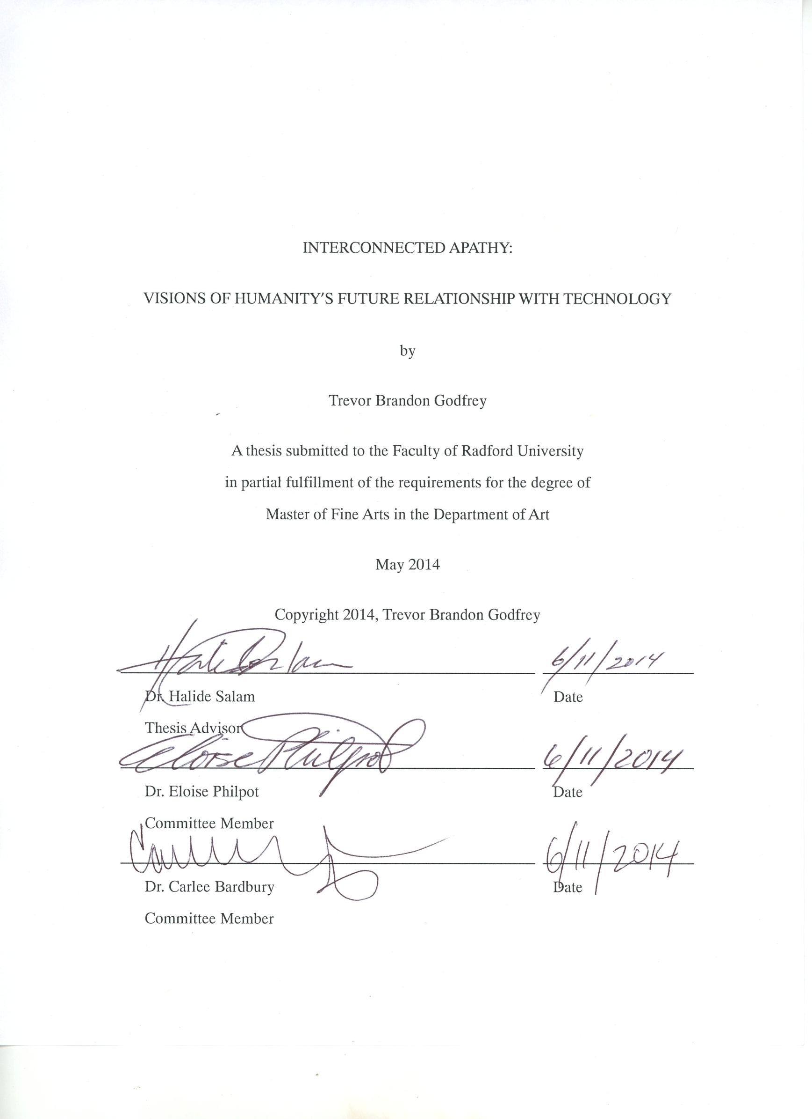

Abstract
My thesis consists of work that extrapolates on observations of the relationship between humans and technology, taking it to a far imagined and abstracted future. Do we as a species presently possess the foresight to develop this relationship into the future with wisdom? Are we losing our ability to empathize by abandoning the natural world in favor of integrating the digital world we have created? Does the near-obsessive and oft-times reckless manner in which we as a species pursue the advancement of this world mean the end of humanity as we know it today? Are we creating a future generation of monstrous technological post-humans with our current approach to our bond with technology?
It is my goal to focus on these questions within my written thesis. The exploration of them, written here, has given rise to the body of visual artwork in which I make a social commentary on what I see as several main points of concern within the interplay of humanity and technology. I also recognize my personal explorations within this thesis, and the fact that I have only begun to touch the surface of this subject matter.
Trevor Brandon Godfrey
Department of Art, 2014
Radford University

Dedication and Acknowledgements
This thesis, and the work it took to create it is dedicated to myself as an artist and humanity on the whole, as the messages within concerns my entire species. As thanking acknowledgements go, this work would not have been possible without the women in my life:
Dr. Halide Salam, for being my mentor and my defendant. I am the artist I am today through her efforts.
My mother, Joyce Godfrey, for supporting me as only a mother could and keeping me going when I was at my worst.
My sister, Sharessa Godfrey, for being my editor and reminding me I am not the worst writer in all of academia.
Julie Hawk, you gave me Heaven. You gave me Hell. You changed my way of understanding this world and my life, for good or ill.
A special thank-you also goes to Bill, Coleman, Katie, Nathan, and Shaun for helping me set up the exhibition and getting me through some near-impossible times.
Finally, for the rest, those who are a part of me, who helped me make this work a reality, and whom I do not have the space to thank individually, you have my eternal gratitude.

Table of Contents
Abstract ii
Dedication and Acknowledgements iii
Table of Figures v
Introduction 1
Chapter 1: An Artist’s Interpretation of Humanity’s Future with Technology 2
Chapter 2: Influences 6
Chapter 3: Process and Aesthetics 17
Materials and Creative Process 17
Post-Human Aesthetics 19
Chapter 4: Interconnected Apathy: the Artwork 21
Urban Scenes 21
Human Studies 22
Towerland III 27
Family Triptych 30
Cradle 36
Conclusions 39
Bibliography 41

Table of Figures
Figure 1: Umberto Boccioni, States of Mind—The Farewells. Oil on Canvas, 1911 7
Figure 2: Warren Ellis and Darick Robertson, Transmetropolitan, Vol. 4 Cover, 2009 9
Figure 3: Zdislaw Beksinski, Untitled. Oil on canvas, 1979 11
Figure 4: Zdislaw Beksinski, Untitled. Oil on canvas, 1980 12
Figure 5: Dariusz Zawadzki, The Tracker. Oil on canvas, 2003 13
Figure 6: H.R. Giger, Necronom IV. Airbrush, 1979 14
Figure 7: H.R. Giger, Alien Monster IV. Airbrush, 1996 15
Figure 9: Trevor Godfrey, Sprawl II. Oil on canvas, 2014 21
Figure 8: Trevor Godfrey, Sprawl I. Oil on canvas, 2012 21
Figure 10: Trevor Godfrey, Sprawl III. Oil on canvas, 2014 22
Figure 11: Trevor Godfrey, Information Processing - initial. Ink on paper, 2012 22
Figure 13: Francisco Goya, Saturn Devouring His Son. Oil on canvas, 1823 23
Figure 12: Trevor Godfrey, Information Processing. Oil on canvas, 2014 23
Figure 14: Trevor Godfrey, Portraiture I. Oil on panel, 2014 24
Figure 15: Trevor Godfrey, FLOW--initial. Pen on paper, date unknown 25
Figure 16: Trevor Godfrey, For Love of Want. Mixed collage on panel, 2012 26
Figure 17: Trevor Godfrey, Towerland III -- initial A. Pen on paper, date unknown 27
Figure 18: Trevor Godfrey, Towerland III -- initial B. Pen on paper, 2013 27
Figure 19: Trevor Godfrey, Towerland III. Oil on canvas, 2014 28
Figure 20: Trevor Godfrey, Family Triptych: Father—initial. Pen on paper, date unknown 30
Figure 21: Trevor Godfrey, Family Triptych: Father. Oil on canvas, 2013 31
Figure 22: Trevor Godfrey, Family Triptych: Mother. Oil on canvas, 2014 32
Figure 23: Trevor Godfrey, Family Triptych: Child--poses. Pen on paper, 2014 33
Figure 24: Trevor Godfrey, Family Triptych: Child--initial. Pen on paper, 2014 34
Figure 25: Trevor Godfrey, Family Triptych: Child. Oil on canvas, 2014 35
Figure 26:Trevor Godfrey, Cradle. Oil on canvas, 2014 37

Introduction
My artwork focuses on the relationship between humankind, technology, and a possible future the two might share. Using the canvas in an effort to investigate this future, I create what it might be like if mankind were to integrate with technology and completely lose social and physical definition. The resulting exploration of this has led to a series of multimedia artwork depicting biomechanical human-like forms in surrealistic technological scenes of apathetic contentment.
The following has been divided into four chapters. Chapter 1 summarizes the basic ideas that form the core explanation of the reasoning behind my artwork. Chapter 2 describes my influences and how they have helped develop my thesis. Chapter 3 is an in-depth look at my process as an artist, including a step-by-step look at one of my pieces of artwork as it is created. Chapter 4 analyzes the body of work that makes up my thesis exhibition and the fifth, final chapter highlights the conclusions I have drawn from my artwork and research.

Chapter 1: An Artist’s Interpretation of Humanity’s Future with Technology
“You read what others had done and you took the next step. You didn't earn the knowledge for yourselves, so you don't take any responsibility for it. You stood on the shoulders of geniuses to accomplish something as fast as you could, and before you even knew what you had, you patented it, and packaged it, and slapped it on a plastic lunchbox, and now you’re selling it…”
-Michael Crichton, Jurassic Park
From the creation of the wheel to the modern-day nuclear power plant and the electronic age, the human race continues to develop a close dependence on its technology. Serving us in manners both mundane and incredible, this facet of human nature explodes in complexity and application over the last century. The upward spiral of this seemingly unstoppable growth forces even the newest variations of technologies to be obsolete almost as soon as they are created. This reality continues day by day while mankind seems uninterested in the possible hazardous result of unchecked technological advancement.
This electronic technological world physically manifests itself in everyday life. For example, looking at any given crowd of people, one is hard pressed to find even one amongst them who does not have a cell phone, electronic music player, miniature personal computer or some gizmo that somehow accomplishes all three of these or more. The obsession with social media is progressing to the point of rendering even this handheld technology obsolete, favoring virtual computer interface glasses, or even surgical implants. One sees humanity’s undeniable stamp on the landscape as well; gentle hilltops are racing tracks between the newest competing cell phone towers and high powered electrical lines; sunsets are transformed from a glowing horizon into the jagged teeth of city skylines.
In the process of integrating technology into every moment of our lives, the preservation of and respect for the natural world is a secondary concern, held dear only to those considered backwards. The rest of the world rushes onward to industrialize every bit of land and obtain every bit of new technology possible.
This rapid-fire model of designing technology appeals to the personal needs of the consumer truth that anything new is interesting. Despite the belief that advancement makes our lives easier, the reality is that soon we will be incapable of achieving even the simplest of tasks on our own. As William Gibson asserts, “Our hardware is evolving at the speed of light, while we are still the product, for the most part, of unskilled labor.” The unceasing flow of new upgraded products makes anything slightly out of date easy to cast aside and contributes to the massive amounts of electronic refuse that will overrun the world in the future. New technologies implanting computers into the human body shows that man is not satisfied by simply using technology, but are integrating their physical bodies with it as well. These processes are not for medical, but recreational uses, which brings humanity one step closer to the path of trans-humanism and the resulting future of post-humanism.
What will that future be? As an artist, I created a body of works that are a prognostic interpretation of my observations within our current, human culture. In the future as I imagine it, technology and humanity become so interchangeable that the lines between the two are blurred, broken and erased in a very literal sense. The beings I depict are composed more of tubes, wires, and digital apparatus than of flesh and blood. Although some may view it as nightmarish, it is my idea that man will inevitably become enveloped by machinery rather than use it for advancement.
In my works, I strive to create daily portraits in the vein of Fantastic Realism. Life and landscape within these works are of a future where all needs are met by a technology that envelops the world as we know it. A similar view is expressed by Christopher Dewdney in Last Flesh: “As humans continue to interconnect, and the power of electronic collectives begins to be felt, we will probably abandon the territorial notions of self in the rush to contribute to the transformation of human consciousness.” Humans will have taken the trivial distractions of today and let them completely rule their existence and their bodies, eliminating the once human need for physical definitions and boundaries.
So is technology bad? Is it a malicious and insidious force that corrupts and replaces the natural? No. Technology has drastically improved our lives, lengthened our lifespan, and expanded the universe as we know it. The undeniable benefits of technology cannot be ignored. While the electronic world may be the next stage of human evolution, it may also be our downfall in the future. I believe that the danger comes not from some obvious or violent source, but from the importance we place on insignificant media and immediate satisfaction. Obsessively wasting time on pointless information sharing, thoughtless game playing, and self-congratulatory statements, this world is entirely unaware of what surrounds them despite the widely held belief that instantaneous connection brings people closer together than ever. Online networks have always claimed to provide humanity with more access to information than ever. If you see a commercial about the internet in any capacity, you know this claim is a regular refrain. But this overload of instant accessibility also inspires a total sense of apathy amongst those who would normally go out into the world to find the information for themselves. This unfortunate side effect has in effect bred a generation of desensitized, apathetic cyberspace fanatics, possibly not even decades away from the futuristic dystopia I’ve created in my paintings.

Chapter 2: Influences
Before my graduate studies, I always felt a great deal of inspiration from science fiction imagery and literature—television shows, including the 1960’s sci-fi classic Star Trek and the almost Grimm-like moral approach of The Twilight Zone, or books such as the clever wonders of Isaac Asimov and the richly described worlds of Frank Herbert. To extrapolate upon the present, apply one’s imagination and scientific knowledge to it, and create anything one wanted, is what got me started on my initial explorations of technology as something to make into art.
In my graduate efforts I initially drew inspiration from the Italian futurists, though now I find the influence slightly ironic. The futurist movement was begun around the industrial revolution, a key moment in the relationship between humanity and technology. This stood out to me as a good starting point for this reason and that the futurists were some of the first artists to make their artworks exclusively representative of this relationship. Selected paintings from a major contributor to the Futuristic movement, Umberto Boccioni as well as fellow Futurist, French-Italian Gino Severini, were counted among my favorites for the inspiration of many of my past paintings. There is a frenetic energy to the fractured perspectives and multiplied forms that inhabit the futurist works, and their early concepts of mankind's embracement of technology displaying a form of dramatic, chaotic forward motion made sense to me in particular, as exemplified in Boccioni’s States of Mind—The Farewells (Figure 1). I took this energy and motion and enfolded it into the atmosphere of my own works, as I too believe in the powerful and completely reckless energy that humanity and technology will inevitably share.
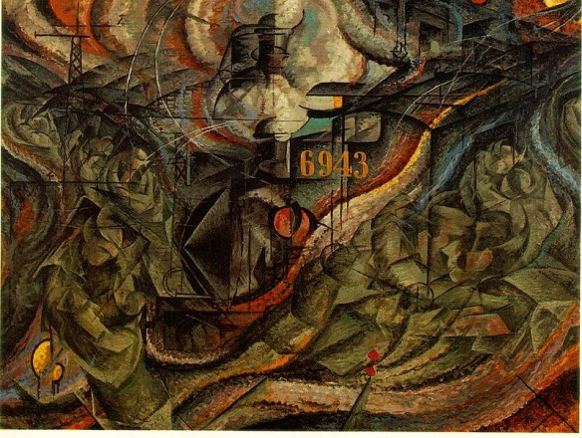
In my undergraduate studies there were several paintings in my senior show that could be considered examples of this type of futurist art featuring fractured shards of explosive angles and shapes which dominated entire 12-foot canvases. However, I do not choose to venerate or glorify this energy; instead I use it to bring attention to the division between humanity and the real world. By distorting the sharply-detailed reality in my paintings, certain areas become almost an abstraction. These abstractions, created directly for their ambiguity to the viewer, bring visual representation to the normally un-seeable in the aesthetic of my artwork.
Figure 1: Umberto Boccioni, States of Mind—The Farewells. Oil on Canvas, 1911
As I deepened the research into my thesis, some particular artists and works stand out as having been major influences in my development. Of literature, Technopoly by Neil Postman has proven a vital help in bringing an expert focus to my thesis. His critiques on a human culture that places absolute, almost blind faith in the uncontrollably technological world reinforced my beliefs on the subject and explained logically how the future of technology will result in the erasure of society as we know it. “Stated in the most dramatic terms, the accusation can be made that the uncontrolled growth of technology destroys the vital sources of our humanity. It creates a culture without a moral foundation. It undermines certain mental processes and social relations that make life worth living.”
Postman points out that since the 18th century, humanity has embraced the idea that if something can be done through technological advancement, it should be, without questioning why. “We learned how to invent things and the question of why we invent things receded in importance.” While computers become more and more capable, mankind finds comfort in the notion that technological advancement and human progress mean the same thing, handing morality over to science, and society over to the technopoly. Postman states that a technopoly’s basic assumptions are that "the primary, if not the only, goal of human labor and thought is efficiency, that technical calculation is in all respects superior to human judgment ... and that the affairs of citizens are best guided and conducted by experts."
Completely removing human error, technopolies follow the belief that “technique of any kind can do our thinking for us,” the result being a society centered not on familial obligations, religious moralities, or normal human values, but on training to achieve technological “expert” status and fulfilling the most extravagant of consumer impulses. In the technopoly Postman describes, human life finds its meaning through its machinery and technology.
Postman’s ideas provide an excellent present day reinforcement of the ideas in my thesis; from Postman’s description of a technopoly, it’s not a difficult leap of the imagination to the desolate future envisioned in my paintings.
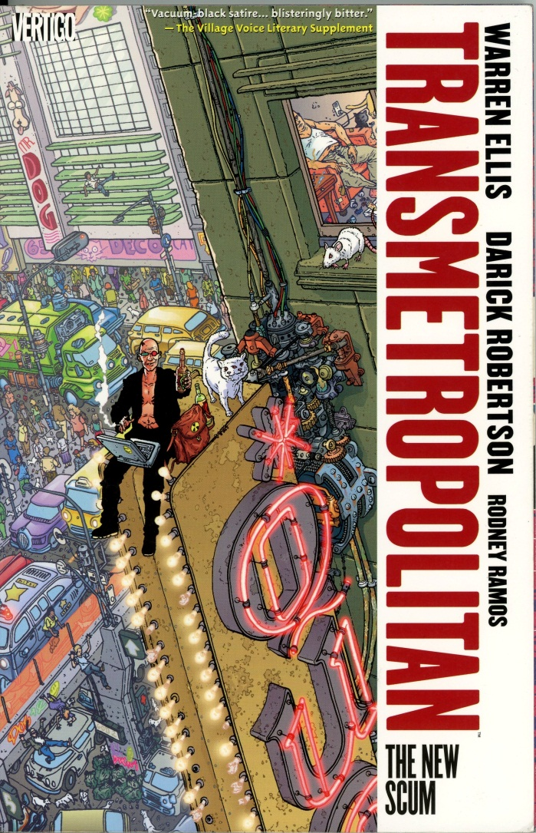
The insightful and shrewd graphic novel Transmetropolitan, written by Warren Ellis and illustrated by Darick Robertson, helped bring my unconnected dystopian views of the future to a fuller understanding of my own artwork and its meaning. This comic series is an excellent encapsulation of many of the principles within my own thesis. I don’t recommend it to those who are offended by nudity, extreme foul language, and some of the most imaginative violence I’ve ever seen (Figure 2). Yet underneath is an insightfully profound message of morality in a decaying world. Much like myself, Ellis and Robertson are creating their vision of the future, and few reading Transmetropolitan call it lowbrow. It is a fictional creation of an over-exposed far flung future where not only the line between man and machine is blurred, but those between man and his fellow man as well.
Figure 2: Warren Ellis and Darick Robertson, Transmetropolitan, Vol. 4 Cover, 2009
Easily abandoning all forms of conscience and depicting wild scenes of every imaginable sort of debauchery, Transmetropolitan is exactly the type of gratuitous anti-social attitude I feel I share sentiments with in my own work. Here is an example of day-to-day life in this future, as described by the main character, outlaw journalist Spider Jerusalem: “Yesterday, here in the middle of the City, I saw a wolf turn into a Russian ex-gymnast and hand over a business card that read ‘Your own personal trans-human security! Sterilized innards! Accepts all major credit cards!’ to a large man who wore trained attack cancers on his face and possessed seventy-five indentured Komodo Dragons instead of legs. And they had sex. Right in front of me. And six of the Komodo Dragons spat napalm on my new shoes.”
Ellis and Robertson’s creations portray man as thriving on cheap, visceral thrills and finally shedding the skin of sentimentality to become the cruel, callous species nature has always expected of us. Technology, and a rampant lack of wisdom on how to apply such technology, erodes what little empathy lies within the human race and is the main culprit for creating the insane anti-culture featured in this dystopian work of fiction. Just as Technopoly is an insight to my thesis as it applies to the present, Transmetropolitan applies perspective to a distant, technology-run future, where the trans-human era is portrayed. The bonding of biology and machine begins, but it has not reached the level of distortion or bleakness that I strive to express in my artwork.
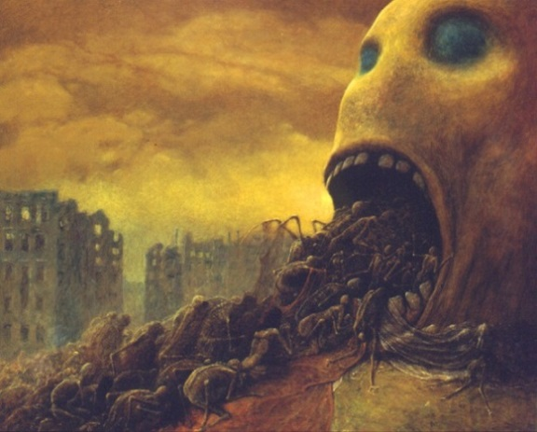
Emerging from the ruins of postwar Poland, Painter Zdzisław Beksiński created many desperately compelling works within the fantastic realism portion of his career in the early 1960s. Using his trademark style of extreme detail and subtle, murky color schemes, many of his paintings in this time period show his three favorite subjects: death, deformity, and decay. Though I understand the concept of his work as an insight into his survival of WWII, Beksiński has described his work in much simpler terms, “I think about a painting in terms of a late 19th century symphonic poem. And that is why I do not care what is going to be painted; the important thing cannot be expressed in words but I do hope I am able to convey it in my best paintings. It is a kind of elation which cannot be defined.”
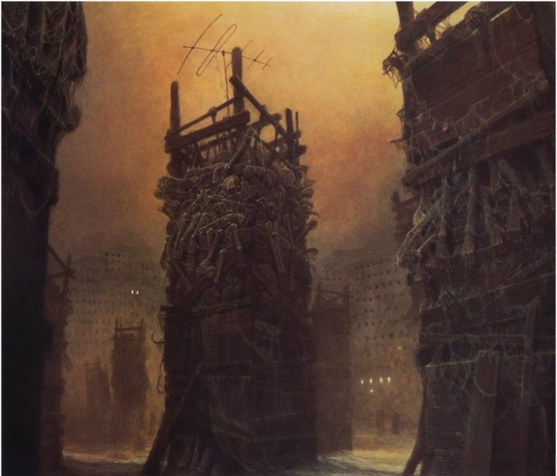
I find myself appreciating his ability to depict horrific skeletal scenes in rotten earthy tones, burnt umber and rust, yet still give a very real sense of life and movement, of humanity feeding upon itself (Figure 3). His paintings from the 1970’s and 80’s came from his paintings which focused on buildings. Abandoned, bleak for the most part, and constructed of repurposed human form, Beksinski’s work is post-apocalyptic in a very real sense, showing empty blown-up-looking buildings with few survivors staying alive in their desolate surroundings (Figure 4). My efforts focus on humanity willfully abandoning the façade of everyday life in favor of post-human biomechanicals, and yet I found this abstract Polish master to be extremely helpful in creating the bleak atmospheres of my paintings.
Figure 3: Zdislaw Beksinski, Untitled. Oil on canvas, 1979
While researching into Zdislaw Beksinksi, another artist in a similar vein came to my attention. Dariusz Zawadzki, also Polish, paints in a comparable style of fantastic realism to the late Beksinksi. As described by the supporting Morpheus gallery (which began by publishing and showing many early HR Giger works), Zawadzki has always had an “unusual sensitivity to the surrounding world” and the ability “to deeply move the spectators, with the feelings and emotions as well as high attention to painterly details.” Like many other fantastic futurist artists, Zawadzki doesn’t hold any particular central message about his paintings, stating simply, “Since I was a child I have had various visions and dreams that built surreal worlds in my imagination. These worlds came first, and then I felt a need to express them by drawing.” Like Beksinksi, Zawadzki delves heavily into biomechanical imagery, such as in his 2003 painting The Tracker (Figure 5).
Figure 4: Zdislaw Beksinski, Untitled. Oil on canvas, 1980
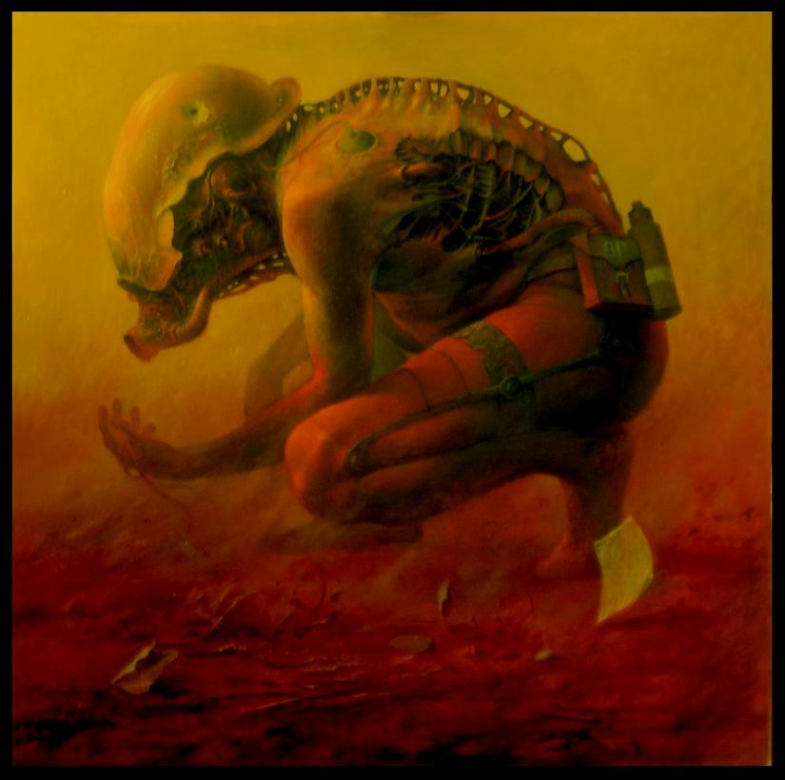
In it, a crouched figure possesses a humanoid form, but the cables, tubes and other machinery that poke through the skin of this creature reveal it to be something else. Zawadzki also uses the same palette and dusty barren landscapes to show the disintegration of reality, again possibly due to the influence of the mass destruction in postwar Poland. This post-apocalyptic palette and specific integration of the mechanical elements into the human form would inspire me immensely in the creation of my own biomechanical humanoids for my thesis work.
Both of these artists were important in helping me develop the composition and aesthetic of my paintings. Regardless of the visual impact and structure of their work to me, their guiding philosophies were highly internal. To quote Beksinkski: “It misses the point to ask me what scenes in my paintings 'mean'. Simply, I do not know, myself. Moreover, I am not at all interested in knowing.”
Figure 5: Dariusz Zawadzki, The Tracker. Oil on canvas, 2003
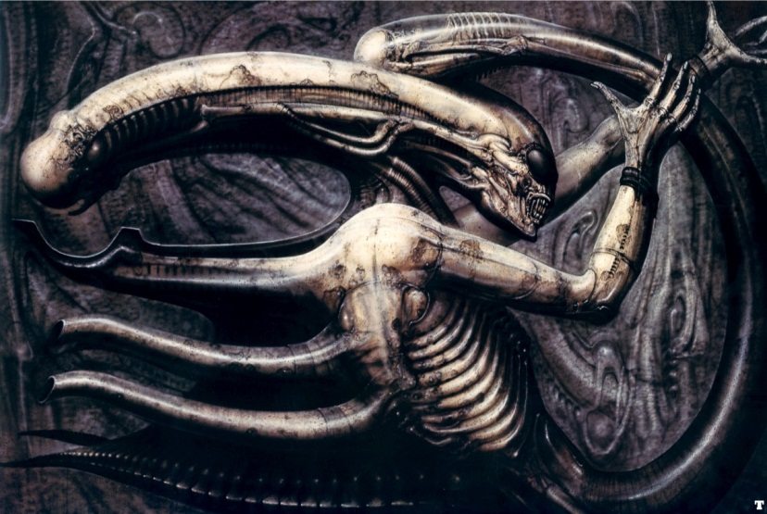
The recently deceased Swiss artist Hans Rudi Giger, known commonly for his work on the Alien franchise, (most notably the concept of the actual alien in these movies, considered one of the most terrifying and gruesome alien creatures of our time) influenced me since the time I viewed his creations on film as a child. Later in life, as I developed my artistic senses, I was able to appreciate his work more than the simple wonder and horror of a child (Figure 6). Much like he stated himself, "some people say my work is often depressing and pessimistic, with the emphasis on death, blood, overcrowding, strange beings and so on, but I don't really think it is. There is hope and a kind of beauty in there somewhere, if you look for it." I agree and do not think his work is horrifying, feeling instead a calm, reflective quality about it, in the understanding that even in dark places life is created with such a power of beauty that the horror element becomes overwhelmed. This is an aesthetic sensibility I explored in the creation of my own artwork.
Figure 6: H.R. Giger, Necronom IV. Airbrush, 1979
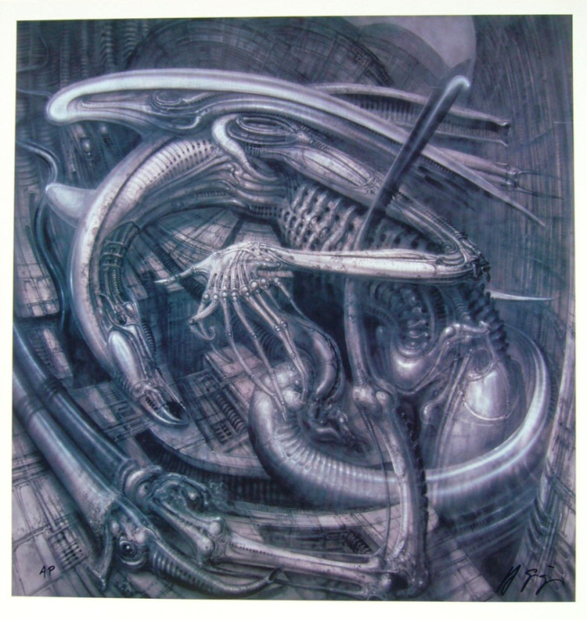
Giger talked of an interchange between human and machine, something that does resonate within my own thesis, of exploring the “biomechanical aesthetic, a dialectic between man and machine, representing a universe at once disturbing and sublime.” And while these creatures may appear monstrous to our sensibilities, they are at home and happy within the architecture of the world he created. Similarly, I create beings that all seem to be perfectly ecstatic in their world, one which we as human beings now can perceive as nightmarish (Figure 7).
Figure 7: H.R. Giger, Alien Monster IV. Airbrush, 1996
Giger’s use of humanoid figures blending into the landscape captured my attention. These warped shapes of recognition are included as parts of the land and highlight the desolate surroundings These landscapes leave the viewer with a sense of vast space, somewhat ethereal, with a hint of forewarning. However Giger again doesn't see his work in such a light, having said, "If people want to interpret my work as warnings about too much overpopulation, disease and mechanization in the future, then that is up to them. I like to combine human beings, creatures and biomechanics." The general color palette he used, one so drained of color it is almost monochromatic, often influenced me in my own work for providing emphasis to key elements. His color palette allows the viewer to be pulled into the image, drawing the eye to the high contrast and the dramatic detail within it.

Chapter 3: Process and Aesthetics
Before introducing the individual works within this thesis, some explanation will be given of my working aesthetic. The process or aesthetic of my artwork is, in a simple explanation, a depiction of various humanesque elements and landscapes engaging with technological imagery in a form of biomechanical surrealism. The realistic aspect for anatomy in my paintings comes from sketch studies of people going about everyday life around me while engaging with technology. People tapping their phones or hunched over on their computers inspire me, so I sketch them quickly and use them as references to create the narrative in larger conceptual works.

Materials and Creative Process
To get ideas for how these humanoids might function, the technology that replaced the organic joints in my images was modeled after inspecting equipment such as artificial limbs and robotic arms in use in today’s industry. One of the first things my post-humans seem to replace with machinery are their extremities. For the landscapes, I was influenced by real life imagery ranging from cell phone towers and photos of industrial complexes, to industrial wreckage and derelict factories. My imagination used this forsaken machinery as the raw material for the background in many of my paintings.
I prefer to work with larger surface areas for my paintings, though this is by no means a set rule. These bigger canvases give plenty of room to include large amounts of detail for viewing up close while farther away the viewer can be impacted by the sweeping, almost overwhelming composition of the painting. Smaller canvasses are more practical however, and I feel that they create a sense of intimacy between the viewer and the painting. As a result my works range from modest proportions of one to two feet with the most extravagant paintings exceeding ten feet in dimension. This variance is also due in part to the fact that I salvage painting surfaces that were abandoned by others. There is, amongst the works of my thesis, only one set of canvases using specific dimensions: My five-by-five triptych Family series.
I prefer oil paint to achieve a depth and vividness of color, form, and texture that the other paints just cannot reach, as I find acrylic paint too flat and watercolor too anemic. The use of color is frustrating for me and has been since the very beginnings of my interest in creating art. A partial color blindness in my eyesight is my main source of problems in this regard, one which I continue to make progress compensating for today. Overall my works range in very cool, low key tones, with many shades of jewel, viridian, and violet. Rust reds and dirty orange tones highlight the organic materials as they weave themselves into a vast, dimly lit technological wasteland. The importance of these areas is felt through these highlights, drawing the eye of the viewer, while still imparting the oppressive weight of the rest of the surrounding world.
When I initially set out to create a painting, I start with a series of sketches, which help to solidify the concept of the painting on paper. Once the physical blueprint of the painting is created, I lay down the initial layers of paint on the canvas or panel. These layers are a very thin pigment, achieved by mixing the paint with large amounts of turpenoids. This becomes my loose sketch of the painting which is then followed by layer after layer of low scale colors, in the traditional manner of painting the darker compositional elements first before working the paint ‘up’ the value scale. In the same traditional manner, the further I get toward the end of a painting, the less painting mediums (such as linseed oil and stand oil) I mix with the paint until by the last session I end up using completely undiluted oil paints. I complete the painting by pulling out the most intense colors to give the painting its overall flow and focus.

Post-Human Aesthetics
Are the post-human creations that inhabit my paintings monsters? Yes and no. A traditional interpretation of a monster is some sort of creature whose appearance is unsettling or frightening. Jeffrey Cohen, author of the book, Monster Theory, had this to say in his first thesis: “The monster is born only at this metaphoric crossroads, as an embodiment of a cultural moment.” In such a manner my post-humans can be seen as monsters of the crossroads in our modern, technophile culture. These creatures highlight the crossroads of our relationship with technology with their very physical appearance. As a species on the border of being manufactured instead of born, these monstrous post-humans have many thematic ties. They virtually share the same pallor of skin, a kind of dull-ochre orange. They are shorn, elaborate bundles of connective cables and machinery replacing the form of where hair should be. The eyes on many figures are vacant and lens-like, emphasizing the detachment from their physical world, their withdrawal into the digital one.
While reproduction and sexuality do exist in the world of my thesis, their points are subtle. Reproduction is a subject that is touched but not elaborated upon by any specific piece. The Family Triptych, for example features a child as one of the three works. It is not established how that child came to be, but visual clues from the Mother painting within the triptych suggest that it was almost certainly not a natural process. The difference in genders in other paintings meanwhile has become blurred, as mechanization has removed many defining characteristics. There is an almost asexual appearance to many of the figures in other works from this process, particularly Information Processing.
On sexuality, though all the post-humans I create have no garments, this is more to allow viewers to see the extent of the change they have undergone. It also sets a message about how far these beings are departed from concern about the environment around them. After all, why bother protecting an organic body almost never seen, replaced with machinery when parts wear out or it just becomes convenient? The blissful, vacantly rapturous expressions on many of the figures’ faces, however, are indicative of an unknowable sensation being experienced, just beyond the veil of the digital world.

Chapter 4: Interconnected Apathy: the Artwork
“I can’t solve any problems. All I can do is try to make sure other people can’t avoid noticing them. To make other people solve them. The right people.”
–Warren Ellis & Darick Robertson, Transmetropolitan

Urban Scenes
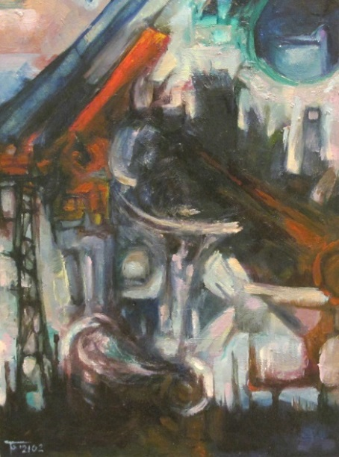
Over the course of working on the larger pieces that would make up the bulk of my thesis exhibition, I also created a series of smaller works, never exceeding two feet in any direction. These paintings, called the Sprawl series, focused on a particular relation to my thesis. I downplayed the organic integration of the human form into the landscape and focused on the architecture within the urban world in my imagined future.
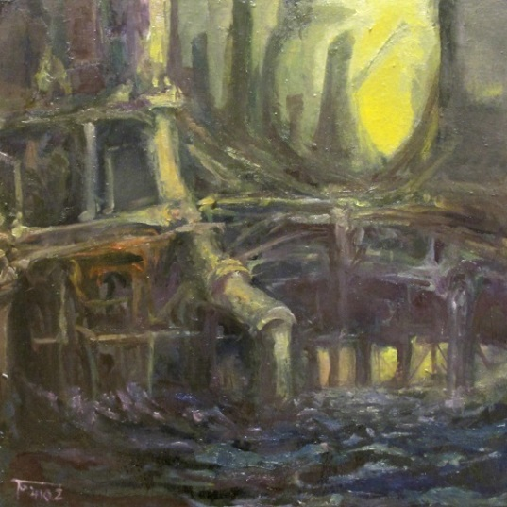
Because these three paintings lacked the biological elements, the shapes were allowed to become more abstract, the space more distorted. This is particularly the case in Sprawl I, where the perspective view intersects haphazardly to convey the chaotic density of a city (Figure 8). In Sprawl II, the sense of perspective is a little more concrete, creating an industrial waterfront painted with warm, rotten, bronze tones describing the compounded layers of machinery lying above the slate-cool sea (Figure 9). For the final painting, Sprawl III, I took the scale further out to portray a large horizon of skyscrapers. The emphasis on this work was atmospheric perspective—layers upon layers of buildings fading into each other almost indistinctly into the distance of an ominous, artificial red glow (Figure 10). The process of rendering the structures in these paintings and the way that they interact with each other within a space influenced the creation of my larger paintings in the thesis.
Figure 9: Trevor Godfrey, Sprawl II. Oil on canvas, 2014
Figure 8: Trevor Godfrey, Sprawl I. Oil on canvas, 2012
Figure 10: Trevor Godfrey, Sprawl III. Oil on canvas, 2014

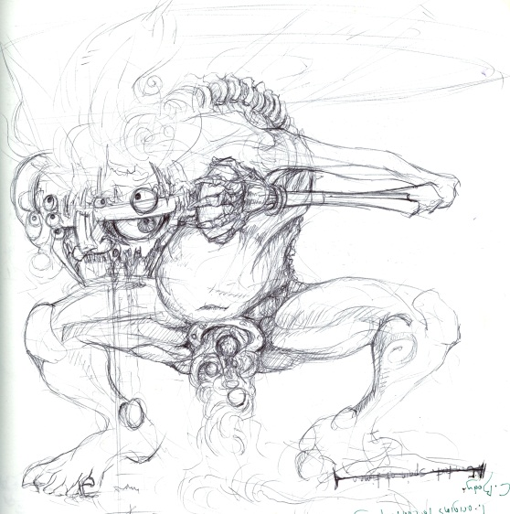
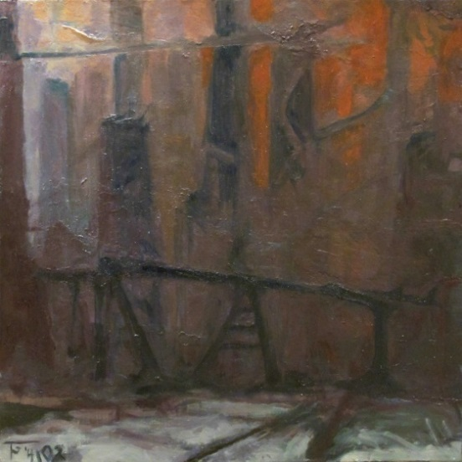
Human Studies
The second group of smaller works within the thesis exhibition involves a focus on the human form derived from specific, real world observations of individuals. These observed individuals are then transmuted into imagined beings that populate the reality of my thesis. A monstrous quality becomes imparted to these figures as they are recreated in my renditions. This is most prominent in the painting Information Processing. In this painting, the figure was derived from a series of quick sketches I had made of a person I observed who was utterly absorbed in the information being poured into him from a set of headphones while in a museum (Figure 11).
Figure 11: Trevor Godfrey, Information Processing - initial. Ink on paper, 2012
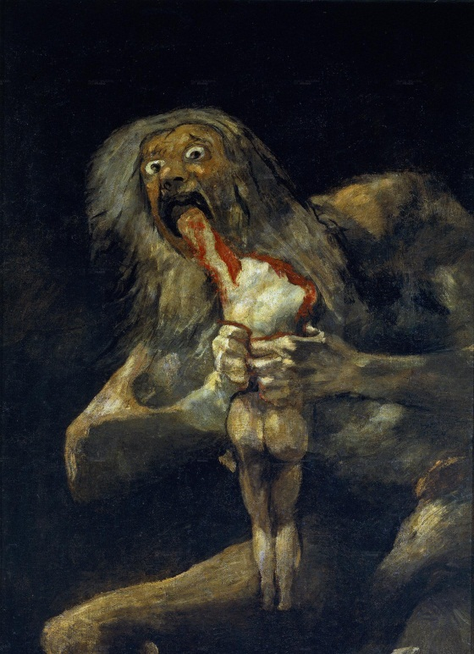
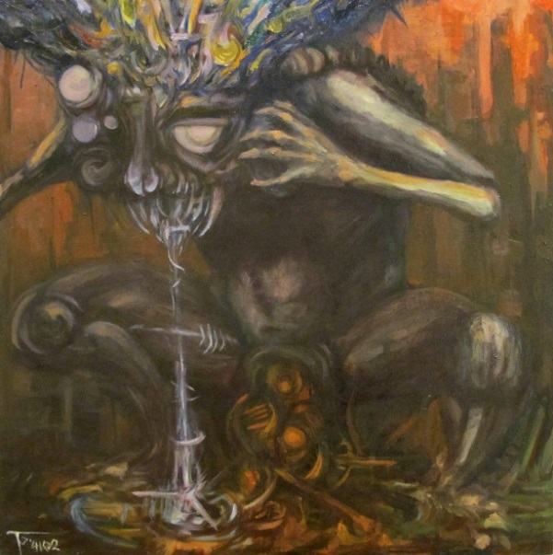
As the sketches evolved into the painting, the being from the drawings took on the character of a literal information processor (Figure 12). The human form was integrated with machine with elements such as the artificial, exposed spine, lens-like multiple eyes, and piston-joint knees. The data itself is represented as a multicolored mass pouring into the post-human’s skull. This is in keeping with my aesthetic of representing the invisible energy of the digital world with distortions of color and geometric shapes in paint. The information is filtered, shaded, and organized by the individual’s opinion, then released as white-blue and red-black columns from orifices on its body.
Figure 13: Francisco Goya, Saturn Devouring His Son. Oil on canvas, 1823
Figure 12: Trevor Godfrey, Information Processing. Oil on canvas, 2014
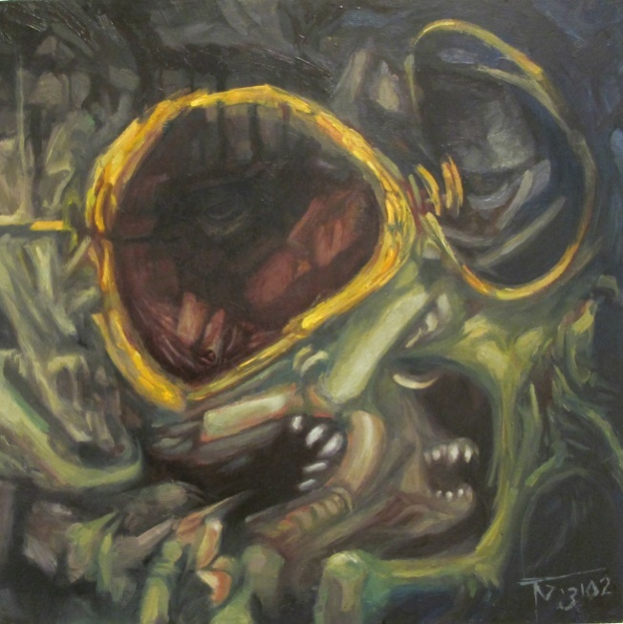
The figure is hunched over and absorbed in its actions, in its processes. The pose and mood of the project drew parallels to Francisco Goya’s Saturn Devouring His Son as it developed (Figure 13). I found this similarity aesthetically stimulating, ringing true to Cohen’s ideas pertaining to the monster of difference, the one which is “a form between forms that threatens to smash distinctions.”
Portraiture I was born from a request from a personal friend to create a portrait-painting of him. I agreed on the condition that I chose the pose, and requested to do an elapsed portrait of him interacting with his smartphone throughout the painting sessions. The subject’s personality unfolded and changed while using the device, and it was this change I represented in painting (Figure 14). The multiple fronts of digital reality reaching him though the phone altered his mood from happiness to boredom to irritation—the subject’s emotional spectrum as I saw it emerge. These feelings would come quickly, go quickly, and regardless of their intensity have little to no effect on the subject after their passing. The ineffectiveness of these emotions’ lasting impact is an example of the kind of apathy that I fear our current relationship with technology can, has, and will continue to create.
Figure 14: Trevor Godfrey, Portraiture I. Oil on panel, 2014
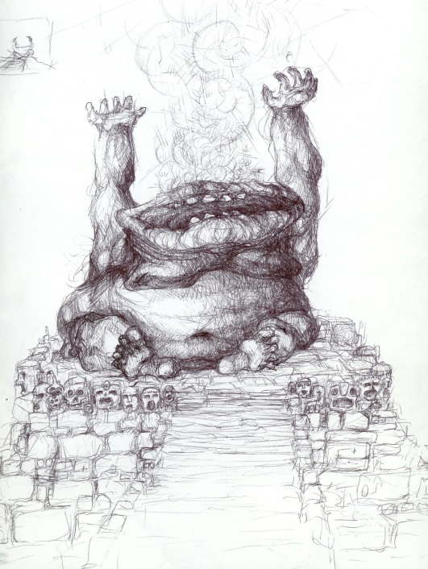
Portraiture I became one of the most abstracted and intuitively created paintings in my thesis. The planes of the face fracture into and out of various planes of waxy flesh possessing elements suggestive of both biology and man-made products such as cables and pipes. The focus of the painting is two large gold rings, the subject’s eyeglasses, which encircle pools of extremely low-value and glossy colors. Within these colors lie the shapes of eyes in the throes of boredom.
A special place in this thesis must be held for the work For Love of Want (or FLOW). It is unique both as the only multimedia collage, and as the only piece that possesses a spiritual inclination to the composition. The concept began as a somewhat romantic conversation between a colleague and me about human nature. It dwelt upon the human condition of needing novelty in all forms throughout life. A metaphor representing this condition was a metaphysical hole in humanity which it tries to fill with this need. The discussion piqued my imagination and I jotted down a quick sketch. In the sketch, this pursuit of getting new things in life becomes a spiritual ideal, represented by an altar and humanity’s love and devotion to it (Figure 15).
Figure 15: Trevor Godfrey, FLOW--initial. Pen on paper, date unknown
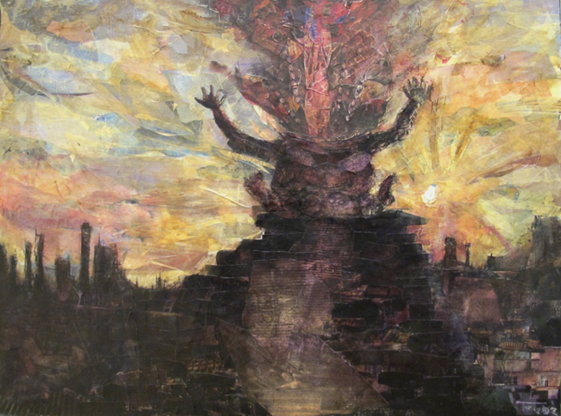
Collage is a fairly foreign process and medium to me, one I have only begun to work in within the last two years. I approached the medium from a painterly perspective, cutting out each shape analogous to a brush stroke. To unify these shapes after they had been glued onto the surface, I applied layers of transparent tissue paper, drawing with ballpoint pen, and minute quantities of highly transparent oil paints such as Alizerin Crimson and Dioxozene Violet.
The result (Figure 16) is a highly contrasted image, with the ramshackle step-pyramid and its corpulent centerpiece silhouetted against a decaying city-line and a fractured yellow sunset in the sky. The brassy-toned figure is seated, raising its arms upward. The head, comprised entirely of mouth, absorbs a vast flow of abstracted materials. This theme, recurring several times in my works, is the primary focus of this one: that for all the input going into humanity, the materials and information, very little if anything is actually being done with it besides the absorption.
Figure 16: Trevor Godfrey, For Love of Want. Mixed collage on panel, 2012

Towerland III
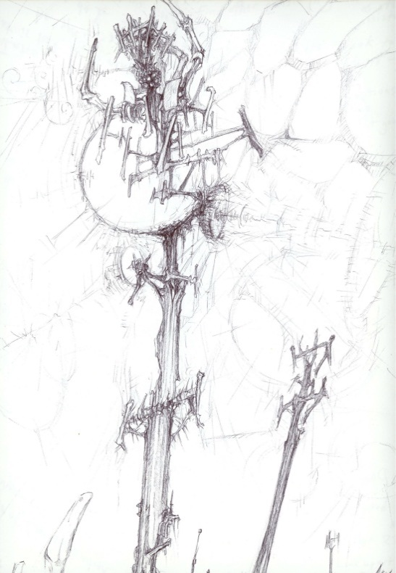
Towerland III highlights another of the key visual symbols within my works: the cell phone tower. There are multiple reasons for this. First, it functions as a facilitator of technological mass communication. The electronic world of the cell phone, brought about by these needle-like constructions, speaks to one of the core elements of my thesis, the invisible digital pseudo-world. Secondly, by nature of its function, the cell phone tower is often placed in positions of hierarchical prominence on landscapes. At the tops of hills and buildings, towering over almost all else so as to better send and receive their signals, these machines don’t need the warping of my imagination to make them ominous and foreboding for the future.
Figure 17: Trevor Godfrey, Towerland III -- initial A. Pen on paper, date unknown
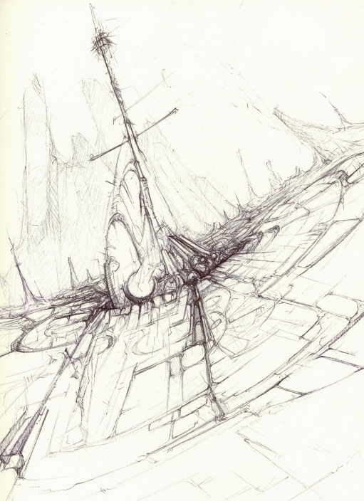
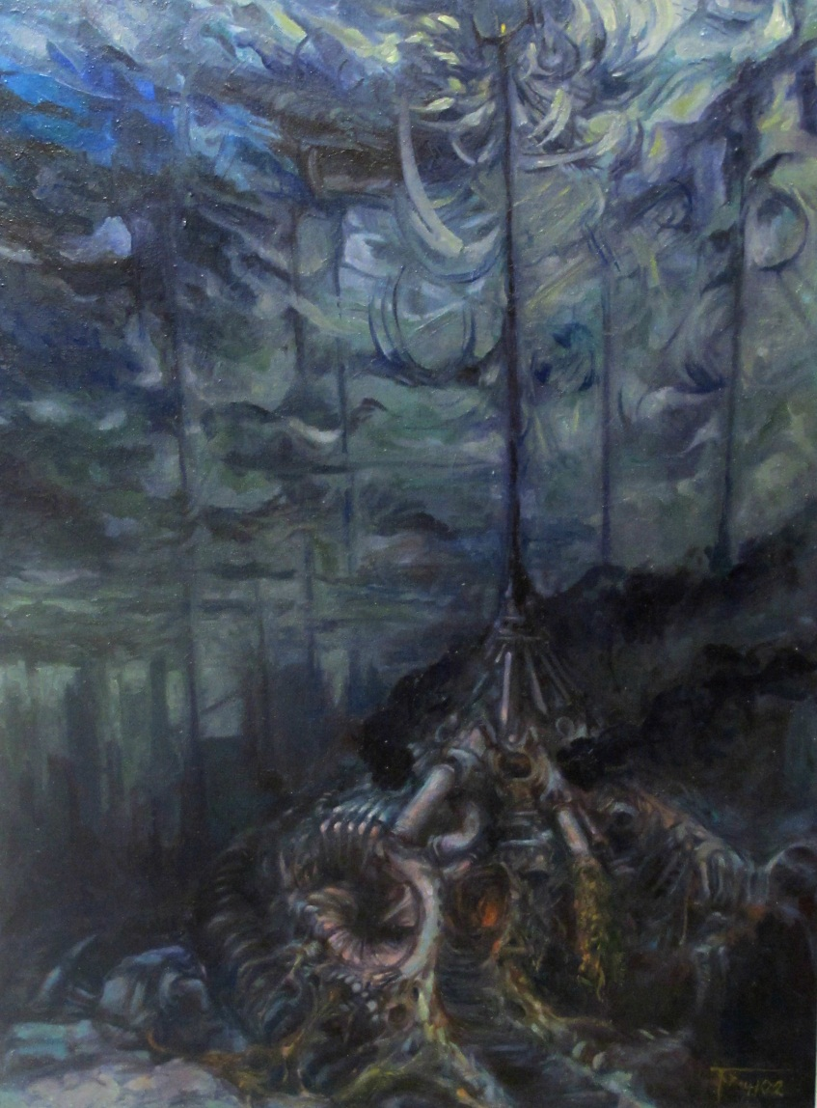
Third and finally, these towers are already in great abundance all over the world. They seem to be sprouting up on the modern horizon with an almost Orwellian level of pervasiveness. As a local example and thought exercise, I counted and studied the cell phone towers between the city of Radford and Roanoke, not even fifty miles away. I counted twenty-eight towers. Despite this number and the conspicuousness of their placement, people I speak to almost never seem to care or notice the towers. They take for granted that these things must exist in these numbers, removing the natural world to better connect their demands for an electronic one. This concept unsettled me on a fundamental level, resulting in the symbol of the cell phone tower recurring in many of my works. It eventually became the central focus of several pieces, which I named the Towerland series.
Figure 18: Trevor Godfrey, Towerland III -- initial B. Pen on paper, 2013
I had previously sold and destroyed Towerland I and II, respectively. For the beginnings of Towerland III, I created a pair of sketches depicting a tower-structure in a centralized, dynamic landscape composition (Figures 17 and 18). With the help of these sketches I began painting, selecting a three foot wide by four foot tall canvas. This would allow me to take advantage of the vertical emphasis of my composition (see Figure 19). The hill at the base of the painting is mechanical pipe and machinery venting noxiously black exhaust clouds and studded with deep recessive pits. Integrated with these elements are subtle references that create a massive human face and hands which envelope a narrow, winding staircase. These steps, made uneven by scabs of organic material and pieces of intruding machinery, lead up the hill into a recessed, blood-red lit entrance that in turn leads back down into unknown depths. Atop all of this, at the crown of the hill, is the tower itself.
Figure 19: Trevor Godfrey, Towerland III. Oil on canvas, 2014
I decided upon the single-stalk, three-pronged array type of cell tower to be the central focus of the painting. It stabs upward, silhouetted against a sky of viridian and splashes of very deep blue. Virtually the only light source on this structure comes from the bleary red of a marker light, nestled among the prongs at the apex.
I was not subtle in representing the theme of humanity’s digital world’s warping and abstracting effect on the physical in this work. The blue-green sky is shattered; it seems to be drawn towards the tower like iron filaments around a magnet, becoming more distorted by overlapping geometric forms. There are color changes in the sky near the tower as well, the blue fading and the grey-green turning into fragments of yellow-green pigment. These fragments congregate the most at the tower’s zenith, where the transmissions to the digital world are sent and received, and therefore where the most energetic distortions can be found.

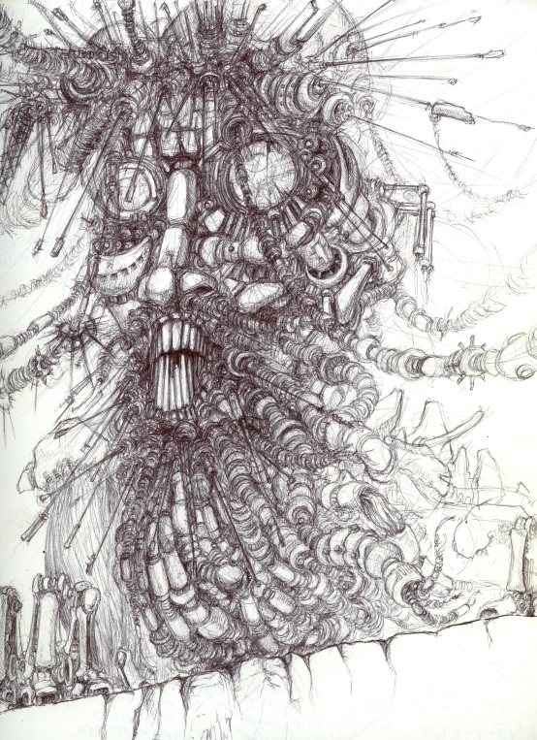
Family Triptych
There are two works which form the core of my thesis and carry the most weight within themselves. The first is Cradle, my largest single work within this thesis. The second is called collectively the Family Triptych. These three paintings, each measuring approximately five feet square, create portraits of individuals within a so-called “nuclear family” living their day-to-day activities in the imagined future of my thesis.
Figure 20: Trevor Godfrey, Family Triptych: Father—initial. Pen on paper, date unknown
The triptych began with a single drawing, depicting a head-and-shoulders portrait of a bearded, male individual so thoroughly merged with mechanical and electronic elements he was more of a machine with a rough likeness to a human being. A particularly defining feature of this being was that all forms of hair in his beard and head had been replaced by connecting electronic cables and miniature aerials (Figure 20). It was a very short leap from the drawing to visualizing a painting.
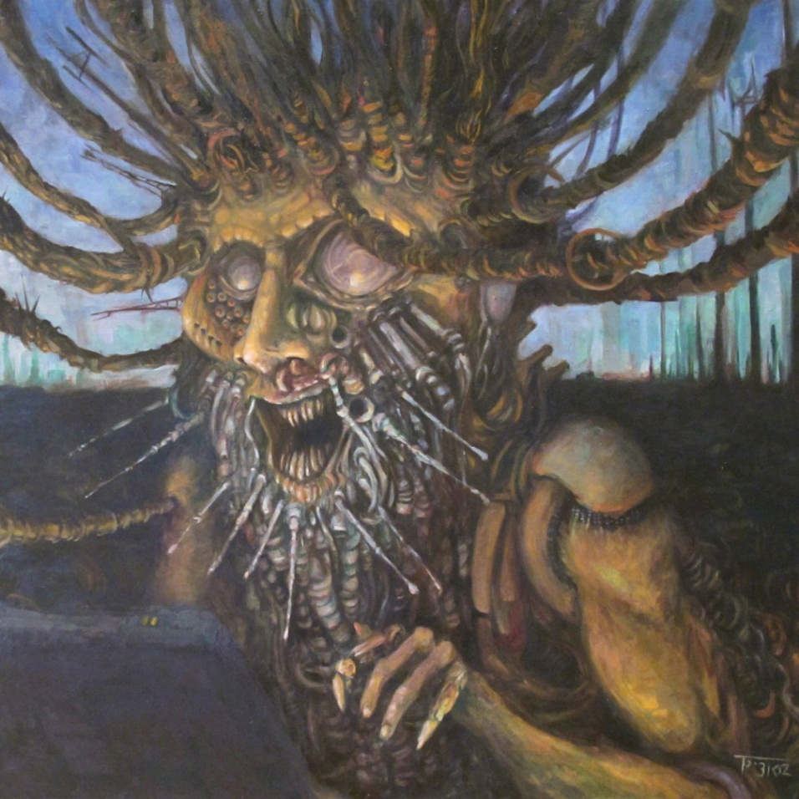
It was the selection of a five foot by five foot canvas, one thrown out by a colleague of mine, upon which the first painting evolved relatively quickly. Using imagery that more closely relates to the tenets of my thesis, the painting shows several compositional differences from the drawing. The perspective was pulled back slightly, allowing more view of the torso and arms and a more complete image of how much human shape remained to his physical attributes. The drawing was perhaps a little too mechanical for what I wanted, so biological elements such as skin and musculature were re-introduced into the painted version.
The skin took the sickly orange-yellow pallor that would be found in many of the human forms in my paintings, and was arranged so that it seems to just barely stretch over parts of the figure. The figure interacts with a dull grey-black foreground shape that can be taken for a computer interface of some kind, like a laptop screen. The light source coming from the screen of this element provides a harsh, unnatural under-light to the figure’s features (Figure 21). The mouth is twisted into an oversized grin filled with needle-like teeth, highlighting an aspect of the world in my paintings. The luxury of the modern world in this evolved future has bred a race of people who are not only willing but happy to accept the horrible conditions around them, being fulfilled by their digital fantasies rather than their material ones.
Figure 21: Trevor Godfrey, Family Triptych: Father. Oil on canvas, 2013
With a portrait this size, I decided to keep the background simple. The sky is a cold blue that decreases in value to deep blue-violet as the eye goes upward. The ground is nearly flat—a featureless slab, possessing only suggestions of structures and tubes nestled within. In the distance, a clustering of cell phone towers and the suggestion of further buildings break up the horizon line.
Figure 22: Trevor Godfrey, Family Triptych: Mother. Oil on canvas, 2014
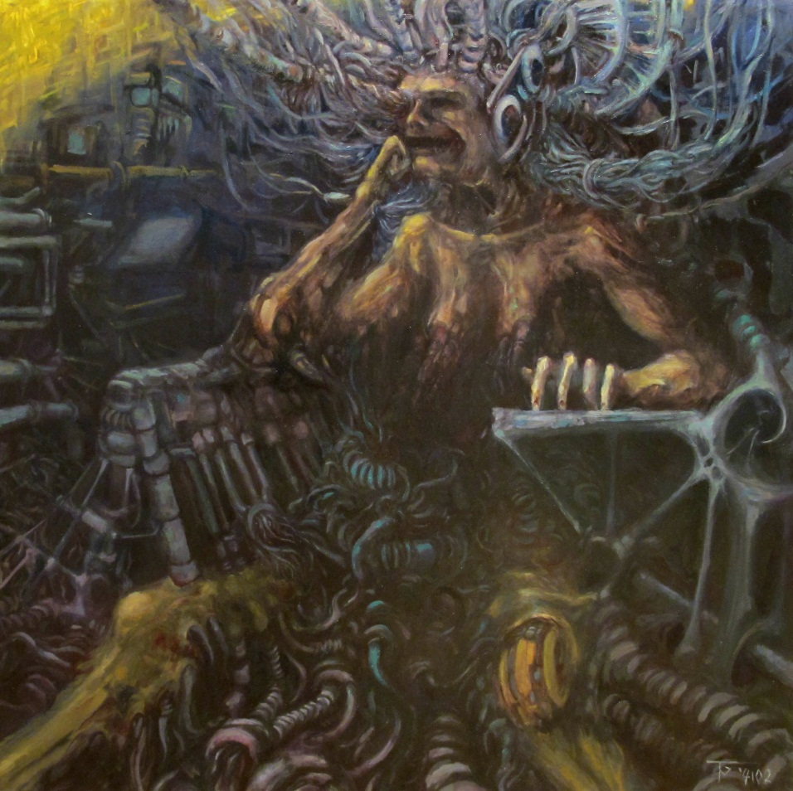
When it was completed, I felt satisfied with the single painting of the male post-human. However, later discussions with my colleagues and my mentor introduced the idea of doing a series of portrait-like paintings in the same size and manner. I chose to make the series into three parts: a father, a mother, and a child or adolescent. The second painting, Family Triptych: Mother, was painted with thematic similarities from the first painting (Figure 22).
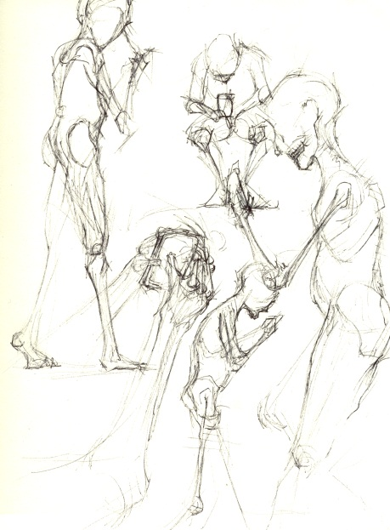
Like the figure in Father, the skin of the post-human represented here is a stretched veneer, under which the hard geometries of mechanical elements are suggested. A similar look of vacant, almost mask-like bliss contorts the facial features of this female figure. One of the main facets of this painting is that the female figure is seated in its chair for a long period of time—so much so that the chair and myriad attachments grow up through the person now. A radiating mass of cables are attached to the skull and body of the figure, obscuring the lower torso with their mechanical complexity. Effort was made to ‘sink’ and ‘wrap’ the lines of perspective around the figure; with small shifts of the orientation of the shapes in the painting, the entire background and foreground by design emphasizes the organic elements. Coloration suggests an interior environment, with the dull metallic greys and greens of machinery fading to black and blue. Light in the form of sickly yellows and greens highlight the figure’s features, cast from the floating field of a bright yellow glyph-like object just within view in the far left corner.
The final painting, Family Triptych: Child, acts as a center focus to the three works as a combined unit, being both similar yet compositionally different from its counterparts. Its creation took several more preparatory sketches than the other two paintings before I was satisfied to move onto the canvas I had prepared. Like the mother and father the subject of the painting would be interacting with some kind of technological interface, in this particular case a small handheld device, such as a cell phone. Studies were done of people from various angles interacting with their phones (Figure 23), before the concept sketch was made (Figure 24).
Figure 23: Trevor Godfrey, Family Triptych: Child--poses. Pen on paper, 2014
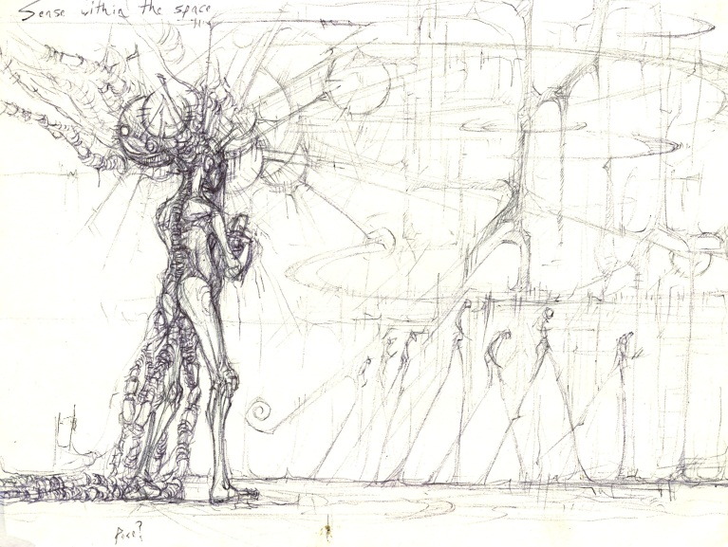
The perspective has continued to broaden from the other two, finally reaching landscape perspectives. The far distance from the figure is defined by a city skyline comprised of very narrow, needle-like structures. The coloration of the figure is similar to its parents with its dull, fleshy tones. Unlike the parents, however, I have chosen to include lighter tones of color, pastels almost, to symbolize the youth of the subject. The anatomy of the figure also has similar traits to its parents in that it possesses a likeness to human physiology, but parts have been warped by the inclusion of mechanical and technological elements under and through its skin.
Figure 24: Trevor Godfrey, Family Triptych: Child--initial. Pen on paper, 2014
Whilst the first two paintings have very dark, murky color dominance, the overall color composition of Child is more highly contrasted. (Figure 25). Very pale, creamy tones of yellow and pink make up the sky and atmospheric perspective of the city-line, punctuated by stabs of richer color from the geometric radials and shapes flowing toward the child. The earth is also the same kind of near-white, reflecting the sky and broken up only by the dark mass of cables trailing behind the child. In a similar theme to Information Processing and Towerland III, the digital data being absorbed by the figure becomes a visual aspect of the painting, manifesting in the darker masses of cables trailing from the spine and brain of the child. This energy weaves through the cables while trailing consistently towards the focal point of the child.
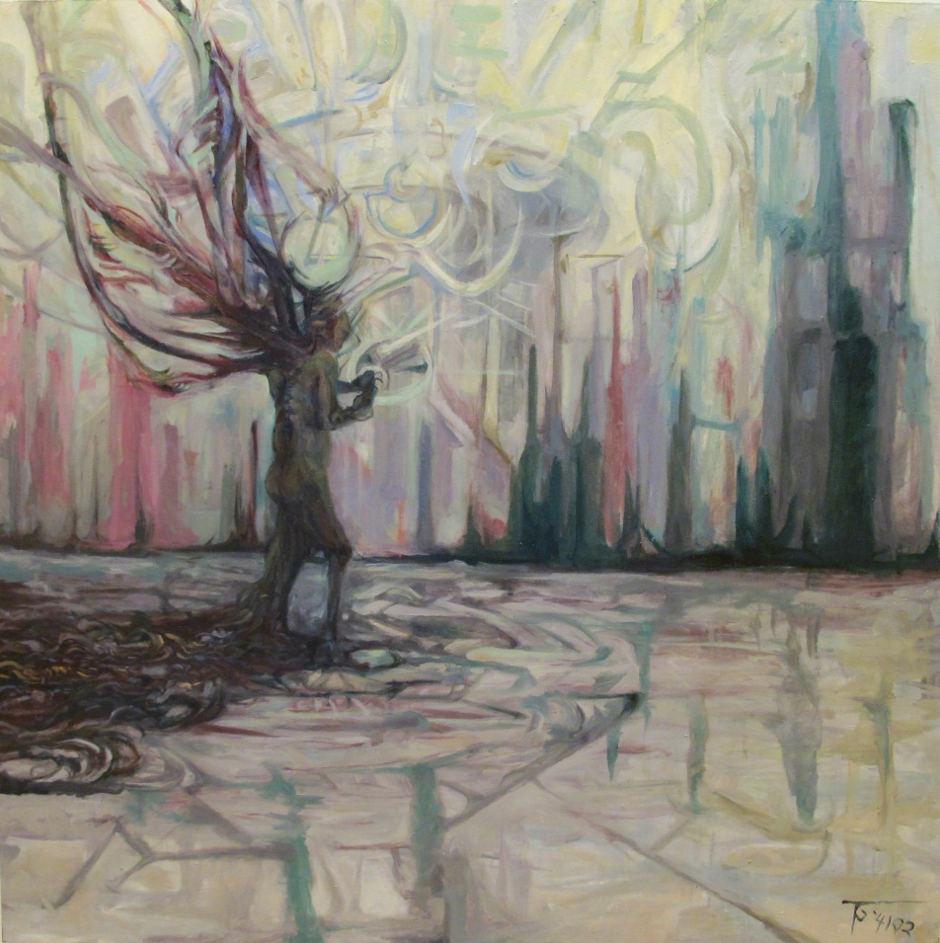
The pose of the child is facing away from the viewing plane, a reversal from that of its parents. The hunched posture inspired from the observation sketches emphasizes the child’s focus upon the device in its hands and obliviousness to the unnatural and unhealthy around it.
Figure 25: Trevor Godfrey, Family Triptych: Child. Oil on canvas, 2014
The three paintings of this triptych represent one of the darker outcomes of my thesis. Each is utterly absorbed in their mechanized, digital world, connected to it, rooted to it. In their physical world this family has become disconnected, from each other and anyone else. This isolation even extends literally: each member of the family is cut off physically from the others in a separate canvas space.

Cradle
Early on in my graduate work, I determined there must be an anchor to counterbalance the bleak outlooks dominating some of the other paintings. The core of my thesis is an exploration of what might happen to our species in a highly evolving technological world, not will. This note of hope that we are not certainly doomed, that as a species we have the capacity for change, was still in need of poignant expression within my artwork. The piece to illustrate this point would become a centerpiece for the exhibition, and thus needed to draw the most attention. The last painting addressed within this chapter is also the singularly most ambitious painting I created.
Measuring approximately eleven feet in length, Cradle is the largest painting within this exhibition. Compositionally, it depicts a panoramic landscape within the post-human world of my thesis. This painting was also a break-away from my usual working process. Beginning it so late in my studies and confronted with creating work of this size, I made the decision not to do any preparatory sketches with pen and paper. I instead used the painting surface of the canvas as the sketch area. By applying highly diluted pigments in multiple painting sessions, I was able to keep texture buildup to a minimum while resolving the overall composition to my satisfaction.
The city-scape depicted in Cradle is much more industrial in nature, with dense pipe formations, exposed girder superstructures, and exhaust stacks pouring oily clouds of material upwards . The influence of the polish fantasy painters Zwadski and Beksinski is readily seen in the superstructure of the buildings and their bony, finger-like nature as they support a massive helix-structure that curves in from the lower foreground and dominates the composition on the left half of the painting. This structure started as a kind of above-ground transportation system, including elements of both micro and macro organics. In the micro level the structure bears similarity to deoxyribonucleic acid or DNA, the fundamental blueprint material of almost all life on Earth. Large spherical objects, representing individual atomic masses, dot the structure. In the macro the structure has warped shapings of human anatomy: lips and teeth in leering configurations make up the mass of the ‘tracks’ (Figure 26). 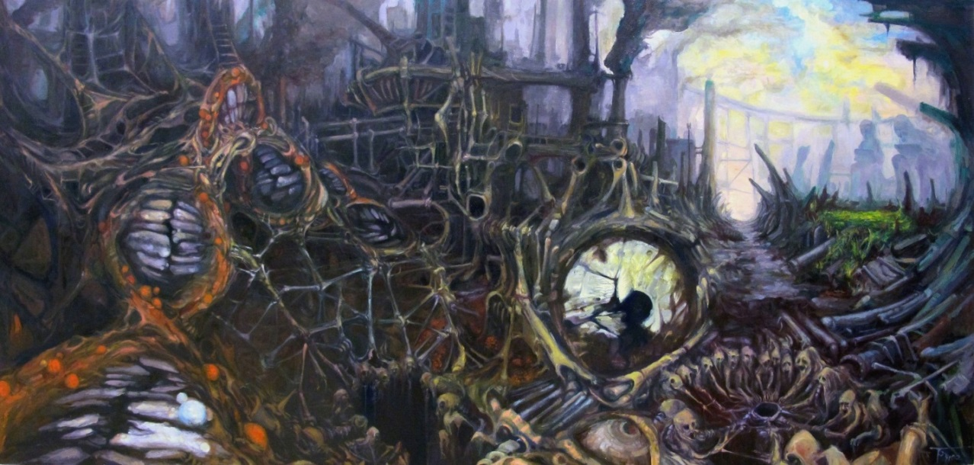
Figure 26:Trevor Godfrey, Cradle. Oil on canvas, 2014
Below these tracks and buildings can be seen human forms that make up the foreground. These creatures are a take on the concept of a ‘social circle’. That is, the need for sentient beings to knot together in close groups. However, the process has become lost on these post-humans. Integrated with technology and buried in an invisible digital world, these beings congregate on sub-levels around circles of nothing in a very literal sense. Above these circles and compositionally led into by them is a large, fractured, orb-like shape. This element was originally started to represent a kind of oculus, a window showing the electric, intangible, digital world the post-humans are truly conscious within. However as the painting evolved it took on a more ambiguous role alongside the other man-made features in the landscape as a thing serving a purpose, even if it is not readily apparent to the viewer.
Where the left and center areas of the painting are densely filled and dark in their palette, the left third of the painting is the contrasting focus. The buildings pull far back, disappearing into atmospheric perspectives of grey and lavender. The sky above, freed from the confines of the industrial excess within the rest of the painting, reveals airy shades of blue and yellow. Below this sky lies the cradle for which the painting is named. It sits amongst monolithically large human-structure figures and scattered fingers of architecture, a small yet verdantly colored thicket of green plants. This tiny patch of green, innocuous compared to the imagery elsewhere in this thesis, is the ‘might be, not will be’ point I emphasize. The post humans of the painting have no interest in this patch of non-manmade world and continue about their doomed reality. This enclave of the natural world in the painting is a place made for the viewer, to envision the natural world in my thesis, to see that a short-sighted, techno-minded reality does not have to be the ending truth of humanity’s future.

Conclusions
When I set out into my graduate studies, I knew that there were fundamental aspects of humanity I wanted to discuss in my work. I also knew that my concerns dwelt with the future of my species as much as the present. The intervening years of recognizing this relationship between humanity and technology and exploring it through visual art has been the most demanding trial of my life. I have learned so much, yet I feel as though I have only begun to understand the complexity of this relationship.
I plan to continue my research out of graduate school, and expand upon the ideas first broached here. I want to do works focusing upon visualizing the immaterial digital world and to represent what it is that makes it so alluring to human beings of modern times. I want to explore the vivid overlap between biological and technological processes on an intimate scale in a series of smaller paintings. I want to experiment more with collages and create more imagery with overlapping planes of salvaged detail. I want to do a large series of detailed drawings depicting the present day realities in our relationship with technology. There are other ideas that would begin with the phrase “I want to” for how my art will proceed after this thesis, but I believe the point has been made. This thesis is not the ending of an idea but the beginning of one, an exploration I will be excited to pursue long after the completion of this work.
To the questions I posed at the beginning of this thesis however, I have these conclusions: Do we as a species presently possess the foresight to develop this relationship into the future with wisdom? Yes, we do. Were this not the case we would not be able to foresee the dangers of misusing this relationship, and my paintings would not exist. Are we losing our ability to empathize by abandoning the natural world in favor of integrating the digital world we have created? In many ways, yes, we are. However, our species is still in its infancy of this abandonment, and with awareness of where it might go, adherence to this path may falter. Does the near-obsessive and oft-times reckless manner in which we as a species pursue the advancement of this world mean the end of humanity as we know it today? Not today, but within the limitless possibilities of the future, anything is possible. This admission of possibility is the final point of this thesis I would like to make. Through it all, we as a species are capable of altering the path of our existence, and thusly our future, to any reality we choose.

Bibliography
Beksiński, Zdislaw. “Interview: Zdislaw Beksiński”. Interview by Projekt, Projekt (June, 1981). http://zdzislawbeksinski.blogspot.com/2012/02/zdzislaw-beksinski-interview.html (Accessed February 2014).
Cohen, Jeffery. Monster Theory: Reading Culture. Minneapolis: University of Minnesota Press, 1996, Chapter 1.
Dewdney Christopher. Last Flesh: Life in the Transhuman Era. Toronto: Harper Collins, 1998.
Ellis, Warren and Darick Robertson. Transmetropolitan Volume 2: Lust for life. New York: DC Comics, 2009.
Gibson, William. “Will We Have Computer Chips in Our Heads?” Distrust That Particular Flavor. New York: Putnam, 2012.
Giger, Hans Rudolph. “Giger the Great Alienest of Artists”. Interview by Ed Ackerman, Famous Monsters No. 158 (1979). http://www.littlegiger.com/articles/files/FamousMonsters_158.pdf (accessed May, 2014).
Giger, Hans Rudolph. “The HR Giger Website”. http://www.hrgiger.com/ (accessed May, 2014).
Morpheus Gallery, “Dariusz Zawadski Biography,” Morpheus Gallery, http://morpheusgallery.com/Dariusz%20Zawadzki/biography.php (Accessed February 2014).
Mumford, Lewis. Technics and Civilization. New York: Harcort, Brace, and World Inc., 1934.
Plafky, James. “Brave Transhumanist Pioneer Self-Implants a Computer Into His Arm: November 1, 2013”. Extremetech. http://www.extremetech.com/extreme/170112-brave-idiot-transhumanist-pioneer-self-implants-a-computer-into-his-arm (accessed April 2013).
Postman, Neil. Technopoly: The Surrender of Culture to Technology. New York: Vintage Books, 1993.
Zawadzki, Dariusz. “Artist Spotlight: Dariusz Zawadzki”. Interview by J.T. Glover, Fantasy Magazine No. 50 (May 2011). http://www.fantasy-magazine.com/new/artist-spotlight/artist-spotlight-dariusz-zawadzki/ (Accessed February, 2014).

Lewis Mumford, Technics and Civilization (New York and London, Harcort, Brace, and World Inc. 1934): 9-12
William Gibson, “Will We Have Computer Chips in Our Heads?”, in Distrust That Particular Flavor (Putnam, 2012): 215
James Plafky, “Brave Transhumanist Pioneer Self-Implants a Computer Into His Arm: November 1, 2013 ”, Extremetech, http://www.extremetech.com/extreme/170112-brave-idiot-transhumanist-pioneer-self-implants-a-computer-into-his-arm.
Christopher Dewdney, Last Flesh: Life in the Transhuman Era (Harper Collins, 1998), 28.
Neil Postman, Technopoly: The Surrender of Culture to Technology (Vintage Books, 1993), 51.
Ibid, 42.
Ibid, 51.
Ibid, 52.
Warren Ellis & Darick Robertson, Transmetropolitan, Vol. 2 (DC Comics, 2009), 2.
Zdzislaw Beksiński, “Interview: Zdislaw Beksiński,” Projekt (1981), http://zdzislawbeksinski.blogspot.com/2012/02/zdzislaw-beksinski-interview.html (Accessed February 2014).
Morpheus Gallery, “Dariusz Zawadski Biography,” Morpheus Gallery, http://morpheusgallery.com/Dariusz%20Zawadzki/biography.php (Accessed February 2014).
Dariusz Zawadzki, “Artist Spotlight: Dariusz Zawadzki,” J.T. Glover, Fantasy Magazine No. 50 (May 2011), http://www.fantasy-magazine.com/new/artist-spotlight/artist-spotlight-dariusz-zawadzki/ (Accessed February, 2014)
Beksinski, “Interview”
HR Giger, “Giger the Great Alienest of Artists,” Ed Ackerman, Famous Monsters No. 158, (1979): 28, http://www.littlegiger.com/articles/files/FamousMonsters_158.pdf (accessed May, 2014).
HR Giger, “The HR Giger Website,” http://www.hrgiger.com/ (accessed April, 2014)
Giger, “Giger Website”
Jeffery Cohen, Monster Theory (University of Minnesota Press, 1996), 5.
Jeffery Cohen, Monster Theory (University of Minnesota Press, 1996), 6.

