THE EFFECT OF GROUP MUSIC THERAPY ON PERCEIVED SELF-EFFICACY
OF UNDERGRADUATE STUDENTS PURSUING THE HELPING PROFESSIONS: A
PILOT STUDY

by

Laura A. Streit

A thesis submitted to the faculty of Radford University
in partial fulfillment of the requirements for the degree of
Master of Science in the Department of Music

Thesis Advisor: Dr. Patricia Winter

April 2014

Copyright 2014, Laura A. Streit

___________________________________ _________________________
Patricia Winter Date
Thesis Advisor

___________________________________ _________________________
James Borling Date
Committee Member

___________________________________ _________________________
Joseph Scartelli Date
Committee Member

ABSTRACT
Research indicates that therapeutic interventions designed to target levels of self-efficacy serve useful for college students who wish to pursue helping professions in the role of counselor, therapist, or nurse. Group music therapy targeting self-efficacy goals with undergraduates has rarely been researched. In this study, two undergraduate students at a southwestern Virginia university participated in a music therapy intervention. The General Self-Efficacy Scale and the Outcome Rating Scale were used to determine whether perceived levels of self-efficacy changed throughout the course of the intervention. A mixed methods design was used to compare the different phases of data collection and to determine any relationships between the quantitative and qualitative data collected. No significant differences were found between pretest and posttest scores of the two quantitative measures. The qualitative data indicated that the subjects experienced changes in their perceptions of music therapy, especially concerning their understanding of personal benefits from music therapy, and in levels of self-confidence. The subjects also showed an increase in positive feeling states as they became familiar with the music therapy process. Implications for further research are discussed.

Laura A. Streit, M.S.
Department of Music, 2014
Radford University

ACKNOWLEDGMENTS

I would like to express my deepest gratitude to my thesis advisor Trish Winter, without whose guidance and feedback this paper would not have been accomplished. Her insights were invaluable both to the implementation and to the write-up of this study. Her constant support and encouragement allowed me to put forth my fullest efforts throughout this process.
I would also like to thank my committee members, Jim Borling and Jo Scartelli. Professor Borling is a mentor whose obvious passion for our field will stay with me long past the completion of this project. Dr. Scartelli is a research guru who has given me a starting point from which to build my knowledge about research and statistics, knowledge that someday I can only hope will reach the breadth of his.
I also owe a great deal to my parents, who let me follow whatever course I wanted without judgment or doubt. Their lifelong support and unwavering faith in my abilities strengthened my own dedication and continue to give me a foundation on which to stand.
And lastly, a big thank you goes to my fiancé Jared, who bore witness to all of my complaints, triumphs, frustrations, and successes. Just having his presence near me gave me assurance, and his support, patience, and affection are deeply appreciated.

TABLE OF CONTENTS

Page

Abstract……………………………………………………………………………………………ii

Acknowledgements………………………………………………………………………………iii

Table of Contents………………………………………………………………………………iv-v

List of Tables…………..…………………………………………………………………………vi

List of Figures……………………………………………………………………………………vii

Chapter 1. Introduction……………………………………………………………………………1
Purpose…………………………………………………………………………………….1
Need for the Study………………………………………………………………………...2
Definitions…………………………………………………………………………………4

Chapter 2. Review of Literature…………………………………...………………………………6
Definitions and Sources of Self-Efficacy…………………………………………………6
Research Involving Levels of Self-Efficacy………………………………………………7
Benefits of Therapy for Future and Current Helping Professionals………………………9
Research on Students’ Inclinations to Participate in Therapy…………………………...11
The Characteristics of Group Therapy…………………………………………………...13
The Benefits of Group Therapy………………………………………………………….16
Elements of Music Therapy……………………………………………………….……..18 Becoming a Music Therapist…………………………………………………………….21
The Prevalence of Music Therapy Interventions………………………………………...22
Summary…………………………………………………………………………………25
Purpose of Present Study………………………………………………………………...25

Chapter 3. Methodology……………………………………………………………...………….27
Participants……………………………………………………………………………….27
Design……………………………………………………………………………………29
Measures…………………………………………………………………………………30
Procedure………………………………………………………………………………...32
Sessions…………………………………………………………………………………..37
Ethical Considerations…………………………………………………………………...41

Chapter 4. Results………………………………………………………………………………..43
Introduction………………………………………………………………………………43
Quantitative Results……………………………………………………………………...43
Qualitative Results……………………………………………………………………….47
Integration of the Data…………………………………………………………………...57
Additional Qualitative Insight……………………………………………………………59
Chapter 5. Discussion……………………………………………………………………………67
Indications toward Changes in Self-Efficacy……………………………………………67
Limitations……………………………………………………………………………….69

Chapter 6. Conclusion…………………………………………………………………………....70
Implications for Future Research………………………………………………………...70

References ……………………………………………………………………………………….73

Appendices……………………………………………………………………………………….83
Appendix A – The General Self-Efficacy Scale…………………………………………83
Appendix B – The Outcome Rating Scale……………………………………………….85
Appendix C – Post-Intervention Interview………………………………………………87
Appendix D – Group Flyer………………………………………………………………88
Appendix E – Demographic Form……………………………………………………….89
Appendix F – Consent Form……………………………………………………………..90
Appendix G – Permission to Audio Record……………………………………………..92
Appendix H – Session Plans……………………………………………………………..93
Appendix I – Raw Quantitative Scores…………………………………………………102

LIST OF TABLES

Table 1 – Data from Pre and Posttest GSE Scores………………………………………………44

Table 2 – Wilcoxon Ranks for Subject A ORS Scores………………………………..…………45

Table 3 – Wilcoxon Ranks for Subject B ORS Scores…………………………………………..45

Table 4 – Data from First and Last ORS Scores…………………………………………………46

Table 5 – Codes from the Subject Interviews………………………………………………...48-49

Table 6 – Ranks and Prevalence of Codes from Subject Interviews…………………………….50

Table 7 – Codes from the Session Notes………………………………………………………...60

Table 8 – Ranks and Prevalence of Codes from Session Notes…………………………………61

LIST OF FIGURES

Figure 1 – TREND Flow Diagram……..………………………………………………………...28

Figure 2 – Phases of Data Collection…………………………………..………………………...30

Figure 3 – Decision Tree for the Group Process.…………………………………………….34-36

CHAPTER 1. INTRODUCTION
Purpose
The purpose of this study was to evaluate the effect of group music therapy on perceived levels of self-efficacy of undergraduate psychology, social work, and nursing students using a mixed-methods design with one group.
By definition, self-efficacy is one’s drive and competence to “successfully execute a course of action necessary to reach desired outcomes” (Zajacova, Lynch, and Espenshade, 2005, p. 678). Personal growth in the area of confidence and the ability to approach problems can be considered as aspects of self-efficacy. For the helping professions especially, desired outcomes often involve professional engagement with people who may be vulnerable, which must be approached in a sensitive and competent way. The development of self-efficacy is an important characteristic for psychology, social work, and nursing students because it helps to determine levels of perseverance, efforts in approaching difficulties, and the ability to overcome challenges and anxiety (Usher and Pajares, 2008).
Psychology, social work, and nursing are all prospective fields for which students must gain academic as well as practical experience if they wish to be effectively prepared for entry into those professional areas. Because these helping professions deal heavily with interpersonal relationships, many undergraduate programs require students to engage in experiential classwork, observation sessions, or fieldwork placements that provide direct experience in working with clients that the students would see upon becoming a professional in their respective fields. Though clinical observation and experiential work can help to develop characteristics related to self-efficacy, personal therapy can also help students to develop higher levels of self-efficacy and evoke both personal insights as well as provide experiences in which to overcome challenges (Breso, Schaufeli, and Salanova, 2011).
Need for the Study
Though undergraduate programs may require clinical experience, it is uncertain how many students entering the helping professions are required to receive therapy or how many students choose to pursue any type of therapy at their undergraduate establishments. Digiuni, Jones, and Camic (2013) stated in one study that the majority of the research concerning personal therapy focuses on licensed professionals rather than on students pursuing the helping professions. The study considers the importance of personal therapy for undergraduate psychology students and suggests that “since student-therapists are acquiring skills to work in clinical practice, having the opportunity to learn from an experienced therapist as a role model and gaining the experience of being in the client’s chair is particularly relevant to them” (p. 214). Cankaya and Duman (2010) looked at undergraduate nursing students’ inclinations to receive personal therapy. The study found that upper-division nursing students were much more likely to voluntarily participate in personal therapy and suggests that first- and second-year nursing students should be given more opportunities to access personal therapy and to be exposed to its benefits (Cankaya and Duman, 2010).
While those studies strongly suggested that personal therapy is important for undergraduate students pursuing the helping professions, other studies have sought to directly examine the effects of personal therapy on students’ approaches to their chosen field and to take those results into consideration when discussing whether therapy should be required for students entering the helping professions. Breso, Schaufeli, and Salanova (2011) researched university students who had received cognitive-behavioral therapy, after which they reported “higher levels of self-efficacy, higher levels of engagement, and higher levels of performance” (p. 13). Positive states of mind and healthy psychological states seem to be more effectively developed given access to counseling and therapy services (Breso, Schaufeli, and Salanova, 2011). There are many types of personal therapies available, such as psychotherapy, counseling, art therapy, and music therapy. As far as participation in music therapy, it is uncertain as to how many students actively pursue and receive music therapy. Studies have been done with music therapy students and their experiences in music therapy, but group music therapy has rarely been studied with undergraduate students in other programs (Amir and Bodner, 2012).
Though degree programs may offer assistance in terms of counseling, there may not be as many opportunities to participate in a music therapy group. For undergraduate students who have not received therapy, the group setting would be a beneficial environment that would allow them to personally experience the group process and its subsequent influences on their own approaches to academic or personal pursuits. The group setting will also allow for participants to collaborate on working toward the goals of the group, and shared experiences will provide opportunities to reflect both on the self and on how the self is perceived by others (Baker and Krout, 2011). Expressions of insecurity as well as perceived levels of self-confidence can be both validated as well as challenged by the group in order for each client to gain insight into his or her own perceptions. The facilitator can also observe ways that clients choose to participate in the group as well as the styles of participating, which can reflect intrapersonal processes (Amir and Bodner, 2012).
In implementing a music therapy group, each session has designated musical experiences designed to consider the characteristics and direction of group process. Music serves as a meaningful medium for interpersonal interaction due to the various domains through which it allows expression. Understanding the significance in musical experiences often happens through direct participation in that experience, rather than observing or discussing it (Aigen, 2001). Self-reflection and self-expression can both be challenging for academically thriving students, and activities involving musical processes such as song-writing and improvisation can assist in developing these areas (Baker and Krout, 2011). Music also has the capability to evoke strong emotional reactions whose sources the subjects may or may not be aware of. In this emotional process, subjects in the group will have the opportunity to find meaning in the music and use the meaning to strengthen their work toward their goals (Craig, 2009).
Definitions
There is an assortment of terms that were continuously used in the process of conducting this study. The following terms are introduced in alphabetical order and are defined based on the context of how the appeared in the study.
Helping professions are defined as any field in which direct interpersonal relationships help to address physical, psychological, emotional, cognitive, or spiritual issues. Within these fields, helping professionals are the individuals who initiate these relationships and determine the most effective methods of treatment. Helping professions include (but are not limited to) counseling, nursing, social work, music therapy, psychotherapy, and psychiatry.
Improvisation is an experience that involves active music-making. Within an improvisation experience, those who are involved play or sing extemporaneous melodies or rhythms. They “may use any musical medium within his or her capabilities” and “may improvise alone, in a duet, or in a group” (Bruscia, 1998, p. 116). There are two main types of improvisation experience, referential and non-referential. A referential improvisation uses an object or idea that the participants express through musical means. A nonreferential improvisation has no ideas or objects for the participants to refer to, and allows them to create music that happens spontaneously. Nonreferential improvisations can also allow for personal expressions or for musical connections between participants. Within in the context of this study, both referential and nonreferential formats were used.
An intervention is defined as the process that is designed to address and potentially change an aspect of the participants’ functioning. The music therapy implemented in this study is an intervention in that it directly addressed aspects of self-efficacy. The study sought to examine changes in the subjects’ perceived levels of self-efficacy.
In the context of this study, music therapy was defined as the process by which a facilitator (in this case, a music therapy student) formed connections with the group subjects through music as well as through verbal communication. Music served as the principle medium through which subjects experienced the music therapy process and was the starting point for self-awareness and perceptions of self. Within the music therapy process, the facilitator designated the music experiences that would most effectively address the goals of the group.
Self-efficacy has many characteristics and contexts in which it can be applied. In the case of this study, self-efficacy was defined as personal traits that affect external interactions. These personal traits include levels of self-confidence, the belief in one’s abilities, and the effectiveness of approaching goals and handling stress. These are the aspects targeted by this intervention.

CHAPTER 2. REVIEW OF LITERATURE
Definitions and Sources of Self-Efficacy
Working in any professional field requires certain characteristics that contribute to successful experiences with an end goal of overall mastery. One personality characteristic that is tied to vocational choices is self-efficacy, which determines one’s level of performance within his or her field (Nauta, Kahn, Angell, & Cantarelli, 2002). Self-efficacy is defined as a “person’s belief or confidence in her or his ability to perform a given behavior or set of tasks” (Nauta et al., 2002, p. 290). This concept was introduced by psychologist Albert Bandura in 1977 and encompasses levels of assertiveness, effort, and endurance in the face of obstacles or difficulties (Nauta et al., 2002). Self-efficacy is highly relevant to career development due to its influence on professional behavior.
Levels of self-efficacy can develop from different sources, and one of the most effective sources is known as mastery experience (Usher & Pajares, 2008). Rather than learning from secondary sources and hypothetical or theoretical situations, those who gain mastery experience are able to interpret the direct results of personal experiences. When individuals overcome particular difficulties or challenging obstacles that are relevant to their professions, they find that that experience proves valuable in contributing to their levels of self-efficacy (Usher & Pajares, 2008). The experience of overcoming challenges proves useful because it will influence the approach to future situations that may be similarly difficult in terms of handling levels of anxiety and maintaining serenity, which is another characteristic of self-efficacy (Usher & Pajares, 2008).
Self-efficacy is particularly relevant to vocational interests due to its “focus on performance capabilities rather than on personal qualities such as one’s physical or psychological characteristics” (Zimmerman, 2000, p. 83). According to Zimmerman, there is growing evidence that the presence of self-efficacy increases when tasks become familiar as well as relevant to one’s field (2000). Tasks related to strengthening one’s role in a career field become familiar through the mastery experience discussed by Usher and Pajares (2008) and may contribute to levels of competence and confidence. As levels of self-efficacy increase, levels of confidence in overcoming tasks and approaching new situations also tends to increase. “Self-efficacious students undertake difficult and challenging tasks more readily than do inefficacious students” (Zimmerman, 2000, p. 86).
Research Involving Levels of Self-Efficacy
The link among self-efficacy and other essential aspects of professional conduct has been the genesis of several studies that have examined the measurements of self-efficacy and its characteristics. One study conducted by Lent, Hill, and Hoffmann (2003) looked at counselor self-efficacy in terms of experience and career training. The study included 345 students who were in upper-level training classes, including advanced undergraduates, master’s students, and doctoral students. They were observed and rated using the Counseling Self-Estimate Inventory, a test that consists of 18 helping-counseling skills (Lent, Hill, & Hoffmann, 2003). Some of these skills included challenging inconsistencies presented by the client, reflecting and restating what the client said, and guiding the client through a new activity. The results indicated that self-efficacy is necessary to perform satisfactorily in the context of a counseling role due to its emphasis on personal experience as well as on handling specific tasks related to the field of counseling (Lent, Hill, & Hoffmann, 2003).
A similar study by Hill, Roffmann, Stahl, Friedman, Hummel, and Wallace (2008) evaluated “changes in self-efficacy for using the helping skills which were assessed using retrospective changes in self-efficacy” (p. 361). This change was measured using pre-test and post-test measures, which were given to 85 upperclassmen in a psychology lab class. Weekly confidence scales as well as a post-test at the end of the semester indicated that levels of self-efficacy in regard to using the helping skills increased across the span of the semester (Hill et al., 2008). Larson, Clark, Wesely, Koraleski, Daniels, and Smith (1999) focused on the self-efficacy of counseling students, and compared those who were involved in experiential counseling sessions to those viewing a video tape of a counseling session. Students who had positive experiences in the experiential sessions showed an increase in levels of self-efficacy (Larson et al., 1999). It appears that actively practicing skills and gaining personal experience is a consistent factor in affecting levels of self-efficacy, especially in regard to students pursuing the helping professions.
Though self-efficacy often deals with experience in overcoming challenging tasks, it also includes the ability to deal with higher levels of anxiety in a more useful way. One study by Mallinckrodt and Wei (2005) sought to discover connections between anxiety and perceived social support. The study was based on the belief that social self-efficacy gained in the context of a supportive psychotherapeutic relationship could decrease levels of anxiety. Surveys were taken from 435 psychology students, and the results supported that “anxiety and avoidance were both positively associated with psychological distress and negatively associated with perceived social support” (Mallinckrodt & Wei, 2005, p. 364-365). Another study that provided an intervention to 64 out of 478 college students showed that self-efficacy was promoted by specific tutoring strategies as well as the ability to choose the learning environment, suggesting that an environment in which choice and control are an option is conducive for increasing self-efficacy along with perceived social support (Wei, 2004).
Specific therapy techniques are also used to measure levels of self-efficacy, one of which is the cognitive theory. Breso, Schaufeli, and Salanova (2011) used the social cognitive theory as the basis for their theoretical framework in an intervention designated to increase self-efficacy and decrease burnout for college students. Social cognitive theory espouses that observing others and reflecting others’ actions plays a large role in social learning (Wood & Bandura, 1989). The study involved one experimental group that received the therapeutic intervention and two control groups, one of which was considered normal and the other considered stressed (Breso, Schaufeli, & Salanova, 2011). Cognitive-behavioral theory was also offered to the experimental group primarily because of the documented successes of these interventions for the reduction of anxiety, and because the “results demonstrate the effectiveness of the intervention on students’ psychological states and their levels of self-efficacy and engagement” (Breso, Schaufeli, & Salanova, 2011, p. 351). Though personal experience and mastery experience play a large role in increasing self-efficacy, therapeutic factors concerning social learning also contribute to the ability to increase engagement.
Benefits of Therapy for Future and Current Helping Professionals
Research indicates that therapeutic interventions designed to target levels of self-efficacy serve useful for college students who wish to pursue helping professions in the role of counselor, therapist, or nurse. These students in particular are more inclined than other college students to seek personal therapy due to the potential for professional development as well as their “empathic views about mental health issues” (Digiuni, Jones, & Camic, 2013, p. 214). Rather than undergoing personal therapy for solely mental health reasons, students also seek perspectives on clinical experience by learning from a professional and viewing therapy from the client’s seat (Digiuni, Jones, & Camic, 2013). Personal therapy is considered by many professionals to be one of the most important aspects of experiential training, as it allows future therapists a means for personal modeling for their clients (Yalom, 2009). Personal therapy affords many benefits to professional training, including “socializing experiences, support for the emerging professional, and interactions between personal and professional development” (Lindvag, 2013).
Personal therapy can provide benefits for both current and future helping professionals in the context of their work in a variety of ways. In terms of training, therapy exemplifies different models and techniques as well as personal styles that the trainee can learn from (Corey, 2013). Interpersonal skills and the ability to approach stress in a healthy manner are also areas that can be developed through therapy, and are important characteristics in regards to working in a helping field. For helping professionals who have already completed their education, therapy also plays a part in furthering their personal and professional experience. According to Corey, “the vast majority of mental health professionals have experienced personal therapy, typically on several occasions” (2013, p. 20). More than 90% of surveyed professionals reported positive experiences and a satisfactory take-away that they could apply to their own careers and when working with clients (Corey, 2013).
Often, professional therapists indicate that their rationale for undergoing therapy “is both personal and professional” (Orlinsky, Norcross, Ron-Nestad, & Wiseman, 2005, p. 214). For one thing, professionals do not differ much from their clients in that they wish to use personal therapy as a means for addressing problems and leading to more fulfilling lives. In terms of professional development, many believe that personal therapy “is a desirable, if not an essential, prerequisite for clinical work” (Orlinsky et al., 2005, p. 214). Just as students use therapy to increase their experience and knowledge in becoming able helping professionals, those working in the helping fields also take advantage of the various benefits of personal therapy. However, professionals may be dissuaded from participating in personal therapy, as there is still a certain amount of stigma involved in attending therapy. Emotional exhaustion and a loss of satisfaction with one’s career may also negatively impact one’s decision to pursue his or her own therapy (Verhaeghe & Bracke, 2012).
Research on Students’ Inclinations to Participate in Therapy
Clinical training is a necessary requirement for most undergraduate programs in which students will be working directly with clients. At this time, it is uncertain how many programs require personal therapy as a requirement for entering the helping professions (Pederson, 2012). In considering the likelihood of a student pursuing therapy, two studies focused specifically on personal factors such as perceived social support and levels of anxiety as well as attitudes toward therapy (Cramer, 1999). A study conducted by Cramer (1999) reanalyzed those studies and found that students are more likely to seek personal therapy when their attitudes toward it are positive and their personal stress levels are high.
Another study focused on nursing students, who typically experience high levels of stress during their academic and clinical training. Personal therapy is often pursued to help overcome problems that they face in dealing with these stress levels (Cankaya & Duman, 2010). The study surveyed 248 nursing students and found that students became more open to the idea of therapy as they progressed through the program; third- or fourth-year students would more likely seek personal therapy than first- or second-year students (Cankaya & Duman, 2010). Scherer, Scherer, and Pimenta-Cavalho (2007) aimed to find out whether nursing students would benefit from group therapy to cope with anxiety as they engaged in the experiential training necessary for their programs. 12 students were able to express themselves in the group and shared similar experiences dealing with stress in caring for patients (Scherer, Scherer, & Pimenta-Cavalho, 2007). The researchers suggested that nursing programs should consider group therapy as a requirement for students, as it provides a learning tool as well as a personal tool (Scherer, Scherer, & Pimenta-Cavalho, 2007).
Though levels of stress and other personal issues seem to be initiative enough for some students to pursue therapy, attitudes toward receiving therapy can also effect whether they choose it as an option. Warner and Bradley (1991) used a multiple choice test to determine undergraduate psychology students’ attitudes toward professional counselors, clinical psychologists, and psychiatrists. The results indicated that the students viewed counselors as more caring than psychologists or psychiatrists and would more likely go to counselors for personal help (Warner & Bradley, 1991). The findings also suggest that this may have been because of a lack of knowledge about the expertise of clinical psychologists and psychiatrists (Warner & Bradley, 1991). Some research indicates that prior knowledge of the field of psychology influences what students retain in introductory psychology courses and how they apply that to their future role as psychologists (Thompson & Zamboanga, 2004). Their interest in more specific psychologies was shown to lead to their course choices and choices to engage in experiential training (Harackiewicz, Durik, Barron, Linnenbrink-Garcia, & Tauer, 2008).
Stigma, the most cited reason that students refrain from seeking therapy, refers to the notion that seeking psychological help makes one less socially acceptable (Vogel, Wade, & Ascheman, 2009). Just as professionals can avoid persona therapy due to vocational factors, students also avoid it due to pressures from their social networks, which can be academic as well as personal (Vogel, Wade, & Ascheman, 2009). This stigma prevents upper-level students from receiving important benefits from therapy, as the needs for personal therapy become greater as students become closer to entering their chosen fields (Vogel, Wade, & Ascheman, 2009). A survey study of 200 counseling centers saw increases in “emotional and behavioral problems of their clients over 3 years” as their academic programs became more demanding (Benton, Robertson, Tseng, Newton, & Benton, 2003, p. 66).
Along with attitudes toward professional therapists and therapy itself, undergraduate students’ attitudes toward program professors may also influence their perceptions of therapy. A study by Solas (1990) interviewed four undergraduate social work students – two of which were in their first year and two of which were in their fourth year – to determine factors that characterize ineffective teaching and effective teaching. Among all four students, there seemed to be an emphasis on a balance between course content (didactic material) and course process (the dynamics of social work). The study suggested that the latter is important for fourth-year students about to enter the field and should be emphasized due to its relevance in working with clients (Solas, 1990). It seems that professors who emphasize course process are considered more effective at conveying what to expect from the field of social work. There are many types of processes that occur in the helping fields, and students should have experience with them in order to be aware of them and to implement them in effective ways. One important process is group therapy, which takes place in a variety of settings.
The Characteristics of Group Therapy
Therapy can take place both in the context of group sessions with multiple clients and one-on-one sessions between the therapist and client. While each has its advantages, many factors are unique to group therapy situations and have the potential to propel client growth in the presence of other group members (Holmes & Kivlighan, 2000). Within a group, clients can learn to work together in a cohesive way to reach goals set forth by the group as a whole, and this usually happens through the succession of certain group stages. These group stages can progress at various rates, but many researchers suggest that it takes multiple sessions to move through each one. An examination of multiple therapy groups led to the development of a Team Development Model (Tuckman, 1977).
In this model, Tuckman organized the characteristics of each group phase and titled them accordingly to include the forming, storming, norming, and performing stages. In the forming stage, subjects get to know one another, explore the meaning of the group, and lead to the development of trust among group members (Tuckman, 1977). Moving into the storming stage, subjects are finding their roles, competing for dominance, and challenging the facilitator or other group members. This is where conflicts within the group may occur (Yalom, 2005). During the norming stage, subjects begin to establish roles, develop norms in behaviorally approaching the group, and problem-solve (Tuckman, 1977). Last, the performing stage is characterized by collaboration, intentional work toward the ultimate aims of the group, and effective solutions to problems (Tuckman, 1977). Yalom (2005) also described these group stages in depth, explaining that an initial stage of finding meaning and establishing goals is followed by a second and third stage in which conflict and cohesiveness emerge, respectively. The last group phase is the termination phase where the group finds closure and comes to a meaningful close before the end of the final session (Yalom, 2005).
Participating in a group often includes being part of a social construct that acts as a microcosm of society and of the clients’ daily lives outside of the therapy group. One study that compared 20 clients in individual counseling and 20 clients in group counseling found that clients were more aware of emotional states in individual counseling, and more aware of the prominence and support of relationships in group counseling. The group becomes “a hypothetical web of communication that draws on the past, present, and future lives of the individual members” (Stewart, 2002, p. 31). This communication can be verbal, non-verbal, conscious, or unconscious, and connects the group in a way that allows for further development in working toward group goals (Stewart, 2002). Group cohesion also increases, and is defined by contributions by both group members and the group therapist. Relationships, whether between members or between members and the therapist, and the quality of those relationships can contribute to group cohesion (Jensen, Abbott, Beecher, Griner, Golightly, & Cannon, 2012). Cohesiveness is also “the prime prerequisite for the successful management of conflict,” as group members “must come to value the group as an important means of meeting personal needs” (Yalom, 2005, p. 264).
There are other factors that play a prominent part in groups, giving group work a different dynamic than that of individual therapy. Some of these factors include sharing connections through similar experiences or reactions with others, ventilating a variety of emotions, feeling responded to and validated by others, experiencing honest feedback, and seeing oneself through others’ perspectives that may contest long-held personal beliefs (Yalom, 2005). These factors – structured by Yalom through years of group work – are considered “central to practice and research in group psychotherapy” (Kivlighan, 2011). Though some of these factors may play out between a therapist and client in a one-on-one situation, the presence of other people who have been in similar situations and are experiencing similar or different reactions provides a sense of genuineness and belonging (Yalom, 2005). Other factors present in groups may include vicarious learning by observing others, role flexibility, altruism through assisting another group member, and universality, or the realization that one is not struggling alone (Holmes & Kivlighan, 2000).
Along with therapeutic factors, certain logistical matters must be considered when forming a therapy group. Clinical literature suggests that a group consisting of five to ten members is ideal, with the prime amount being seven (Yalom, 2005). The leader of the group should be a professional who has the qualifications to work with a group of clients in the context of their group goals. When the therapist provides sufficient support and the groups are long enough, then the awareness of social support also increases. “The more social support an individual has, the better the quality of life, regardless of the person’s level of stress” (Helgeson, 2003, p. 26). In a group setting especially, the therapist has the responsibility of balancing his or her role of leader and the level of participation within the group by other group members. In acting as the leader, the therapist should work to redirect feedback so that it comes across in a productive manner (Borczon, 1997). However, positive and negative emotions should be addressed in order to continue to facilitate commitment to the group (Kelly & Bostrom, 1998). Because there are many dimensions of group interactions, the group climate – or mood of the group – can differ between the group stages. Cohesion is the ultimate goal of group climate and contributes to the productivity of the group (Gold, Kivlighan, & Patton, 2013).
The Benefits of Group Therapy
The multiple therapeutic factors at work and the different dynamics that may emerge in group therapy create many opportunities for group members to learn from and work with others to reach group goals and, ultimately, personal goals. Marmarosh, Holtz, and Schottenbauer (2005) reviewed Yalom’s specifically identified group factors – self-esteem, hope for the self, and psychological well-being. 102 clients who participated in university counseling center groups were observed in the context of Yalom’s therapeutic factors. Findings indicated that levels of self-esteem increased when hope for the self was at a higher level, and that the latter determined whether collective self-esteem (that of the group) or personal self-esteem was more prominent (Marmarosh, Holtz, & Schottenbauer, 2005). The study indicates that the connection between those factors is emphasized through the group process.
Group members also benefit from the sensation of group cohesion, where the group members work productively toward a goal. Research looking at group cohesion, group climate, and the presence of empathy indicates “that each of these constructs has had mixed to positive results predicting outcomes in group treatment” (Johnson, Burlingame, Olsen, Davies, & Gleave, 2005, p. 310). In one study, 32 participants from college counseling centers were surveyed on each of these constructs following group therapy (Johnson et al., 2005). The study found that the presence of group climate, group cohesion, and empathy correlated with the level of success of group therapy (Johnson et al., 2005). Relationships with other group members were considered more dynamic than the relationship with the group leader, and those relationships were judged by the researchers based on quality (Johnson et al., 2005).
The relationships formed in group therapy are particularly important to personal growth due to the social support that they provide. Social support enhances personal self-esteem and allows clients to view themselves in a new way based on the reflections of other group members (Ahonen-Eerikainen, 2007). Marmarosh and Corazzini (1997) focused on the value of a therapy group by using a week-long intervention that required the clients in the group to carry a symbolic card representing their group membership. At the end of the intervention, those who received the card showed a greater collective self-esteem and valued the group more than did those who did not receive it (Marmarosh & Corazzini, 1997). The results of the intervention were also affected by the duration of the members’ participation in the group as well as levels of self-esteem present before the intervention. It seems that belonging to a group for a longer period of time influences one’s value of it, which is in turn reflected through the progression of the group stages.
Elements of Music Therapy
Music therapy is another type of therapeutic process that can take place in a variety of different settings. The main difference is that music is the primary medium through which clients work in a therapeutic context (Bruscia, 1998). Using music provides many opportunities for clients to address their problems and work with the music therapist in a productive way. Within the music therapy process, “of particular importance is a nonjudgmental acceptance of whatever the client does musically” as well as intentionality in regard “to the purpose, value, and meaning of music” that is used (Bruscia, 1998, p. 22). There are many types of musical experiences that can be implemented within the therapy process, and the music that is used “is not merely an object that operates on the client, rather it is a multifaceted experience involving the person, process, product, and context” (Bruscia, 1998, p. 22). The process of music therapy consists of a personal exploration through music in finding what the client deems personally meaningful (Bruscia, 2000).
Within music therapy, music can be present as a receptive experience or an active experience depending on the needs of the clients. Each type of experience carries distinct advantages for approaching certain goals, and the experiences should be introduced based on how they address the goals of the clients (Bruscia, 1998). Types of musical experiences can include recreative music, receptive music, composition, and different types of improvisation, and they each play a role in clients’ self-explorations (Bruscia, 1998). These explorations take place on many levels, and have the potential to connect to many levels of the human experience. What happens in the music cannot be truly understood until experienced, which is why talking about music therapy and musical experiences is not sufficient (Aigen, 2001). Music therapy happens in the moment and can be reflected on by various narratives (Ansdell, 2003) Music can evoke creativity, playfulness, self-expression, verbal and non-verbal communication, affective states, memories, and images, and can work to address organizational skills, interpersonal skills, and the awareness of sensory of physiological stimulation (Bruscia, 1998). In a way, music experiences reflect psychological processes due to the many forms of music that that conscious can relate to (Smeijsters, 2005).
The types of music used also have the potential to have different effects on each client, as the musical experience can be very subjective and thus evoke many emotional states on a deeper level than other therapies. One study found that “music associated with emotional reactions appeared to exhibit higher levels of meaningfulness” (Craig, 2009). This aligns with many views that music is strongly connected to emotional expression and elicits it very effectively (Davis, Gfeller, & Thaut, 2008). Though it is a subjective experience, one study found that listeners often have a peak aesthetic experience at the same time within a piece of music (Madsen, Brittin, & Capperella-Sheldon, 1993). Music contains so many different dynamic elements – such as timbre, tone, key, instrumentation, pace, and volume – that “the variety of styles, structural features, and forms of engagement is another characteristic of music that contributes to its therapeutic effectiveness” (Davis, Gfeller, & Thaut, 2008, p. 51). It is the responsibility of the music therapist to select music that appropriately fits the clients’ needs as well as their cultural background and age (Davis, Gfeller, & Thaut, 2008). Clients in all age groups can connect in some way to music, making it an advantageous medium for those who are more psychologically withdrawn, such as adolescents (Laiho, 2004).
Music therapists have many techniques at their disposal in order to provide the most successful experiences within the music therapy process. They can also decide which role to take within musical experiences. For instance, the music therapist can choose to lead a client, cue a client, or guide the client based on how comfortable the latter is within musical experiences (Pavlicevic, 2003). Guiding and cueing requires more responsibility and participation from the client, while leading the client requires them to follow (Pavlicevic, 2003). One technique in which the client is guided consists of music and imagery, which is a powerful technique (used by those who are certified) that can affect clients emotionally, physically, and spiritually simultaneously (Bush, 1995). In a different receptive context, music can also be used to reflect a personal identity in the form of a musical collage, in which clients choose different pieces of music that have meaning to them and put them in a certain order on a disc (Amir, 2012). Keeping up with technological advancements that directly apply to using music also allows for more resources for clients to use. Recently, music therapists have been incorporating technology into their sessions, and there has been a growing demand for the use of electronic devices as the age of technology deepens (Magee & Burland, 2008).
In implementing music therapy in a group context, each session has designated musical experiences designed to consider the characteristics and direction of group process. Music serves as a meaningful medium for interpersonal interaction, and the significance of musical experiences can be shared between group members through direct participation in that experience, rather than through just observing or discussing it (Aigen, 2001). Self-reflection and self-expression can be challenging for academically thriving students, and activities involving musical processes such as song-writing and improvisation can assist in developing these areas with group support (Baker & Krout, 2011). Because music has the capability to evoke strong emotional reactions, clients in a group have the opportunity to find meaning in the music and use that meaning to strengthen their work toward their collective goals (Craig, 2009). Discussions may occur following musical experiences to further explore and explain what occurred in those experiences. Though different insights and developments happen through musical experiences, discussing the experiences helps to put psychological processes in cognitive perspective (Corey, 2013). Verbal processing also allows for the therapist to understand emotional, cognitive, and interpersonal reactions that may surface (Nolan, 2005).
Becoming a Music Therapist
When training to become a music therapist, students are required to complete clinical work as part of the experiential part of their training, which allows them to practice their therapeutic skills. The aims of this training include such goals as increasing sensitivity and flexibility, developing more personal insight and resources, and developing musical techniques that connect with clients (Pederson, 2012). Sensitivity relates to emotional as well as physiological sensitivity, as body sensations or sensory awareness allows for an increased understanding of the current state within a session (Pederson, 1993). Students must also explore their own personal values and how those come into play during music therapy sessions. Before using music with clients, it is important to ask “fundamental questions and build up one’s own beliefs concerning life, spirituality, consciousness, energy, intuition, inspiration, and the meaning of life and death” (Perret, 2005, p. 28). Awareness of these values will decrease the likelihood of countertransference that exists between the music therapist and the client (Perret, 2005).
Many students, when beginning their training as music therapists, feel a sense of trepidation in approaching practicum work and often feel vulnerable before gaining any experience (Gold, 2012). Wheeler (2002) interviewed eight students over the course of a year to determine their primary concerns about experiential music therapy. Many of their concerns related to overcoming challenges within a session, becoming used to the structure of practicum, and retaining issues discussed in supervision (Wheeler, 2002). Students often gain more experience as they progress through their programs, and their self-confidence grows along with continued practicum experiences (Bae, 2012). Observations are also useful to students in gaining knowledge and feeling more confident in approaching experiential work. Students who repeatedly observe sessions (either live or through video-recordings) gain more confidence as well as analytical skills of music therapy situations (Gooding & Standley, 2010).
A large part of clinical experience comes from the completion of an internship designated to advance the students’ knowledge of practicing music therapy. Students become more aware of verbal and nonverbal communication, as well as how to use music as an assessment tool (Baxter, Berghofer, MacEwan, Nelson, Peters, & Roberts, 2007). Professional competency also increases to a large degree after completing a music therapy internship (Knight, 2008). The development of professional competencies is one of the most important considerations that have come to shape the training of music therapy students and to prepare them for entry into the music therapy field (Krout, 2012). It is required that students gain the abilities necessary to successfully engage with clients by the time they complete an internship (Jones & Cevasco, 2007). Successful music therapists understand the importance of the relationship between themselves and their clients, and that they can empower their clients using the latter’s own strengths and potential (Rolvsjord, 2004). Music therapy is a growing field, though there are many areas and many types of client populations that have yet to be extensively researched.
The Prevalence of Music Therapy Interventions
Though many college students have access to student counseling centers, it is uncertain how many have access to music therapy. Gardstrom and Jackson (2011) sought to gather information on the accessibility of personal therapy for students. Program coordinators were surveyed on the prevalence of verbal therapy, music therapy, and expressive arts therapy. The study suggested that about 14% of coordinators responded that personal therapy provided by those categories was present in the program (Gardstrom and Jackson, 2011). Abbot (2006) surveyed academic directors in 72 AMTA-approved programs to determine the presence of music therapy clinics. The study found that 12 programs had a music therapy clinic, and that others were dealing with administrative processes in providing access to them (Abbot, 2006). Several factors remain in considering the future development in terms of academic presence and cooperation across administrative levels (Aldridge, 1999).
Though there have been numerous studies on the effects of music therapy interventions, there have been few studies that focus on students’ perspectives of participating in music therapy groups (Amir and Bodner, 2012). One study aimed to categorize different ways of participation that students noticed throughout the course of a group. Music therapy students were requested to describe ways of participation that they observed. Because they were familiar with the music therapy process, they were better able to make such observations than other students (Amir and Bodner, 2012). The feedback from 13 subjects showed that two main categories were prominent, which were ways of participating and styles of participating. Ways of participating included roles that were present in musical experience – talking, playing, observing, or vocalizing. Styles of participating included roles that were prominent in the collective experience – silence, leading, childlike, and identifying with others (Amir and Bodner, 2012). Because these were the main roles that emerged from all the subjects’ feedback, it seems that they were all identifiable to those familiar with music therapy.
A few other studies have also looked at participation on the part of music therapy students in music therapy groups. Jackson and Gardstrom (2012) conducted a collaborative study that looked at upper-level students and what they learned from participating in a music therapy group. The nine students who joined the group were able to take away experiences that they believed would help them in their future careers (Jackson and Gardstrom, 2012). Another study by Luce (2008) focused on music therapy students in terms of their epistemological development, or their gathering of foundational knowledge. A collaborative group was used to gather feedback in both written and verbal forms that elaborated on the students’ experiences with a music therapy group (Luce, 2008). Though music therapy students have provided many forms of feedback in regard to how it relates to their academic and professional development, there has been little research on the participation of students in a music therapy group who are seeking other helping professions. However, music therapy with students has shown to be effective in supporting their approach to academics (Abbot and Sanders, 2012).
Though music therapy students are the main body of subjects in research that looks at music therapy groups with college students, there is a larger body of research on the overall benefits of group music therapy. One advantage of music therapy groups is that clients can participate on both an individual level as well as on a collective level in the form of collaboration (Stige, 2006). Communal participation is of particular importance, as it relates to basic human needs that make it clinically relevant (Stige, 2006). In looking at group collaboration, a study by Baker and Krout (2011) focused on successful means of self-reflection and self-expression in a group setting. The basis for the study was collaborative song-writing, and the findings of the study suggest that song-writing provided the students an opportunity to reflect successfully with other peers and share that experience in a meaningful way (Baker and Krout, 2011).
Summary
Due to its influence on professional conduct and competency, self-efficacy is an important characteristic for students who wish to enter the helping professions. Increases in self-efficacy result in higher levels of confidence as well as in a better ability to handle difficulty and to successfully approach situations. Therapeutic interventions that target levels of self-efficacy have been shown to benefit undergraduate students in their vocational pursuits. Group therapy in particular presents many therapeutic advantages due to its emphasis on social constructs, collaboration, and work toward cohesion. Group music therapy also consists of these advantages while adding the music component that allows for even more therapeutic exploration. Though there have been studies that focus on group music therapy with music therapy students, there have been few studies that look at group music therapy with other types of undergraduate students. There is also little research on group music therapy’s effect on self-efficacy. There is a great need for research that focuses on the effect of group music therapy on levels of self-efficacy of undergraduate students pursuing helping professions other than music therapy. It is hoped that this study will provide a deeper understanding of how group music therapy impacts self-efficacy and how that may benefit students seeking to enter a helping profession.
Purpose of Present Study
The purpose of this study was to evaluate the effect of group music therapy on perceived levels of self-efficacy of undergraduate psychology, social work, and nursing students using a mixed-methods design with one group. The group received a pretest and a posttest measure to evaluate the impact of the intervention on levels of self-efficacy and was interviewed following the intervention to gain deeper insight into participant perspectives of group music therapy experiences. Data were evaluated to determine the impact of group music therapy on the students’ perceived levels of self-efficacy and to gain a deeper understanding of the impact of group music therapy on each participant’s own approach to working in a helping profession. The null hypothesis for this study was as follows, H_{o}: there would be no statistically significant difference between levels of perceived self-efficacy as a result of participation in group music therapy.
The quantitative measures addressed any changes in students’ perceived levels of self-efficacy and were used to evaluate any increases or decreases in perceived levels of self-efficacy as a result of group music therapy. The qualitative data were evaluated to gain a greater understanding of students’ perceptions of participating in a music therapy group. This included expectations, what they may or may have not found useful in the experience, and whether they would take anything from the music therapy group into their respective fields of study. The mixed methods design served to combine both data sets and addressed whether there were corroborations between the quantitative and qualitative data sets and whether there were discrepancies between the data sets. The mixed methods design also provided an opportunity to consider factors involved in either corroborations or discrepancies that emerged between the data sets.

CHAPTER 3. METHODOLOGY
Participants
Participants were selected from a convenience sample of students enrolled at a mid-sized state university in southwest Virginia as psychology, social work, or nursing majors. Participants were required to be at least 18 years of age and to be enrolled at the undergraduate level and could be enrolled with freshman, sophomore, junior, or senior standing. Undergraduate participants would have less experience than graduate participants in terms of personal experience in relation to their field of study and would most likely benefit more from the purpose of the study. In order to participate, the subjects needed to declare that they had not previously received personal therapy of any kind. The subjects who matched this criteria fit the context of the study's purpose because psychology, social work, and nursing students will work in fields that require certain levels of sensitivity, competency, and self-confidence. These aspects are encompassed by self-efficacy, and group music therapy would provide students with an opportunity to evaluate their own levels of self-efficacy and if these perceptions may have changed over the course of the intervention.
Figure 1 displays the flow of participants through the research design. This flow diagram has been included to clarify the process by which participants moved through the research and is part of the Transparent Reporting of Evaluations with Non-randomized Designs (TREND) (Des Jarlais, Lyles, & Crepaz, 2004). This reporting allows for clarity and sufficient detail in understanding the design of the study.

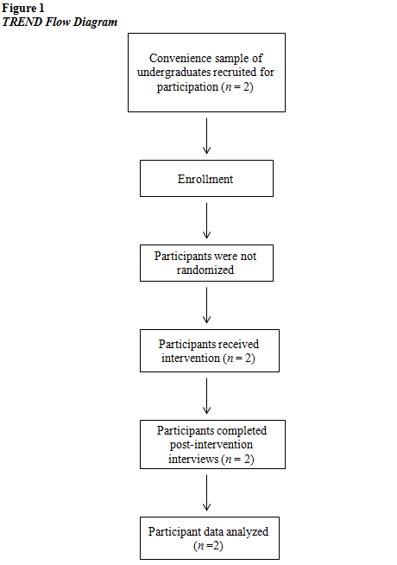

Design
This study was a concurrent, embedded mixed-methods study, in which both quantitative data and qualitative data were collected and analyzed. A mixed methods approach was used to gain a deeper level of feedback from the subjects on the effect of group music therapy on perceived levels of self-efficacy. There were four phases of data collection in this study. The first phase included the collection of two types of pretest quantitative data through the use of the General Self-Efficacy scale (GSE) and Outcome Rating Scale (ORS) measures. The second phase consisted of the collection of only one type of quantitative data through the use of the ORS measure which occurred at the conclusion of each session. The third phase included the collection of two types of posttest quantitative data using the GSE and ORS measures. The fourth and final phase consisted of qualitative data collection through semi-structured telephone interviews (QUAN + QUAN, QUAN, QUAN + QUAN, QUAL). Figure 2 below outlines the phases of data collection.
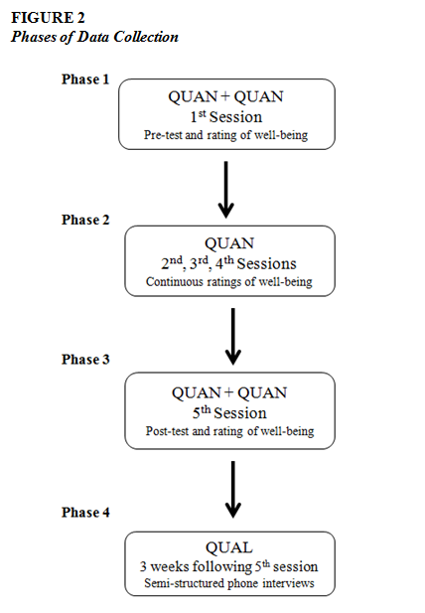
The quantitative data were collected across all phases of the research design followed up by the collection of qualitative data through semi-structured phone interviews with the participants. Thus the quantitative data took precedence in the data analysis (Creswell, 2009).
Measures
Quantitative data and qualitative data were collected in the form of two scale measurements as well as semi-structured interviews based on grounded theory research methods, respectively. Quantitative data were collected using the GSE as both a pretest and a posttest, as it effectively measures levels of self-efficacy (Appendix A). In samples from 23 nations, Cronbach’s alphas show reliability on a unidimensional scale ranging from .76 to .90, with many in the high .80s (Schwarzer & Jerusalem, 1995). Pretest and posttest data from this measure were compared to determine if there were any changes over the course of the study.
Further quantitative data were collected throughout the intervention using the ORS (Appendix B), which served to indicate changes in subjects’ ratings of well-being from the beginning to the end of the intervention (Duncan & Miller, 2007). In reliability testing, Cronbach’s coefficient alpha ranged from .87 at the first administration of the ORS to .96 at the third and fourth administration (Miller, Duncan, Brown, Sparks, & Claud, 2003). The ORS was collected from each subject following each session and was compared at the conclusion of the intervention to determine any differences across sessions.
Qualitative data were collected through semi-structured participant interviews conducted at the conclusion of the intervention to provide deeper insight into participant experiences within the group music therapy process (Appendix C). The questions in the interview were developed to elicit the most relevant information from the subjects and were structured to provide the most reliability (Whiston, 2013). The interviews were coded and analyzed based on grounded theory research methods to determine the prevalence of certain themes (Charmaz, 2006). A line-by-line analysis of the subjects’ responses was conducted to break the data down into discrete parts, so they could be “closely examined, compared for similarities and differences, and [then] questions were asked about the phenomena as reflected in the data” (Corbin & Strauss, 2008, p. 62). Each discrete part consisted of an incident or idea, which was then labeled so they could be grouped with similar occurrences to form specific categories (Corbin & Strauss, 2008). The categories that were the most numerous became the basis of the main themes for qualitative analysis. The interpretation of meaning in these themes was used to determine corroboration or discrepancies between quantitative and qualitative data and to give further insight into the perspectives of the students who experienced the intervention.
Procedure
Subjects were recruited by using an advertisement in the form a flyer that was approved by the Institutional Review Board (IRB). The flyer was distributed as an attachment to an email (Appendix D) that was sent to the deparrment chairmen or women from the psychology, social work, and nursing programs. This flyer was then dissemeinated to the students. The flyer was emailed to students by each department twice in the course of the recruitment period, which lasted about two weeks. The flyer was also posted in approved areas in the appropriate campus buildings where it would be seen by nursing, social work, and psychology students.
In order to determine significance of the study’s measures at the .05 level of confidence, an ideal sample size would be 271 subjects, based on the G*Power Analysis (Faul, Erdfelder, Lang, & Buchner, 2007). Due to various factors, such as the availability of the students, the limited period of time in which to conduct the study, and the researchers’ means to initiate multiple groups, the ideal sample size was not met. Two students were able to take part in the study (n = 2). The researcher met each participant at a time and place of their convenience, where they completed a demographic form (Appendix E), a consent to participate (Appendix F), and a consent to audiorecord the semi-structured interviews at the conclusion of the study (Appendix G). All forms were approved by the IRB of the institution.
The students met for the group music therapy intervention for one hour a week over five weeks. The sessions were held on the university campus in a large, sound-proof room. The door to the room was locked during sessions and had a “session in progress” sign on the door so that there would be no interruptions. Sessions were conducted by the researcher – a graduate level music therapy student – and were supervised by a faculty mentor who observed each session but did not participate.
Group process was addressed across the five sessions based on Tuckman’s Team Development Model (1977). The session plan for each proceeding session depended on the group dynamics that emerged in the previous session and followed the logical course of group therapy phases. Prior to the start of the intervention, the researcher developed a decision tree, which mapped out potential characteristics and techniques that could be incorporated into each session and included steps for moving forward through the group process. The decision tree also outlined the music therapy interventions that would complement the characteristics of each group stage and would most benefit the group in moving forward to proceeding stages. Due to the briefness of this study, it was expected that one of the earlier group stages may have been the end point for the group in terms of where they were in the last session. Regardless of the group phase that was reached, time in the last session was dedicated to closure and final thoughts. The decision tree in Figure 3 on the following page serves as a graphical representation of the multistage decision making process with considerations given to address group development before, during, and after each session (Busemeyer, Weg, Barkan, Li, & Ma, 2000).

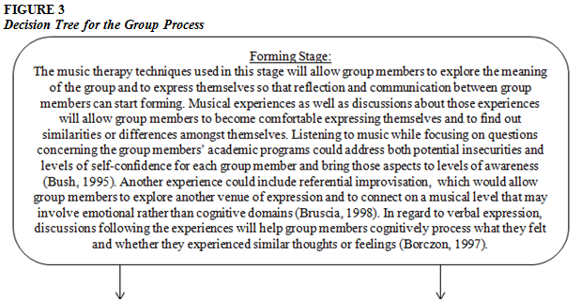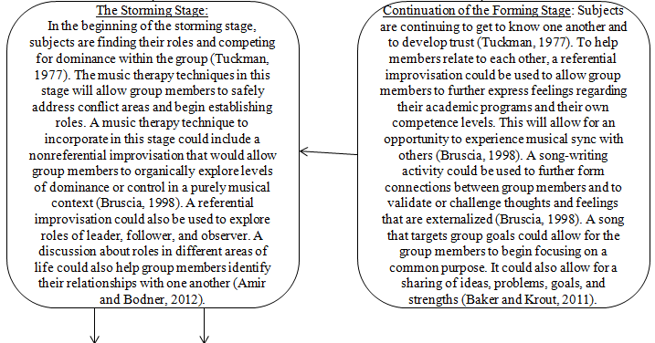
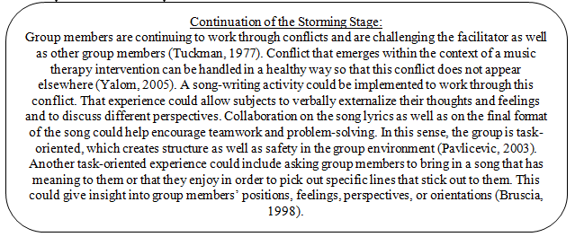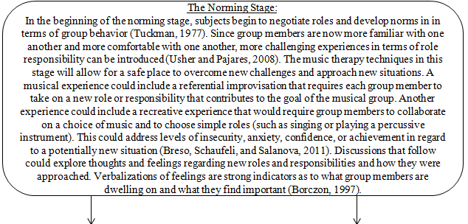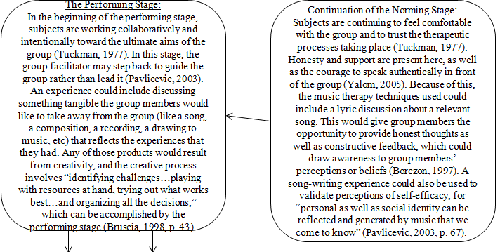
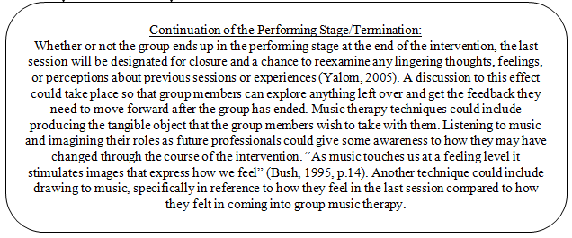

Sessions
The five sessions that were conducted in the study followed Tuckman’s Team Development model as well as the self-efficacy needs of the subjects, which were continuously assessed throughout the intervention. Objective and subjective observations were made by the researchers in order to determine the music therapy techniques that would most effectively meet the subjects’ needs in relation to their levels of self-efficacy. Session plans were written to this effect (Appendix H).
During session one, the participants and the facilitator discussed the purpose of the group as well as characteristics of music therapy. The facilitator also went over logistics of the group, including the importance of confidentiality and reminders about the types of data collection that would take place throughout the intervention. The first session initiated the forming stage and was largely structured with two specific goals in mind: 1) to allow the subjects to get to know each other in order to begin gaining a sense of comfort in the group, and 2) to assess characteristics that pertain to levels of self-efficacy. The researcher and the two subjects gave brief introductions that included names, majors, and class standing. Subject A was female and subject B was male, and they represented the social work program as well as the nursing program. The age range for the participants was between 20 and 45 years.
The first experience of the session consisted of inviting the subjects to choose an instrument that appealed to them out of a variety of instruments. The goal was to give them a chance to tell more about themselves in relation to a musical object. The second activity introduced nonreferential improvisation, in which the subjects were invited to play along on their chosen instruments to a djembe drum played by the facilitator. The last experience consisted of a referential improvisation, which coincided with the forming stage of the group process. This was chosen to allow participants to make connections between the initial improvisation experience and this final experience in order to provide an opportunity for participants to engage in more deeply understanding the impact of personal experiences on self-efficacy. The subjects were invited to choose a different instrument if they wished and were encouraged to think about how they felt on entering their chosen field.
In planning for session two, the observations from both the musical experiences and the verbal discussions were considered in forming self-efficacy goals. It was apparent that subjects A and B each had their own distinct self-efficacy needs to be addressed, as shown by their behaviors within the sessions. The experiences in the second session would incorporate elements that would begin to address those self-efficacy needs, which were determined by the researcher based on the subjects’ behavior and how that related to self-efficacy characteristics. Subject A’s self-efficacy needs included forming deeper musical connections to other group members, feeling supportive of the group product, and releasing self-restrictions during solo improvisation. Subject B’s self-efficacy needs included feeling less obligated to be responsible for the group by joining in the group pulse and experiencing independence and freedom during an improvisation. To address these needs, the second session consisted of a succession of improvisations, each one a bit more involved than the last in terms of instrumentation. Each improvisation provided opportunities to address how these self-efficacy needs would be addressed.
The first improvisation consisted only of djembe drums while the second improvisation included an opportunity for the subjects to choose between a set of bongo drums along and the djembe drums. The third improvisation included a selection of djembe drums, bongo drums, and a glockenspiel. These instruments would further expand the range of musical timbres, and the glockenspiel in particular would be a very prominent instrumental part to play due to it being a pitched percussion instrument.
The researcher’s observations from session two were a consideration when deciding to continue to address the existing self-efficacy needs as well as in identifying additional needs for each of the subjects. The group still seemed to be in the forming stage at this point, so the activities chosen continued to match the characteristics of that stage, allowing for further expression as well as providing for new experiences with which to become familiar. Self-efficacy needs for subject A in this session included taking responsibility for choosing a personally meaningful reference for the music, focusing on connecting to musical expression rather than on technicality, and feeling supported and validated by others. Self-efficacy needs for subject B included focusing more on musical expression rather than on the awareness of others who were watching him, having more opportunities to try new ways of being expressive, and contributing to the music process by providing a theme that was personally meaningful.
Session three began with an imagery exercise in which subjects were encouraged to listen to piano excerpts and become aware of any imagery, visual or otherwise, that they may have experienced. This would allow the subjects to become familiar with the presence of the piano in the space and to have exposure to a new musical experience. The remainder of the session was planned to be dedicated to thematic improvisation that would emerge from the subjects’ musical ideas. This would address the goals concerning references with personal meaning as well as opportunities for further expression. The thematic improvisation was instead replaced with a free improvisation to encourage all types of musical expression and to provide a space for give the subjects to choose how they wanted to contribute.
Researcher observations from session three indicated that the self-efficacy needs of the subjects were continuing to be addressed but that the subjects still had some challenges in overcoming personal barriers. Session four incorporated music experiences that continued to address the self-efficacy needs of the subjects as well as to prepare them for aspects of the storming stage. Self-efficacy needs for subject A included exploring relevant subjects that go below surface level, being comfortable expressing authentic feelings, feeling supported by others, and gaining insight into uncomfortable feelings. Self-efficacy needs for subject B included feeling confidence in his contributions, exploring areas of self-confidence, feeling supported by the group, and gaining insight from others.
Session four began with a music and imagery experience, but it differed in that the piano played a sequence of musical selections rather than separate excerpts. Since the subjects had been exposed to this type of experience in the previous session, their reactions across a range of music were observed and discussed. The remainder of the session was dedicated to lyric discussion of songs that the subjects brought in to the group. They had been previously asked to send the facilitator a song that had some sort of meaning to them.
Based on what was observed in session four, session five would continue to address the need for self-expression and self-exploration and would also allow time for the group to close. As expected, the group process progressed slowly and did not extend far beyond the forming stage with some indications of a storming stage. Based on the decision tree, experiences in the final session would work to align with the initial storming stage but would also support the goals related to self-efficacy. New experiences as well as new roles on the part of the subjects continued to present an awareness of how the subjects approached new situations and new challenges. Self-efficacy needs for subject A included continuing awareness of how she connects with other group members, releasing self-restrictions by expressing something personal, and feeling a connection between the music and something personal. Self-efficacy needs for subject B included feeling confident in choosing a reference for an improvisation, feeling supported by others, and releasing self-restrictions by reflecting upon what is personally meaningful.
Session five incorporated a sequence of experiences that unfolded for each subject. The sequence began with an improvisation that was directed by the subjects. Each subject determined what the improvisation would reflect and how that would come about musically. Subjects chose roles for each group member and the instruments that they would play. The second experience consisted of drawing his and her individual theme for the improvisation while the other group members accompanied the process on djembe drums. The third experience was an additional improvisation – once again directed by the subjects – that would musically reflect what they had sketched.
At the conclusion of session five, the subjects were encouraged to take their drawings with them as a product of what they had created in that space. The subjects were reminded that they would be contacted for a phone interview in order to gain more of their feedback about the intervention.
Ethical Considerations
The consent forms signed by the two subjects outlined that the data the subjects provided would be recorded anonymously and anything they did or said during the sessions would be held in the strictest confidence. The consent forms and demographic forms were stored in a manila folder in a locked filing cabinet separate from the other quantitative data collectio forms to protect participant confidentiality. All data, both quantitative and qualitative, retrieved from the study were stored on a password-protected laptop. The student researcher and the supervising researcher were the only people to have access to the data, and the names of the subjects were not linked to any specific information.
In implementing the music therapy process, it was important that the group facilitator be supervised to ensure that the music therapy techniques were effectively structured and supported the rationale of the group. This supervision consisted of important aspects for the student researcher to consider, including leader responsibilities, music therapy interventions that would effectively address participant goals, and what to be aware of in terms of the subjects’ participation. Both subjects were informed before and during the first sessions about what the group entailed, what was expected of them, and that they could choose to leave the study at any time. The major benefits of participating in the group were acknowledged as well as the purpose of the group (Wilson, 2011).
In conducting this study, it was necessary to survey prospective subjects and choose those subjects from the specified population so that the goals intended by the group work were applicable to all those involved in the group (Linde, Erford, Hays, and Wilson, 2011). Due to the purpose of this group, it was important to be aware of the social dimensions at work and to be able to balance group tasks and socioemotional factors that may have emerged (Kelly and Bostrom, 1998). In order to establish expectations and to maintain respect for the group members involved, it was the researcher’s responsibility to emphasize confidentiality within the group process. Though confidentiality cannot always be guaranteed, it is of key importance in developing trust within the group and was upheld in this study (Linde et al., 2011).

CHAPTER 4. RESULTS
Introduction
The purpose of this study was to evaluate the effect of group music therapy on perceived levels of self-efficacy of undergraduate psychology, social work, and nursing students using a mixed-methods design with one group. The quantitative measures addressed any changes in students’ perceived levels of self-efficacy and were evaluated to determine if there were any significant changes from pretest to posttest scores. The qualitative measures were collected to evaluate students’ perceptions of participating in a music therapy group, to include expectations, what they may or may have not found useful in the experience, and whether they would take anything from the music therapy group into their respective fields of study. The mixed methods design was employed to allow for the combining of both data sets and addressed whether there were corroborations between the quantitative and qualitative data sets and whether there were discrepancies between the data sets. The mixed methods design also provided an opportunity to consider factors involved in either corroborations or discrepancies that emerged between the data sets. The null hypothesis for this study was as follows, H_{o}: there would be no statistically significant difference between levels of perceived self-efficacy as a result of participation in group music therapy.
Quantitative Results
To prepare for hypothesis testing, pre and posttests of the GSE scale were scored for each subject (n = 2). Each item on the scale was a statement that related to aspects of self-efficacy, and each had scores possible from 1 to 4, with 1 marked as “false” and 4 marked as “true” as it related to each item, allowing for a maximum possible score of 40. A dependent t test was conducted to determine if there was a significance difference between the pre and posttest scores (p > .05). Table 1 shows the results for the GSE measures.
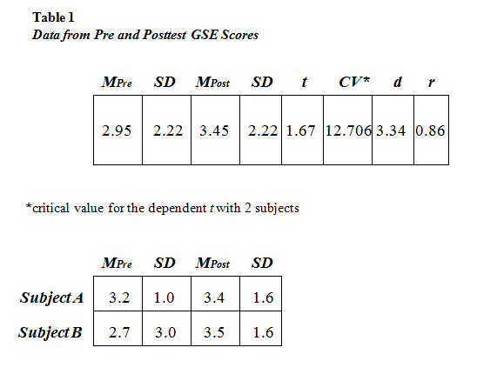
Based on the critical value of t at the .05 level of confidence, there were no significant differences between the pre and posttest GSE scores. The correlation coefficient (r) measures the linear relationship between the intervention and the posttest scores. The coefficient was calculated using the UCCS Effect Size Calculator (Becker, 1999). The r value for the GSE scores is 0.86, indicating a strong correlation between the posttest scores and the area targeted by the intervention.
Subjects also completed a visual analogue scale following each session, marking the ORS based on how they perceived different areas of their lives, with the right side of the scale representing a higher level of satisfaction. Each item had a range of 70 tick marks, for a maximum satisfaction score of 280. For each subject, a Wilcoxon ranks scale was used to determine any significant differences among ORS scores across sessions (p > .05). Table 2 shows the Wilcoxon ranks for subject A.
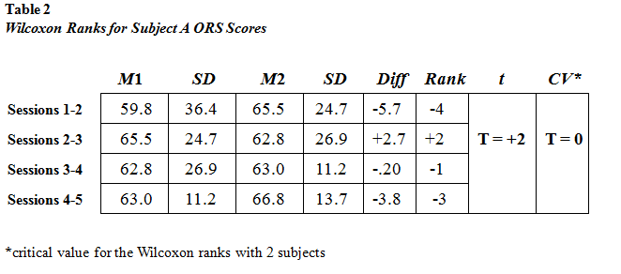
The ranks between each session’s scores had a t value of +2. Given the critical value of t at the .05 level of confidence, there were no significant differences among any of the ORS scores for subject A. Table 3 shows the Wilcoxon ranks scale for subject B.
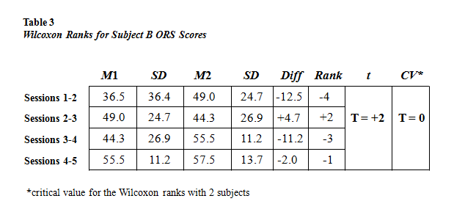
The ranks between each session’s scores for subject B had a t value of +2. Given the critical value of t at the .05 level of confidence, there were no significant differences among any of the ORS scores for subject B.
The Wilcoxon ranks were used to determine any significant differences that emerged among a span of ORS scores that were recorded throughout the intervention. To determine whether there were significant changes in the ORS scores from the beginning of the intervention to the end of the intervention, a dependent t test was used to compare the first and last ORS scores for both subjects (p > .05). Table 4 shows the data for the subjects’ ORS scores.
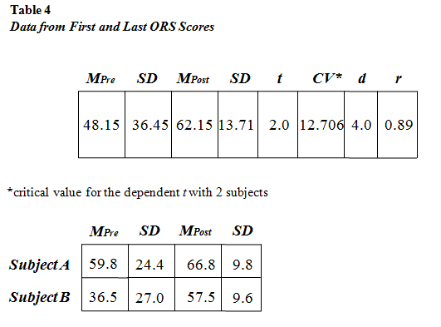
Based on the critical value of t at the .05 level of confidence, there were no significant differences between the first and last ORS scores. The correlation coefficient (r) for the ORS scores is 0.89, indicating a strong correlation between the intervention and the posttest scores. The correlation coefficient was calculated using the UCCS Effect Size Calculator (Becker, 1999).
All of the quantitative measures indicate to accept the null hypothesis, H_{o}: there was no statistically significant difference between levels of perceived self-efficacy as a result of participation in group music therapy.
Qualitative Results
Following the completion of the intervention, the subjects were interviewed by phone to gain further insight into their experiences and to help build a greater understanding of their perspectives. The semi-structured telephone interviews were recorded using a Flip video-audio recorder and then transcribed in order to be analyzed in depth. The transcribed interviews were coded line-by-line based on the Grounded Theory methodology. This approach allows for the conceptualization of patterns emergent within the data based on comparing lines within the interview. The code categories were allowed to emerge from the data and were not predetermined prior to the start of the analysis. The codes that emerged from the transcriptions were categorized to incorporate the most consistent themes and key elements. Table 5 shows the codes that emerged.
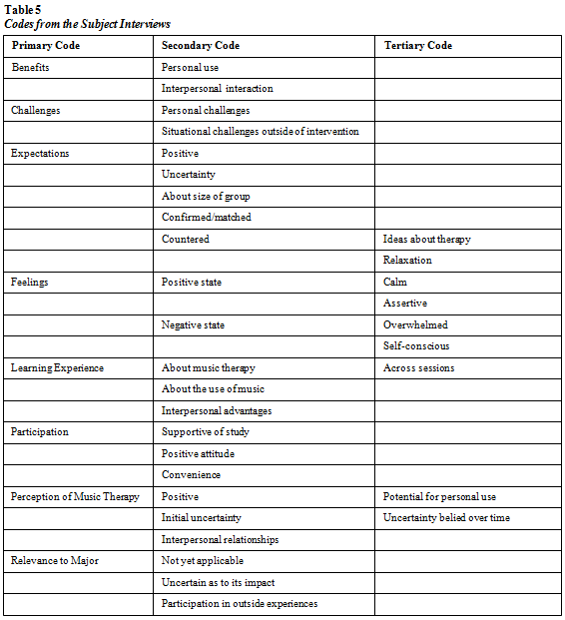

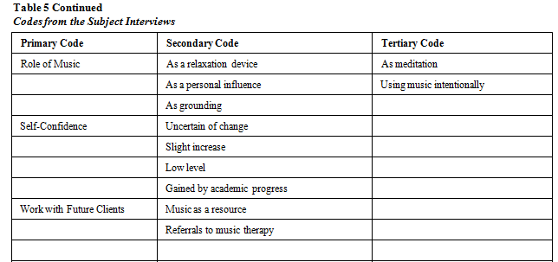

Each category of codes consisted of elements that were related to how that category was defined. These definitions allowed for the sensible categorization of other lines and phrases that emerged. Overall, 11 primary codes emerged from the interviews. Each code was then ranked according to the number of occurrences within the interviews. Table 6 shows the occurrences and definitions of the codes.

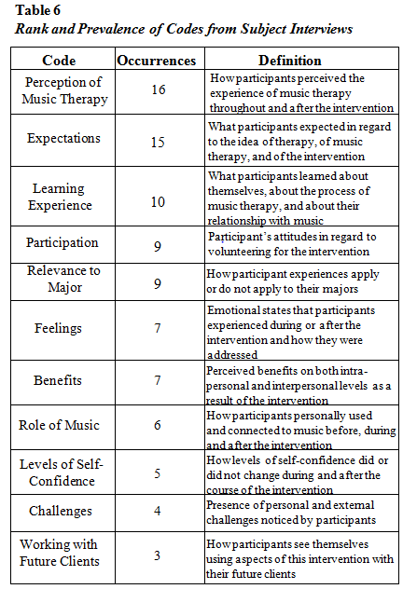
The codes and their occurrences resulted directly from statements made by the subjects in their interviews. Based on Grounded Theory methodology, axial coding was employed in order to group the codes based on their relativity to one another. This focused the codes into a cohesive narrative that exhibited the most prominent themes as they directly applied to the intervention (Strauss & Corbin, 1998). The most frequently cited code at 16 occurrences – the perception of music therapy – involved any statement made by the subjects that related to how they perceived their own experiences within the music therapy process. This included perceptions throughout and after the sequence of sessions. Each subject stated different perceptions that they held during points in the sessions. There was one question on the interview that directly related to participant perceptions of music therapy.
I guess I thought more of like recorded music or something, but I didn’t know exactly….During the sessions, you know, mostly it was about being able to get out of my own skin… (subject A)
From the first session, I, um, I saw that it had potential… but by the end of the last session I think I could see a lot more of the benefits, um, that I saw that I could even have or that I could have for like future clients (subject B)
Perceptions of music therapy also emerged when the subjects were asked about what was meaningful as well as what was not as meaningful during the intervention.
What I really liked was when we would discuss between each other, um, you know kind of what we expected either from the session or the little exercise and, um, what we got out of it and kind of played off of the other people in the room....when I had to lead the group…it kind of like drew me out of it [the music] more…that was the part that kind of like, you know, took me away from the relaxation piece because it made me too aware of everything (subject A)
I thought that [the last session] was a very good session. I liked, I don’t know, at first I was, I didn’t see how improvising could be very helpful. But the I actually, like, ended up liking the improvisation….music therapy seems to be more activity-focused…
I don’t think we really did anything that wasn’t helpful…it all seemed to have kind of a purpose (subject B)
The second most frequent code consisted of expectations, which were stated 15 times. The subjects’ statements about expectations related to both expectations about music therapy and about this specific intervention.
I thought [music therapy]’d be more like, how to use music to relax, you know, like some kind of relaxation technique. Um, it had that but it wasn’t exactly like I was expecting. So I guess I thought, you know, I’d learn some relaxation techniques involving music….
One expectation I had, which, you know, couldn’t really be helped, was I thought there would be more people (subject A).
I think [the group] met what I expected. I mean, I expected there to be more people….Um, but beside that, it was similar to what I expected….I guess I kind of maybe expected a little more talking about how we felt…not that we didn’t talk about ourselves, but it seemed more activity-based (subject B).
The intervention as a learning experience was stated 10 times. Statements were categorized into the learning experience code if it related in some way to what the subjects learned about music therapy, about the use of music, or about themselves. Certain interview questions were focused on what the subjects may have learned about themselves or what they would take away from the experience.
You go back and forth and you say, oh yea I was thinking of that but, you know, I didn’t know quite how to express it…so I liked the interactions after the exercises….Sometimes I felt self-conscious…but I kind of had to learn to use that… (subject A)
I wanted to learn, um, about music therapy because I wasn’t very familiar with it….I didn’t really know that much about [music therapy] also, so even going to the first session, um, I learned something about it but it took a few more before I really, um, got a grasp of the process…I think now I can recognize, um, the music and meditation as like a tool. So I have used it a few times, the times I’ve had rough days (subject B).
The fourth and fifth most prominent codes each occurred a total of nine times. One of those codes was in relation to participation, namely the subjects’ attitudes in regard to participating for this intervention. The first interview question specifically asked about the subjects’ views on participating.
I felt good about it. I wasn’t nervous or anything. I’d seen it and actually thought it was a good idea but then I forgot about it. But then we were doing something for one of my classes involving relaxation…and I immediately thought of the study. And so I’m like, oh I’ll do something like that. So it just worked out (subject A).
I thought it would be fine, I guess, I don’t know. I just think that research is, like, a really good thing. And it didn’t seem very inconvenient…I wasn’t like yes, I’m excited, but I mean I volunteered for it. So I had a good attitude going into it (subject B).
The other code was related to the participants’ areas of study, which were defined by the subjects’ statements about whether or not the experience related to their majors.
I can’t gage whether it helped me or not, but it, I think it gave me a couple extra thing to, um, deal with…it was right at the end of the semester. So the only time, the only other place I’ve been around are with people I knew, like family members and friends. So I can’t say I’ve had to utilize any of the techniques… (subject A).
I’ve been volunteering a lot at [a local community center]. So that’s the most, the thing I’ve been doing the most that, you know, relates to [my major]…since the group ended I haven’t had any classes… (subject B).
The sixth and seventh codes each had 7 occurrences. One of the codes dealt with the subjects’ feelings, specifically their subjective emotions and perceptions about certain events.
Sometimes I just felt, you know, it was mostly me, but I was feeling self-conscious. Sometimes I felt self-conscious… (subject A)
I actually, like, ended up liking the improvising cause, like, I don’t know, it made me feel calmer and better….I have tough days where it’s just kind of emotional…where you talk to people there [at a local community center] and they kind of, you know, talk to you about their experiences and it can be kind of overwhelming… (subject B).
The other code dealt with benefits, specifically benefits from the intervention that were perceived on interpersonal or intrapersonal levels.
I’m, you know, constantly trying to get over that [levels of self-confidence], so I think it’s really helped me, you know, figure out ways to looking at a situation… (subject A).
By the last session I could see a lot more of the benefits, um, that I saw that I could even have or that I could have for, like, future client….Sometimes it’s easy to stay in the front and answer the phone, but if [people at the community center] are around I’ll try to have conversations with them and things like that. Things I wouldn’t necessarily have done when I, like, a while ago….[I] try to be more grounded and kind of make sure that I’m taking care of myself… (subject B).
The eighth code occurred six times and addressed the role of music, specifically how the subjects related to music or their use of music. Subject B’s interview was the only one that this code emerged from.
I liked listening to music and, like, not exactly using it to meditate, but like intentionally listening to music and kind of like grounding ourselves….I put on some music and sit quietly for a little bit by myself and kind of then try to be more grounded…I can, like, recognize, um, the music and meditation as like a tool… (subject B).
The ninth code occurred five times and dealt with levels of self-confidence. There was an question in the interview that specifically inquired about any changes that the subjects perceived in their levels of self-confidence.
I didn’t have enough confidence as it was in my musical abilities….it’s not so much that my levels of self-confidence went up, I mean, I, you know, constantly try to get over that… (subject A).
I haven’t really [noticed a change] since the group has ended, I haven’t been in class or anything…. So, I don’t know, I guess maybe like a slight boost in confidence. I don’t know if it’s directly attributed to that or it’s more like I’m getting, completed almost all my semesters of classes… (subject B).
The tenth code only occurred four times and was categorized based on the challenges named by the subjects. These challenges were separated categorically from the other codes, as they addressed personal challenges rather than interactions with the music. The challenges that were mentioned emerged both within the intervention as well as after the intervention.
When I had to lead the group…I didn’t have confidence as it was in my musical abilities…I mean, I’m, you know, constantly trying to get over that… (subject A).
[The last session] was definitely challenging…I’ve noticed sometimes I’ve had intense experiences [at the community center] and I come home, and it’s kind of just intense… (subject B).
The final code occurred only three times and related to the subjects’ future work with clients. This was separated from the benefits code and the learning experience code because it addressed future work with others rather than the experiences that happened in the study.
I think [music therapy] gave me a couple extra thing to, um, deal with…if I’m in the forefront. Or if I’m helping someone else, you know, with music relaxation or whatever (subject A).
I wanted to learn, um, about music therapy…if it could be something that I could, like, list for clients eventually…if it could be helpful… (subject B).
Integration of the Data
Both quantitative and qualitative data were used to determine any changes in the subjects’ (n = 2) perceived levels of self-efficacy. The GSE scale was used to directly address the presence of efficacious characteristics, such as self-confidence, the ability to overcome challenges, and the ability to accomplish goals. The ORS measured how the subjects felt about different areas of their lives, such as interpersonal, social, personal, and overall states of being. Changes in these areas were considered due to their potential reflections of changes in levels of self-efficacy.
Though neither the GSE scores nor the ORS scores showed any statistically significant changes between the beginning of the intervention and the end of the intervention, the effect sizes of both measures indicate that there was a strong positive correlation between the intervention and the score outcomes. The qualitative data that were collected indicate that the subjects perceived changes in certain areas, which seems to corroborate the effect sizes. In order to determine any corroborations or discrepancies in comparison with the quantitative results, some questions in the interviews were directly related to any changes in personal levels that the subjects may have experienced. While coding the subjects’ interviews, statements reflecting any changes were categorized accordingly. The perception of music therapy, the benefits of the intervention, and levels of self-confidence were the codes in which the most instances of change appeared. This happened organically within the process of the music therapy sessions and was relayed by the subjects’ own experiences.
In relation to the perception of music therapy, subject B stated a change in her perception of music therapy’s benefit for her own personal use: “From the first session, I, um, I saw that it had potential… but by the end of the last session I think I could see a lot more of the benefits.” Benefits of the intervention related to overcoming some personal challenges. Subject A stated “I’m, you know, constantly trying to get over that [levels of self-confidence], so I think it’s really helped me, you know, figure out ways to looking at a situation.” Overcoming challenges is one component relevant to self-efficacy, and it seems that both subject A and subject B had experiences that assisted in addressing their own challenges.
However, when asked about their levels of self-confidence, neither subject A nor subject B could identify whether their levels of confidence had changed. Subject A stated that “it’s not so much that my levels of self-confidence went up, I mean, I, you know, constantly try to get over that.” Subject B stated “I haven’t really [noticed a change] since the group has ended….I used to volunteer at the [community center] and I haven’t for a long time. So, I don’t know, I guess maybe like a slight boost in confidence.” It seems that she could not definitely identify whether that source of confidence was due to the music therapy intervention. She also mentioned that “I don’t know if it’s directly attributed to that or it’s more like I’m getting, completed almost all my semesters of classes.”
The subjects were also asked a question regarding if the intervention was relevant to their majors. Since the interviews were conducted after the fall semester and prior to the spring semester, both subjects indicated that it was difficult to determine any relevance to their majors since they had not had any coursework since the intervention. Subject A said: “I can’t gage whether it helped me or not, but it, I think it gave me a couple extra thing to, um, deal with…” and subject B said: I’ve been volunteering a lot at the [community center]. So that’s the most, the thing I’ve been doing the most that, you know, relates to social work…since the group ended I haven’t had any classes.”
Though both subjects stated that they had positive changes in the perception of music therapy and that they perceived some personal benefit, their statements about their levels of confidence as well as about the relevance to their majors corroborates the quantitative results. Their statements do not reflect any major changes in characteristics related to self-efficacy other than an indication that they were able to use the intervention to address some personal challenges.
Additional Qualitative Insight
For further insight into the subjects’ experiences within the music therapy process, the researchers’ session notes were also coded. The session notes were coded line-by-line and were not predetermined prior to the analysis. These codes were used to provide further understanding of the subjects’ interview responses and to observe any further parallels that may or may not have emerged in relation to the quantitative data. Table 7 shows the codes that emerged from the researchers’ notes for all five sessions.
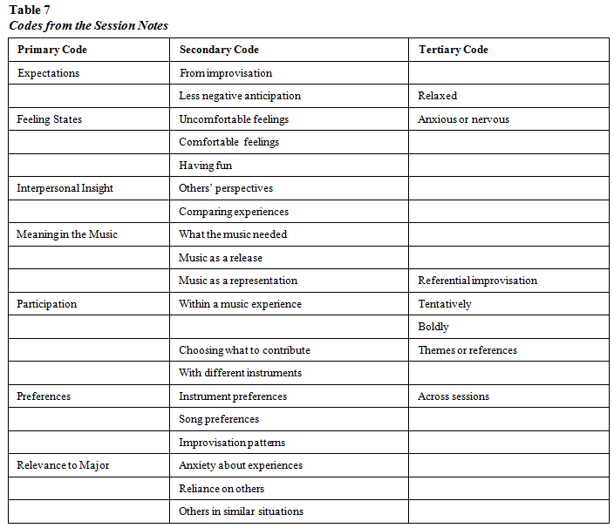
Seven primary codes were identified based on the analysis. Each code resulted directly from the researchers’ session notes, which included both direct quotes from the subjects as well as objective observations by the researcher. The same process of analysis used with the interview codes was used to categorize the session codes. Each code that emerged from the session notes was categorized based on its definition. Axial coding was used to determine the most prominent and relevant codes. Table 8 shows the number of occurrences and the definition for each code.
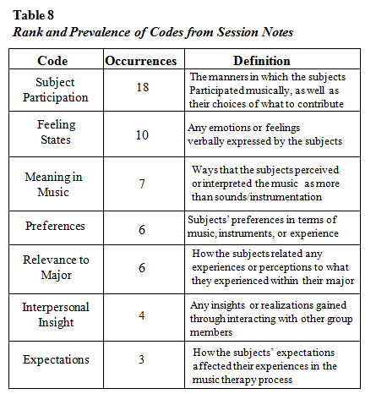
The most numerous code was subject participation, which included the manner in which the subjects participated in musical experiences as well as the choices they made in relation to collaborating on a musical experience. The session notes show that the subjects’ behaviors in terms of their musical participation changed throughout the course of the intervention. This seems to corroborate the interview codes (perception of music therapy, benefits) in that the subjects were able to overcome challenges related to participating in the music.
Subject B began tentatively, playing the frog once every few beats. She began playing more regularly on the beat and then eventually established her own beat that fit with the established rhythm of the drum (session 1).
Subject B tried different patterns and playing styles on the Djembe and also contributed differences in dynamics (subject 2).
Subject A also began tentatively and continuously watched the SMT for the beat and rhythmic cues. He was leaned forward in his chair in that direction (session 1).
Subject A was able to solo over the other djembes, but seemed to approach it with some caution (session 2).
A similar code to participation was preferences, as it dealt specifically with musical preferences, such as songs, instruments, and choices of references for improvisation. Preferences were mentioned six times within the session notes and were coded separately due to their individual impacts on music experiences. Meaning in music was identified seven times, and this was also coded separately as it took into account personal meaning for the subjects rather than objective observations on the part of the researcher.
When asked if he was able to express what he wanted to [after a referential improvisation], subject A stated that he tried to convey a hectic musical theme when expressing his feelings about tests and assignments (session 2).
Subject B said after [a free improvisation] that she stopped thinking about all of the things she had to do and just thought about the music happening in the present moment (session 3).
A code that occurred four times was interpersonal insight, which was defined by insights or realizations gained directly from interacting with another person in the sessions. Because this study focused on group music therapy, the instances of interpersonal insight that occurred corroborate the perceived benefits of group music therapy.
Subject B stated that she had not thought that other members of the group could be self-conscious like herself after subject A stated he was self-conscious during the improvisation (session 1).
Both subject A and subject B appeared comfortable sharing their visual imagery experiences with one another. They compared specific feelings and validated each others’ images (session 4).
The codes from the session notes that most resembled the interview codes were feeling states, expectations, and relevance to major. Feeling states occurred 10 times within the session notes and showed a noticeably higher shift from uncomfortable to comfortable feelings states within the sessions.
Subject B stated that she felt ‘awkward’ at first… She stated that by the end of the improvisation exercise she felt more comfortable….Subject B admitted that she felt less awkward and more comfortable during the second improvisation experience (session 1).
Subject A stated that he felt very nervous during the improvisation… He said he feels more comfortable being surrounded by a group of people, as he was in [previous groups]…. Subject B admitted to feeling less nervous during the second improvisation. (session 1).
Subject A stated that he had had fun during the last improvisatory experience (session 3).
Subject B stated that at the end of the hour, she was more relaxed than she was when she first got there (session 3).
The code of expectations occurred only three times in the session notes (as compared to 15 times within the interview code). Within the sessions, expectations seemed to affect the subject’s perceptions of their experiences.
During the final improvisation of the session, subject B stated that she had a better sense of what to expect from the music and that it didn’t have to sound perfect to be acceptable (session 1).
Subject A stated that because he had a better idea of what to expect, he wasn’t as nervous about anticipating what was expected of him during the second and third improvisations (session 1).
Subject B stated it was easier to begin the first improvisation than the previous ones because she knew what to expect (session 2).
The statements that dealt directly with expectations gave a better sense of how it benefited the subjects within the music therapy experiences. While the expectation statements coded in the interviews dealt more with logistics of the group or with music therapy, the expectations stated in the session related to how expectations altered the subjects’ perceptions of the music experiences. This seems to parallel the perceptions and benefits identified in the interviews, as the subjects recognized their own comfort levels in relation to the music experiences. Gaining familiarity with relevant experiences is one of the factors important to the concept of self-efficacy.
The last code similar to emerge was the relevance to major, which occurred six times within the session notes. Relevance to major was defined as any perceptions or experiences within the music therapy process that related to or reflected experiences within the subjects’ majors.
Subject B mentioned that in her [school] program, she had to lead a group and that made her anxious because she thought she would be awkward. She stated it was similar to the improvisation in that after watching everyone else lead the group, she realized she was no more awkward than them and felt better about herself. She said that she cannot expect to know what to do all of the time… (session 1).
Subject A stated that in his [school] program, he feels comfortable when he is around other professionals. He admitted that he does not expect…to know everything, but having someone else there to have a discussion with is reassuring for him. He stated that he must appear confident and professional in front of clients, and connected that to his experience in the improvisation (session 1).
The statements in the interviews that were coded as relating to areas of study did not show any prominent effects of the intervention on how the subjects approached their majors. However, the statements that the subjects made within the course of the sessions indicated that they could reflect some aspects of their majors within musical improvisations.
Overall, the codes that emerged from the researchers’ session notes supported the subjects’ perceptions of music therapy and the benefits that were mentioned in the interviews. The session codes also provided additional insight into the change of subjects’ feelings states as well as how their expectations affected their comfort levels within music experiences. The subjects were also able to connect music experiences to their own areas of study within the sessions. Though there were no statistically significant results found in the quantitative data, the qualitative data showed some growth in the area of overcoming personal challenges and in gaining personal experience that could be of use in future fields. This also corroborates the large effect sizes that exhibited a strong positive correlation between the intervention and the scores.

CHAPTER 5. DISCUSSION

Indications toward Changes in Self-Efficacy
Because there was such a small sample size, it is no surprise that statistical analyses would indicate little significance in terms of changes between the pre and posttests. The correlation coefficients for each measure were high, indicating that there was a strong relationship between the areas targeted by the intervention and the posttest scores. Though neither of the t tests showed statistically significant differences, the scores for each measure moved in a positive direction. The Wilcoxon ranks corroborated this movement, showing a gradual yet consistent movement toward higher scores on the ORS by the end of the intervention.
Because there was a difference between the raw pre and posttest scores, looking at the change in terms of percentage values may better show quantitative implications. Considering that the GSE consisted of a 4-point scale, the mean percentage for the GSE pretest was 73.8%, while the mean percentage for the GSE posttest was 86.3%. There was a 12.5% increase in the GSE score average between the first and last sessions of the intervention. The ORS had a possible maximum score of 70, so the mean percentage of the first ORS collected was 68.8% while the mean percentage of the last ORS collected was 88.8%. There was a 20% increase in the score average between the first and last ORS. This shows that though significance was not reached due to a limited sample size, change did occur across the span of the intervention.
The qualitative data provided deeper insights into the subjects’ perceptions participating as a group member and of music therapy in general. Both subjects explicitly stated that they had positive attitudes going into the study. Reasons for participating included support of research, understanding the importance of getting involved, and a convenient resource in relation to another course. It is interesting that neither subject stated that they wanted to participate for personal reasons or for personal development. Though their interviews showed that they experienced changes in regard to their expectations about music therapy and personal benefits from music therapy, they seemed to have had a certain level of self-efficacy characteristics to begin with, as volunteering for something new is a characteristic in and of itself.
The session notes indicated that both subjects experienced an increase in positive feeling states – especially comfort levels – as the sessions and musical experiences progressed. This supports the definition of self-efficacy in that direct personal experience affects how people perceive a certain situation. Personal experience leads to mastery experience, which in turn allows for a calmer and more comfortable approach to situations (Usher and Pajares, 2008). Challenges expressed in the interviews as well as participation noted in the session notes indicated that there were particular challenges for each of the subjects. Their changes in feeling states as well as their noticeable changes in participation also relate to characteristics of self-efficacy. Overcoming challenges allows for the ability to handle future situations more effectively (Usher and Pajares, 2008).
Both personal experience and the ability to overcome challenges are two aspects that directly relate to self-efficacy, though it is difficult to determine if the subjects will benefit from them in the long term. At the conclusion of the study, the subjects had not the opportunity to apply their experiences to their areas of study. This made it difficult for them to perceive changes in self-confidence, which is a large component of self-efficacy. Statements regarding subjects’ perception of their own levels of self-confidence were tentatively expressed and seemed ambiguous. They were not certain how the music therapy intervention directly affected their levels of self-confidence in other areas of their lives. The areas in which they noticed change, such as comfort levels and the beneficial use of music, were contained within the music therapy process. It is uncertain how those aspects will relate to other areas of their lives as they continue their programs at the university.
Limitations
Sample size was by far the largest limitation present in this study. There were only two subjects who consented to participate. As the ideal sample size was 271 subjects, this lowered the likelihood of finding statistical significances in the evaluation of the quantitative data. The sample size was not sufficiently large enough to generalize results that emerged from this study.
Other limitations included the time limit in gaining the subjects needed for the study group as well as the time limit in conducting the sessions for the study. There was only a given amount of time between gaining approval from the IRB and concluding the intervention before the end of the university’s fall semester. Full advantage of this time was taken, but the maximum amount of sessions that could be included were five sessions.
There are also threats to validity that may have affected the overall outcome in reviewing the subjects’ measures after the completion of the intervention. These threats include history, where events outside of the intervention may have influenced the measurements (particularly how the subjects perceived their interpersonal relationships and family life), and maturation, where subjects may have changed or developed on personal levels over the course of the intervention (Creswell, 2009).

CHAPTER 6. CONCLUSION
The mixed methods design implemented in this study allowed for many different perspectives in the process of evaluating changes in self-efficacy. Many aspects of self-efficacy were present within the intervention and emerged through the quantitative measures and qualitative data. Though the quantitative data did not show statistical differences, the measures all showed an increase in scores between the pretests and posttests in the direction of positive changes in self-efficacy and feeling states around the process of therapy. The percentages of the score averages noticeably increased between pre and posttests, indicating that change did occur.
The subjects exhibited change in certain areas that directly related to self-efficacy. Overcoming personal challenges, perceiving the benefits from a new experience, and the effect of personal experience and familiarity on comfort levels were all aspects present for both subjects within the music therapy process. They viewed the experience largely as a learning experience and expressed changes in the perception of music therapy as well as the role of music on a personal level. It is uncertain how these changes affect their approaches to their areas of study and how they will come into play in the long run.
Implications for Future Research
This study was a pilot study, and there are many areas that require further research. For one thing, the two subjects who participated readily volunteered for the study and showed a higher level of self-efficacy in the beginning of the study due to their age and experience levels. It would be opportune to involve first- and second-year students, as well as students who are younger in age, in order to observe how a music therapy intervention would affect their perceived levels of self-efficacy.
Though this study considered the intervention group music therapy, a larger group would be needed in order to determine statistical significance using the current measures. A volunteer group could be observed that consisted of more students, or a mandated group could be implemented. This would require students to participate without actively volunteering, but it may prove different results than a volunteer group. Students who volunteer to participate in new experiences, as the subjects in this study did, may not be the ones who would most benefit from them. There may be students entering the helping profession who could benefit from a music therapy group, but would not actively engage due to a variety of reasons, one of which may include a lower baseline level of self-efficacy.
A music therapy group targeting levels of self-efficacy may also show more results if implemented for a longer period of time. This study consisted of only five sessions, but more sessions would procure more statistical scores as well as the opportunity for more personal experiences. 10 or 15 sessions would be a more ideal amount in terms of allowing for the greatest amount of change in the client group.
Because the interviews for this study were conducted prior to the start of the university’s spring semester, it was uncertain how the music therapy intervention would affect the academic areas of the subjects. Future studies should look at more long-term effects and conduct post-hoc analyses of how music therapy affects other areas of study. Characteristics of self-efficacy should be observed in order to determine which aspects of music therapy, if any, are the most effective at maintaining levels of self-efficacy.
Lastly, more research should be done to determine how many students entering the helping professions would actively volunteer for any type of therapy. For the helping professions especially, understanding situations from a client’s point of view and gaining knowledge in terms of personal growth contributes greatly to one’s self-efficacy in those fields (Breso, Schaufeli, and Salanova, 2011). Further research could involve surveying students in terms of whether they would willingly participate in personal therapy or not. If not, it should be determined why so that further knowledge can be gained from their perspectives. Current research supports the advantages of personal therapy for students seeking the helping professions, but further research is needed to determine how much that principle is present within academic programs. It is still uncertain how many programs require therapy for students, and yet more uncertain as to how many students feel that therapy should be a requirement.

References
Abbot, E. & Sanders, L. (2012). Paraeducators’ perceptions of music therapy sessions. Music
Therapy Perspectives, 30(2), 145-150.
Abbot, E. (2006). The administration of music therapy training clinics: A descriptive study.
Journal of Music Therapy, 43, 63-81.
Ahonen-Eerikainen, H. (2007). Group analytic music therapy. Gilsum, NH: Barcelona
Publishers.
Aigen, K. (2001). Music, meaning, and experience as therapy. Nordic Journal of Music Therapy,
10(1), 86-99.
Aldridge, D. (1999). Personal opinion: Developing a community of inquiry. Nordic Journal of
Music Therapy, 8(1), 25-35.
Amir, D. & Bodner, E. (2012). Music therapy students’ reflections on their participation in a
music therapy group. Nordic Journal of Music Therapy, 22(3), 243-273.
Amir, D. (2012). My music is me: Musical presentation as a way of forming and sharing identity
in the music therapy group. Nordic Journal of Music Therapy, 21(2), 176-193.
Ansdell, G. (2003). The stories we tell. Nordic Journal of Music Therapy, 12(2), 192-259.
Bae, M. (2012). Student music therapists’ differences in their clinical reflections across
practicum levels. Music Therapy Perspectives, 30(1), 89-93.
Baker, F. & Krout, R. (2011). Collaborative peer lyric writing during music therapy training: A
tool for facilitating students’ reflections about clinical practicum experiences. Nordic
Journal of Music Therapy, 20(1), 62-89.
Baxter, H., Berghofer, J., MacEwan, L., Nelson, J., Peters, K., & Roberts, P. (2007). The

individualized music therapy assessment profile. Philadelphia: Jessica Kingsley

Publishers.

Beck, K. (2005). Ethnographic decision tree modeling: A research method for counseling

psychology. Journal of Counseling Psychology, 52, 243-249.

Benton, S., Robertson, J., Tseng, W., Newton, F., & Benton, S. (2003). Changes in counseling

center client problems across 13 years. Professional Psychology: Research and Practice,

34, 66-72.

Borczon, R. (1997). Music therapy: Group vignettes. Gilsum: Barcelona Publishers.

Breso, E., Schaufeli, W., & Salanova, M. (2011). Can a self-efficacy-based intervention
decrease burnout, increase engagement, and enhance performance? A quasi-experimental
study. Higher Education, 61(4), 339-355.
Bruscia, K. (2000). The nature of meaning in music therapy. Nordic Journal of Music Therapy,
9(2), 84-96.
Bruscia, K. (1998). Defining music therapy. New Hampshire: Barcelona Publishers.
Busemeyer, J., Weg, E., Barkan, R., Li, X., & Ma, Z. (2000). Dynamic and consequential
consistency of choices between paths of decision trees. Journal of Experimental
Psychology, 129, 530-545.
Bush, C. (1995). Healing imagery and music. Portland: Rudra Press.
Cankaya, P. & Duman, Z. (2010). Evaluation of nursing students’ attitudes towards seeking
psychological help and factors affecting their attitudes. Nurse Education Today, 30,
784-788.
Charmaz, K. (2006). Constructing grounded theory: A practical guide through qualitative
analysis. New York: Sage Publications, Inc.
Corbin, J. & Strauss, A. (2008). Basics of qualitative research: Techniques and procedures for
developing grounded theory. New York: Sage Publications, Inc.
Corey, G. (2013). Theory and practice of counseling and psychotherapy. Brooks/Col: Belmont,
CA.
Craig, D. (2009). Exploring music preference: Meaningfulness of music as a function of
emotional reactions. Nordic Journal of Music Therapy, 18(1), 57-69.
Cramer, K. (1999). Psychological antecedents to help-seeking behavior: A reanalysis using path
modeling structures. Journal of Counseling Psychology, 46, 381-387.
Creswell, J. (2009). Research design: Qualitative, quantitative, and mixed methods approaches.
Thousand Oaks, CA: Sage Publications.
Davis, W., Gfeller, K., & Thaut, M. (2008) An Introduction to Music Therapy and Practice.
Maryland: The American Music Therapy Association, Inc.
Des Jarlais, D., Lyles, C., & Crepaz, N. (2004). Improving the reporting quality of
nonrandomized evaluations of behavioral and public health interventions: The TREND statement. American Journal of Public Health, 94, 361-366.
Digiuni, M., Jones, F., & Camic, P. (2013). Perceived social stigma and attitudes towards
seeking therapy in training: A cross-national study. Psychotherapy, 50(2), 213-223.
Duncan, B. & Miller, S. (2007). The session rating scale: Preliminary psychometric properties
of a working alliance measure. Journal of Brief Therapy, 3(1), 3-13.
Faul, F., Erdfelder, E., Lang, A., & Buchner, A. (2007). G*Power 3: A flexible statistical
power analysis program for the social, behavioral, and biomedical sciences. Behavior
Research Methods, 39, 175-191.
Gardstrom, S. (2007). Music therapy improvisation for groups: Essential leadership
competencies. Gilsum, NH: Barcelona Publishers.
Gardstrom, S. & Jackson, N. (2011). Personal therapy for undergraduate music therapy
students: A survey of AMTA program coordinators. Journal of Music Therapy, 48, 226-255.
Gold, P., Kivlighan, D., & Patton, M. (2013). Accounting for session-level dependencies in
longitudinal associations of group climate and therapeutic factors in interpersonally
focused counselor-training groups. Group Dynamics: Theory, Research, and Practice,
17(2), 81-94.
Gold, C. (2012). About becoming a music therapist. Nordic Journal of Music Therapy, 21(2),
103-105.
Gooding, L. & Standley, J. (2010). The effect of music therapy exposure and observation
condition on analytical clinical skills and self-confidence levels in pre-intern music
therapy students. Music Therapy Perspectives, 28(2), 140-146.
Harackiewicz, J., Durik, A., Barron, K., Linnenbrink-Garcia, L., & Tauer, J. (2008). The role of
achievement goals in the development of interest: Reciprocal relations between
achievement goals, interest, and performance. Journal of Educational Psychology,
100(1), 105-122.
Helgeson, V. (2003). Social support and quality of life. Quality of Life Research, 12, 25-31.
Hill, C., Roffmann, M., Stahl, J., Friedman, S., Hummel, A., & Wallace, C. (2008). Helping
skills training for undergraduates: Outcomes and prediction of outcomes. Journal of
Counseling Psychology, 55, 359-370.
Holmes, S. & Kivlighan, D. (2000). Comparison of therapeutic factors in group and individual
treatment processes. Journal of Counseling Psychology, 47, 478-484.
Jackson, N. & Gardstrom, S. (2012). Undergraduate music therapy students’ experiences as
clients in short-term group music therapy. Music Therapy Perspectives, 30(1), 65-82.
Jensen, D., Abbott, K., Beecher, M., Griner, D., Golightly, T., & Cannon, J. (2012). Taking the
pulse of the group: The utilization of practice-based evidence in group psychotherapy.
Professional Psychology: Research and Practice, 43(4), 388-394.
Johnson, J., Burlingame, G., Olsen, J., Davies, R., & Gleave, R. (2005). Group climate,
cohesion, alliance, and empathy in group psychotherapy: Multilevel structural equation
models. Journal of Counseling Psychology, 52, 310-321.
Jones, J. & Cevasco, A. (2007). A comparison of music therapy students’ and professional
music therapists’ nonverbal behavior: A pilot study. Music Therapy Perspectives, 25(1), 19-24.
Kelly, G. & Bostrom, R. (1998). A facilitator’s general model for managing socioemotional
issues in group support systems meeting environments. Journal of Management
Information Systems, 14(3), 23-44.
Kivlighan, D. (2011). Individual and group perceptions of therapeutic factors and session
evaluation: An actor-partner interdependence analysis. Group Dynamics: Theory,
Research, and Practice, 15(2), 147-160.
Knight, A. (2008). Music therapy internship supervisors and preinternship students: A
comparative analysis of questionnaires. Journal of Music Therapy, 45, 75-92.
Krout, R. (2012). Music therapy education and training: From theory to practice. Journal of
Music Therapy, 49, 230-233.
Laiho, S. (2004). The psychological functions of music in adolescence. Nordic Journal of Music
Therapy, 13(1), 47-63.
Lafond, D., Lacouture, Y., & Cohen, A. (2009). Decision-tree models of categorization
response times, choice proportions, and typicality judgments. Psychological Review,
116, 833-855.
Larson, L., Clark, M., Wesely, L., Koraleski, S., Daniels, J., & Smith, P. (1999). Counselor
preparation: Videos versus role plays to increase counseling self-efficacy in prepractica
trainees. Counselor Education and Supervision, 38, 237-248.
Lent, R., Hill, C., & Hoffmann, M. (2003). Development and validation of the Counselor
Activity Self-Efficacy Scales. Journal of Counseling Psychology, 50, 97-108.
Linde, L., Erford, B., Hays, D., & Wilson, F. (2011). Ethical and legal foundations of group
work. In B. Erford (Ed.), Group Work Processes and Applications. (21-38). New York:
Pearson Education, Inc.
Lindvag, C. (2013). Resonant learning: A qualitative inquiry into music therapy students’ self-
experiential learning processes. Qualitative Inquiries in Music Therapy, 8, 1-30.
Luce, D. (2008). Epistemological development and collaborative learning: A hermeneutic
analysis of music therapy students’ experience. Journal of Music Therapy, 45, 21-51.

Madill, A. & Gough, B. (2008). Qualitative research and its place in psychological science.

Psychological Methods, 13(3), 254-271.
Madsen, C., Brittin, R., & Capperella-Sheldon, D. (1993). An empirical method for measuring
the aesthetic experience to music. Journal of Research in Music Education, 41(1), 57-69.
Madsen, C. & Moore, R. (1978). Experimental research in music. Raleigh, NC: Contemporary
Publishing Company.
Magee, W. & Burland, K. (2008). An exploratory study of the use of electronic music
technologies in clinical music therapy. Nordic Journal of Music Therapy, 17(2), 124-141.
Mallinckrodt, B. & Wei, M. (2005). Attachment, social competencies, social support, and
psychological distress. Journal of Counseling Psychology, 52, 358-367.
Marmarosh, C., Holtz, A., & Schottenbauer, M. (2005). Group cohesiveness, group-derived
collective self-esteem, group-derived hope, and the well-being of group therapy
members. Group Dynamics: Theory, Research, and Practice, 9(1), 32-44.
Marmarosh, C. & Corazzini, J. (1997). Putting the group in your pocket: Using collective
identity to enhance personal and collective self-esteem. Group Dynamics: Theory,
Research, and Practice, 1(1), 65-74.
Miller, S., Duncan, B., Brown, J., Sparks, J., & Claud, D. (2003). The outcome rating scale: A
preliminary study of the reliability, validity, and feasibility of a brief visual analog
measure. Journal of Brief Therapy, 2(2), 91-100.
Nauta, M., Kahn, J., Angell, J., & Cantarelli, E. (2002). Identifying the antecedent in the

relation between career interests and self-efficacy: Is it one, the other, or both? Journal of

Counseling Psychology, 49, 290-301.

Nolan, P. (2005). Verbal processing within the music therapy relationship. Music Therapy

Perspectives, 23(1), 18-28.

Orlinsky, D., Norcross, J., Ron-Nestad, M., & Wiseman, H. (2005). Outcomes and impacts of

the psychotherapists’ own psychotherapy. In J. Geller, J. Norcross and D. Orlinsky

(Eds.), The psychotherapist’s own psychotherapy: Patient and clinical perspectives (p.

214-230). New York: Oxford University Press.

Pavlicevic, M. (2003). Group in music: Strategies from music therapy. Philadelphia: Jessica

Kingsley Publishers.

Pederson, I. (2012). Self experience for music therapy students. Aalborg: Aalborg University.

Pederson, I. (1993). Psycho-dynamic movement: A basic training methodology for music

therapists. Hamburg: 8th World Congress of Music Therapy.

Perret, D. (2005). Roots of musicality: Music therapy and personal development. Kingsley

Publishers.

Rolvsjord, R. (2004). Therapy as empowerment. Nordic Journal of Music Therapy, 13(2), 99-
111.
Scheiby, B. & Pedersen, I. (1999). Inter music therapy in the training of music therapy
students. Nordic Journal of Music Therapy, 8(1), 58-71.
Scherer, Z., Scherer, E., & Pimenta Carvalho, A. (2007). Group therapy with nursing students
during the theory-practice transition. National Library of Medicine, Revista Latino-
Americana de Enfermagem, 15(2), 214-223.
Schwarzer, R. & Jerusalem, M. (1995). Generalized Self-Efficacy scale. In J. Weinman,
S. Wright, and M. Johnston (Ed.), Measures in health psychology: A user’s portfolio. Causal and control beliefs. (35-37). Windsor: Nfer-Nelson.
Smeijsters, H. (2005). Sounding the self: Analogy in improvisational music therapy. Gilsum,
NH: Barcelona Publishers.
Solas, J. (1990). Effective teaching as construed by social work students. Journal of Social Work
Education, 26(2), 145-154.
Stewart, D. (2002). Psychodynamic group music therapy as facilitating environment,
transformational object, and therapeutic playground. In A. Davies and E. Richards (Ed.)
Music Therapy and Group Work. (27-42). Philadelphia: Jessica Kingsley Publishers.
Stige, B. (2006). On a notion of participation in music therapy. Nordic Journal of Music
Therapy, 15(2), 121-138.
Thompson, R. & Zamboanga, B. (2004). Academic aptitude and prior knowledge as predictors
of student achievement in introduction to psychology. Journal of Educational
Psychology, 96, 778-784.
Tuckman, B. & Jensen, M. (1977). Stages of small-group development revisited. Group and
Organization Studies, 2(4), 419-427.
Tuckman, B. Tuckman’s team developmental model. [PDF] Accessed from
http://salvos.org.au/scribe/sites/2020/files/Resources/Transitions/HANDOUT_-
_Tuckmans_Team_Development_Model.pdf
Usher, E. & Pajares, F. (2008). Sources of self-efficacy in school: Critical review of the
literature and future directions. Review of Educational Research, 78, 751-796.
Verhaeghe, M. & Bracke, P. (2012). Associative stigma among mental health professionals:
Implications for professional and service user well-being. Journal of Health and Social
Behavior, 53(1), 17-32.
Vogel, D., Wade, N. & Ascheman, P. (2009). Measuring perceptions of stigmatization by
others for seeking psychological help: Reliability and validity of new stigma scale with
college students. Journal of Counseling Psychology, 56, 301-308.
Warner, D. & Bradley, J. (1991). Undergraduate psychology students’ views of counselors,
psychiatrists, and psychologists: A challenge to academic psychologists. Professional
Psychology: Research and Practice, 22(2), 138-140.
Wei, Y. (2004). The measurement and intervention of college students’ learning self-efficacy.
Psychological-Science, 27, 905-908.
Wheeler, B. (2002). Experiences and concerns of students during music therapy practica. Journal
of Music Therapy, 39, 274-304.
Whiston, S. (2013). Principles and applications of assessment in counseling. Belmont, CA:
Brooks/Cole, Cengage Learning.
Wilson, F. (2011). Planning for group work. In B. Erford (Ed.), Group Work Processes and
Applications. (75-87). New York: Pearson Education, Inc.
Wood, R. & Bandura, A. (1989). Social cognitive theory of organizational management.
Academy of Management Review, 14, 361-384.
Yalom, I. (2005). The theory and practice of group psychotherapy. New York: Basic Books.
Yalom, I. (2009). The gift of therapy. New York: Harper Perennial.
Zajacova, A., Lynch, S., & Espenshade, T. (2005). Self-efficacy, stress, and academic success
in college. Research in Higher Education, 46, 677-706.
Zimmerman, B. (2000). Self-efficacy: An essential motive to learn. Contemporary Educational
Psychology, 25, 82-91.

Appendix A
The General Self-Efficacy (GSE) Scale - Schwarzer and Jerusalem (1995)

Do I need permission to use the general perceived self-efficacy (GSE) scale?
You do not need our explicit permission to utilize the scale in your research studies. We hereby grant you permission to use and reproduce the General Self-Efficacy Scale for your study, given that appropriate recognition of the source of the scale is made in the write-up of your study.
The main source is: Schwarzer, R., & Jerusalem, M. (1995). Generalized Self-Efficacy scale. In J. Weinman, S. Wright, & M. Johnston, Measures in health psychology: A user’s portfolio. Causal and control beliefs (pp. 35-37). Windsor, England: NFER-NELSON.
An additional source for the German version is: Schwarzer, R., & Jerusalem, M. (Eds.). (1999). Skalen zur Erfassung von Lehrer- und Schülermerkmalen: Dokumentation der psychometrischen Verfahren im Rahmen der Wissenschaftlichen Begleitung des Modellversuchs Selbstwirksame Schulen. Berlin: Freie Universität Berlin.

Schwartzer, R. (2011). Accessed 16 September, 2013. [PDF] Accessed from: http://userpage.fu-berlin.de/~health/faq_gse.pdf

The General Self-Efficacy Scale (GSE)

1 = Not true at all 2 = Hardly True 3 = Moderately True 4 = Exactly True

1.I can always manage to solve difficult problems if I try hard enough.
1 2 3 4
2.If someone opposes me, I can find the means and ways to get what I want.
1 2 3 4
3.It is easy for me to stick to my aims and accomplish my goals.
1 2 3 4
4.I am confident that I could deal efficiently with unexpected events.
1 2 3 4
5.Thanks to my resourcefulness, I know how to handle unforeseen situations.
1 2 3 4
6.I can solve most problems if I invest the necessary effort.
1 2 3 4
7.I can remain calm when facing difficulties because I can rely on my coping abilities.
1 2 3 4
8.When I am confronted with a problem, I can usually find several solutions.
1 2 3 4
9.If I am in trouble, I can usually think of a solution.
1 2 3 4
10.I can usually handle whatever comes my way.
1 2 3 4

Appendix B
The Outcome Rating Scale – Miller and Duncan (2000)
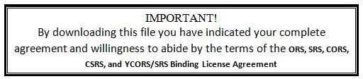
1. Licensee: You are hereby licensed by PCOMS International, Inc (hereafter PCOMS) to use the ORS, SRS, CORS, CSRS, and the YCORS/SRS (hereafter the measures). Any expanded use of these measures would require additional fees.
2. ORS, SRS, CORS, CSRS, and YCORS/SRS: The measures mean any and all paper and pencil or electronic versions of the outcome and process measures, progress and process tracking systems, outcome and process screening, and outcome and process prognosis measurement.
3. License: Subject to the terms and conditions of this agreement, PCOMS grants to the licensee a license to use the measures in connection with the licensee’s bona fide health care practice. The administration and scoring manual, and any and all electronic versions or scoring products associated with the measures may NOT be copied, transmitted, or distributed by the licensee. Paper and pencil versions of the measures may be copied for use in connection with the licensee’s bona fide health care practice.

4. Modifications: The licensee may NOT modify, translate into other languages, change the context, wording, or organization of the measures or create any derivative work based on them. The licensee may put the measures into other written, non-electronic, non-computerized, non-automated formats provided that the content, wording, or organization are not modified or changed. The licensee may modify the item line length so that each prints out 10 cm.

5. Copies, Notices, and Credits: Any and all copies of the measures made by the licensee must include the copyright notice, trademarks, and other notices and credits on measures. Such notices may not be deleted, omitted, obscured or changed by the licensee. Since you are obtaining the license for individual use only, you may NOT distribute copies of the measures.

6. Use, distribution, and Changes: The measures may only be used and distributed by the licensee in connection with licensee’s bona fide health care practice and may not be used or distributed for any other purpose.

7. Responsibility: Before using or relying on the measures, it is the responsibility of the licensee to read and understand the ORS and SRS Administration and Scoring Manual. It is also the responsibility of the licensee to ascertain their suitability for any and all uses made by the licensee. The measures are not diagnostic tools sand should not be used as such. The measures are not substitutes for an independent professional evaluation. Any and all reliance on the measures by the licensee is at the licensee’s sole risk and is the licensee’s sole responsibility. Licensee indemnifies PCOMS and it’s officers, directors, employees, representatives, and authors of the measures against, and hold them harmless from, any and all claims and law suits arising from or relating to any use of or reliance on the measures and related products provided by PCOMS. This obligation to indemnify and hold harmless includes a promise to pay any and all judgments, damages, attorney’s fees, costs and expenses arising from any such claim or lawsuit.

8. Disclaimer: Licensee accepts the measures and associated products “as is” without any warranty of any kind. PCOMS disclaims any and all implied warranties, including implied warranties of merchantability, fitness for a particular purpose, and non-infringement. PCOMS does not warrant that the measures are without error or defect. PCOMS shall not be liable for any consequential, indirect, special, incidental or punitive damages. The aggregate liability of PCOMS for any and all causes of action (including those based on contract, warranty, tort, negligence, strict liability, fraud, malpractice, or otherwise) shall not exceed the fee paid by the licensee to PCOMS. This license agreement, and sections 7 and 8 in particular, define a mutually agreed upon allocation of risk. The fee reflects such allocation of risk.

9. Construction: The language used in this agreement is the language chosen by the parties to express their mutual intent, and no rule of strict construction shall be applied against any party.

10. Entire agreement: This agreement is the entire agreement of the parties relating to the measures.

11. Governing Law: This agreement is made and entered into in the State of Florida and shall be governed by the laws of the State of Florida. In the event of any litigation or arbitration between the parties, such litigation or arbitration shall be conducted in Florida and the parties hereby agree and submit to such jurisdiction and venue.

12. Modification: This agreement may not be modified or amended.

13. Transferability: This agreement may not be transferred, bartered, loaned, assigned, leased, or sold by the licensee.
14. Violations: Violations of any provision or stipulation of this agreement will result in immediate revocation of this license. Punitive damages may be assessed.
Outcome Rating Scale (ORS)
Name ________________________Age (Yrs):____ Sex: M / F
Session # ____ Date: ________________________
Who is filling out this form? Please check one: Self_______ Other_______
If other, what is your relationship to this person? ____________________________

Looking back over the last week, including today, help us understand how you have been feeling by rating how well you have been doing in the following areas of your life, where marks to the left represent low levels and marks to the right indicate high levels. If you are filling out this form for another person, please fill out according to how you think he or she is doing.

Individually
(Personal well-being)

I----------------------------------------------------------------------I

Interpersonally
(Family, close relationships)

I----------------------------------------------------------------------I

Socially
(Work, school, friendships)

I----------------------------------------------------------------------I

Overall
(General sense of well-being)

I----------------------------------------------------------------------I

© 2000, Scott D. Miller and Barry L. Duncan
Appendix C
Post-Intervention Interview – Developed by Student Investigator

1.How did you initially feel about volunteering for this group?

2. What did you hope to learn from participating in this group?

3.Did you perception of group therapy or music therapy change between the first session and the last session? If so, please explain.

4.Did you gain any insights about yourself? If so, please explain.

5.What parts of the group were most meaningful to you?

6.What parts of the group were not as helpful or not as meaningful to you?

7.Did the group meet your expectations? If so, please explain. If not, what would you have done differently?

8.Have you noticed any change in your levels of confidence as a psychology major/nursing major/social work major? If so, please explain.

9. In the last session we discussed what you would take away from this experience. How has that applied to your daily life or your academic life since the group?

10.Would you consider participating in another therapy group if it would target areas that you were interested in working on?

Appendix D
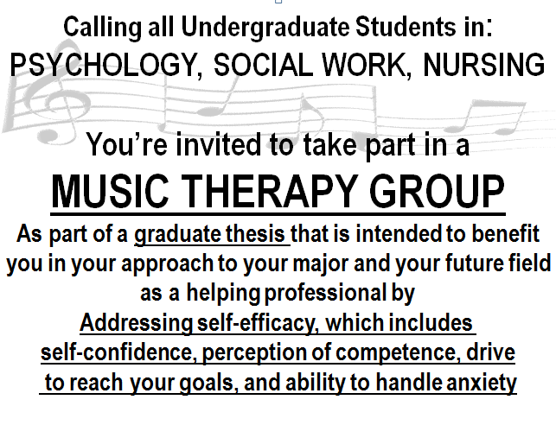
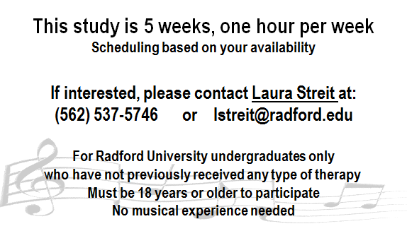
Appendix E
Demographic Form
Participant ID# _______________________________ Date: ____________________

The information you provide on this form will allow for a better understanding of your personal, musical, and therapy-related background so that the student investigator can consider these aspects while planning the group music therapy sessions. Please fill out the form as honestly and completely as possible. No information you provide will be used outside of this thesis study.

Age range: 18-20 21-22 23-25 26-30 31-40 41-50 51+

Which gender do you identify yourself as? ______________________________

Major: __________________________

Year: Freshman Sophomore Junior Senior

Preferred styles of music: _________________________________________________________

Please describe any experience that you may have had with music (such as performing, learning an instrument, drum circles): ______________________________________________________

______________________________________________________________________________

Have you previously received any form of talk therapy? (such as psychotherapy, group therapy, family therapy, Guided Imagery and Music, counseling)

YES NO

Have you previously received any form of creative arts therapy? (such as art therapy, dance therapy, drama therapy, music therapy, or writing therapy)

YES NO

Days (M-F)/Hours you are available to meet for group music therapy sessions: _____________________

_____________________________________________________________________________________

Appendix F
Consent Form
Study Title: The Effect of Group Music Therapy on Perceived Self-Efficacy of Radford University Students Pursuing the Helping Professions: A Pilot Study

Student Investigator’s Name: Laura Streit
Department: Music Therapy
Phone: (562) 537-5746

Principle Investigator’s Name: Patricia Winter, Ph.D., MT-BC
Department: Music Therapy
Phone: (540) 831-6160

We are currently engaged in a study of the effects of group music therapy on students’ perception of their own self-efficacy. To help us gain further insights into this area we will ask you to engage in group music therapy experiences that may include improvisation on various instruments, listening to music and practicing meditation, writing songs with original thoughts and lyrics, and discussions about your perceptions of these experiences. You will be asked to participate in a one-hour session one time per week for a total of five weeks. In addition, you will be asked to answer questions on two measures that will evaluate your perceived level of self-efficacy as well as your perceived levels of well-being in different areas of your life. You may be asked to complete an individual interview following the completion of the music therapy sessions that will be audio-recorded. Participation is voluntary and if you choose to leave the study at any time, there will be no impact on your relationship with Radford University or any of its affiliates. No compensation of any kind will be provided in exchange for participation in this study.

There are no anticipated risks associated with participation in this study. Benefits of this study may include an increase in perception of your own self-efficacy, which means that you may feel more self-confident in approaching goals and reaching higher levels of competency in your given major.

The information you will provide will be recorded anonymously and anything you do or say during the sessions will be held in the strictest confidence. Identifying data will be kept in a locked filing cabinet in the private investigator’s office and on a password-protected laptop in an encrypted file. Only the student investigator and the principle investigator will have access to the data collected in this study.

Although the research team has placed safeguards to maintain the confidentiality of your personal information, there is always a potential risk of an unpermitted disclosure. To that degree, all documents and information pertaining to this research study will be kept confidential, unless required by applicable federal, state, and local laws and regulations to be disclosed. Your signature below indicates that you understand the records and data generated by the study may be reviewed by Radford University and its agents, the study sponsor or the sponsor’s agents (if applicable), and/or government agencies to assure proper conduct of the study and compliance with regulations.

Study Title:
The Effect of Group Music Therapy on Perceived Self-Efficacy of Radford University Students Pursuing the Helping Professions: A Pilot Study

We welcome questions about the study at any time. Your participation in this study is on voluntary basis, and you may refuse to participate at any time without consequence or prejudice.

For questions about your rights as a research subject, you may contact Dr. Dennis Grady, Dean, College of Graduate and Professional Studies at Radford University at (540)831-7163 or by email at dgrady4@radford.edu

Signing your name below indicates that you have read and understand the contents of this Consent Form and that you agree to take part in this study.

___________________________________ _____________
Participant’s Signature Date

___________________________________ _____________
Investigator’s Signature Date

Appendix G
Permission to Audio Record

Student Investigator: Laura Streit
Department: Music Therapy
Project Title: The Effect of Group Music Therapy on Perceived Self-Efficacy of Radford University Students Pursuing the Helping Professions: A Pilot Study

Principle Investigator’s Name: Dr. Patricia Winter, MT-BC
Department: Music Therapy
Phone: (540) 831-6160

Subject: _________________________________ Date: ______________

I give Laura Streit permission to audio record me. This audio recording will be used for the following purpose:

Research
This audio recording will be used as part of a graduate thesis at Radford University. I have already given written consent for my participation in this research project. At no time will my name be used.

When will I be audio recorded?
I agree to be audio recorded at some point between the time period: 11/25/2013 to 1/26/2014

How long will the tapes be used?
I give my permission for these recordings to be used from 11/2013 to 5/2013.

The recordings will be destroyed immediately following the completion of transcription. The transcripts of the recordings will be used for the remainder of the study and are not expected to be used following the completion of the study in 5/2013.

What if I change my mind?
I understand that I can withdraw my permission at any time. Upon my request, the audio recording will no longer be used. This will not affect my care or relationship with the researcher or Radford University in any way.

Other
I understand that I will not be paid for being audio recorded or for the use of the audio recordings.

If I want more information about the audio recordings or if I have questions or concerns at any time, I can contact Dr. Dennis Grady, Dean, College of Graduate and Professional Studies at Radford University at (540) 831- 5187 or by email at dgrady4@radford.edu
Appendix H
Session Plans
Session 1

Introductions
-Introduce myself and Dr. Winter
-Invite each person to say their name, program of study, and something interesting about him or herself

Logistical matters
-Confidentiality within the group
-Group norms (be on time, respect other group members)
-Reminder about specific means of data collection from each person (rating scales after each session, post-test after the last session, interview sometime after the last session)

Purpose of the group
-Briefly define self-efficacy
-Explain how music therapy is largely experiential
-Point out how the new experiences that are introduced in the group sessions will help with the students’ awareness of how they approach new situations
-Explain that discussions will follow musical experiences that explore what each person experienced

First activity – Pick an Instrument
-Purpose: to try something new/think about themselves in a new way; to continue to familiarize members of the group with one another
-There will be a large array of instruments available to choose from
-Invite the students to choose an instrument that they feel represents them, whether in its build, its sound, or its feel
-Each person will go around and explain why they chose that instrument and why they feel it represents some part of them

Second activity – Nonreferential, Instrumental Improvisation
-Purpose: it is an experience that is potentially new and different for the group members; it will allow for an emergence of feelings regarding new situations
-Describe instrumental improvisation and encourage group members to be aware of how they express themselves and how they are relating musically to other members of the group
-Invite group members to use the instruments that they have already picked out from the previous activity
-After the improvisation (it will probably be about 10 minutes), initiate a discussion about what thoughts or feelings emerged for the group members during the experience
-Explore whether those feelings or thoughts are familiar in regard to how they approach new or challenging situations

Third activity – Referential, Instrumental Improvisation
-Explain that now that they have done an improvisation and it is a bit more familiar, a similar experience will take place that will take another factor into consideration
-Group members will be asked to consider how they feel about their position in their programs at this moment and how they feel about entering their professions
-Group members will be invited to change instruments if they wish
-They will be encouraged to express those feelings through their instrumental improvisation and to be aware if what they are expressing connects musically with anyone else in the group
-My role will be supportive of the instrumental improvisation
-A discussion will follow after the improvisation (again about 10 minutes) that explores whether they were able to express the feelings they wanted to, how the experience compared with the first one, and whether there were any differences or similarities between group members’ feelings or thoughts

Closing
-Invite any final thoughts or questions before wrapping up
-Mention that during the last week of classes or during finals week, there will have to be two sessions
-Depending on whether they know their schedules for those weeks, make a plan or plan to schedule it the next session
-Thank everyone for their time and participation

Session 2
Group Matters
-Thank them for coming (on time)
-Remind group members of confidentiality
-Very brief recap of where we left off last week

Opener – Short Induction and Drum Warm-up
-Purpose: to ground the group members in the space, to explore something different with music, and to increase the awareness of current states
-Encourage them to be aware of their bodies and to avoid focusing on specific thoughts that may pass through their minds
-Begin an induction that instructs them to get comfortable in their chairs and to close their eyes if they feel comfortable
-Briefly discuss what they were aware of
-Introduce the Djembe drums, allow group members to handle them and feel them
-Demonstrate how to hold them
-Do a brief call and response where they repeat different playing styles and patterns back to the SMT

Remainder of Session – Building Layers of Improvisation:
First Instrumental Improvisation
-Each of us will have a djembe
-Explain that we will first establish a group beat and then I will invite them to improvise a solo on top of the group beat if they are willing and show how that will be cued (it will be cued with eye contact and a head nod)
-Begin the pulse that will establish the group beat, go through what is outlined
-Briefly discuss the experience
Self-Efficacy needs for subject B: Self-Efficacy needs for subject A:
-Form deeper musical connection -Feel less obligated to be responsible
to other group members for the whole group by being part of
-Feel supportive of the group product the group pulse
by contributing to the group pulse -Experience independence and
-Release self-restrictions by feeling freedom during solo turn as well as
free to solo improv when it’s her turn continued support from group pulse

Second Instrumental Improvisation
-I will have a djembe while subjects A and B have other types of drums
-Have them test out the sounds of the drums
-Again establish a group beat and the use of the same cue gestures
-Have subjects A and B take turns soloing on the drums (it will most likely be easier to discern the sound of the other drums over the bass beat of the djembe, but it will not be completely unique as two different drums are present)
-If the opportunity arises, have them improvise new patterns together over the continuing pulse of the djembe
-Briefly discuss this experience and how it compared with the first improv
Self-Efficacy needs for subject B: Self-Efficacy needs for subject A:
-Continue forming musical connections -Feel supported by the group pulse and
by forming group pulse and playing the continuous djembe beat
off of another group member -Has a bit more responsibility but does
-Feel supported by the djembe beat and not have to hold the group together
collaborative in playing with the other -Freedom to solo with cover from the
hand drum other hand drum

Third Instrumental Improvisation
-I have the djembe, one group member has another type of drum, and the other has access to a Glockenspiel
-Have both of them test out the sounds of the Glockenspiel before taking turns playing it during the improvisations
-Once again, establish the group beat (the Glockenspiel will easily be the most audible instrument in the group)
-Invite the person with the second drum to create a new pattern over the beat
-Cue the person with the Glockenspiel to try and solo over that pattern and the djembe beat
-Have the two group members change instruments, repeat the pattern above
-Have a final brief discussion on this last improv and how it felt compared to the others, especially in terms of musical roles and responsibilities
Self-Efficacy needs for subject B: Self-Efficacy needs for subject A:
-Continue to feel supported by the group -Continue to feel a measure of support
beat while standing out a bit more on a while having more room to solo
different timbre -Feeling the support of the group while
-Realizing the importance of the group soloing on a more prominent instrument
pulse for establishing a ground on which -Being able to let go and solo freely over
to improvise new patterns the group beat

Closing
-Ask for any final thoughts, questions, or concerns
-Inquire about whether they have their schedules for the last two weeks
-Point out what they did well in the session
-Remind them that we will not meet the next week because of Thanksgiving break, but we will meet the week after that (on December 2)

Session 3
Group Matters
-Thank them for coming (on time)
-Ask how their break was
-Mention even though it’s been two weeks instead of one since the last meeting, we will work off of what we did in the last session

Openers – Short Induction
-Purpose: to ground the group members in the space and to increase the awareness of current states
-Induction will be the same as what was done in the previous session:
-Encourage them to be aware of their bodies and to avoid focusing on specific thoughts that may pass through their minds
-Begin an induction that instructs them to get comfortable in their chairs and to close their eyes if they feel comfortable
-Briefly discuss what they were aware of, if they experienced anything different than in the last induction
Music Excerpt Imagery
-Purpose: to explore how they experience imagery/their ability to experience imagery and to familiarize them with the presence of the piano
-I will play short excerpts on the piano that cover a range of textures
-The group members will be encouraged to imagine something that accompanies that excerpt and then share that after the music ends

Remainder of Session – Instrumental Improvisation:
-I will be at the piano and the group members will be situated with access to a variety of instruments
-There will be a set of chimes, one djembe, one set of bongos
-Ask whether they would like to do a practice round to get a sense of the musical space with the piano and the other instruments
-After that, ask what they would like to address with the music and encourage them to come with a theme that would be important to them
-Use what they contribute as a reference for the music, use one mode to create the accompaniment and reflect what they create musically, and encourage them to play more or to try something new if need be
Self-Efficacy needs for subject B: Self-Efficacy needs for subject A:
-Continue to form deeper musical -Focus more on musical expression than
connections to other group members on self-consciousness of others watching
-Take responsibility for choosing a -Have more opportunities to try new
reference for the music that would ways of being more expressive
be personally meaningful -Release self-restrictions by expressing
-Focus on connecting to musical something that is personally meaningful
expression rather than focusing -Contribute to the group musical process
on playing the instrument by providing a theme that is personally
-Feel validated/supported by the piano relevant
Closing
-Ask for any final thoughts, questions, or concerns
--Point out what they did well in the session/briefly summarize what was accomplished in the music
-Inquire about whether they have their schedules for finals week and try to solidify a time during that week for the last session
-Remind them that we will meet next on the Monday of finals week (Dec. 9th)
-Tell them that we will switch gears for the next session and that they have “homework” they need to bring in
-They need to bring in a song that is meaningful to them or that connects to any of the themes that have emerged in the previous sessions

Session 4
Group Matters
-Thank them for coming (on time)
-Thank them for sending their songs and mention that we’ll get to those in the latter half of the session

Openers – Short Induction
-Purpose: to ground the group members in the space and to increase the awareness of current states
-Induction will be the same as what was done in the previous sessions:
-Encourage them to be aware of their bodies and to avoid focusing on specific thoughts that may pass through their minds
-Begin an induction that instructs them to get comfortable in their chairs and to close their eyes if they feel comfortable
-Mention that while their eyes are still closed that music will start
Short Music and Imagery
-Purpose: to explore how they react to continuous music and what emerges as important to them
-I will play 3-4 minutes of piano music that encircles a range of emotions that begin and end in the same tone
-The group members will be invited to share what they experienced

Remainder of Session – Song Discussions:
-I will hand out lyric sheets for each song and explain that we will listen to and talk about one song before moving on to doing the same for the second song
-I will ask them if either of them has a desire to play his or her song first
-We will listen to one song and I will ask whoever brought in that song to explain why he or she chose it and why it is meaningful to him or her
-We will discuss aspects of the song that stick out and are relevant, as well as explore how the group members relate to each other
-The same will be done for the second song
Self-Efficacy needs for subject B: Self-Efficacy needs for subject A:
-Explore relevant subjects that go below -Feel confidence in sharing his chosen
surface level discussion song and why he chose it
-Be comfortable expressing authentic -Be comfortable exploring areas
feelings or perceptions concerning self-consciousness and self-
-Gain insight into uncomfortable feelings confidence
-Feel supported and validated by other -Feel supported and validated by other
group members group members
-Gain insight from other group members -Gain insight from other group members

Closing
-Ask for any final thoughts, questions, or concerns
--Point out what they did well in the session/briefly summarize what was accomplished in the music
Session 5
Group Matters
-Thank them for coming (on time)
-Ask how their break was
-Mention even though it’s been two weeks instead of one since the last meeting, we will work off of what we did in the last session

Openers – Short Induction
-Purpose: to ground the group members in the space and to increase the awareness of current states
-Induction will be the same as what was done in the previous session:
-Encourage them to be aware of their bodies and to avoid focusing on specific thoughts that may pass through their minds
-Begin an induction that instructs them to get comfortable in their chairs and to close their eyes if they feel comfortable
-Briefly discuss what they were aware of, if they experienced anything different than in the last induction
Music Excerpt Imagery
-Purpose: to explore how they experience imagery/their ability to experience imagery and to familiarize them with the presence of the piano
-I will play short excerpts on the piano that cover a range of textures
-The group members will be encouraged to imagine something that accompanies that excerpt and then share that after the music ends

Remainder of Session – Instrumental Improvisation:
-I will be at the piano and the group members will be situated with access to a variety of instruments
-There will be a set of chimes, one djembe, one set of bongos
-Ask whether they would like to do a practice round to get a sense of the musical space with the piano and the other instruments
-After that, ask what they would like to address with the music and encourage them to come with a theme that would be important to them
-Use what they contribute as a reference for the music, use one mode to create the accompaniment and reflect what they create musically, and encourage them to play more or to try something new if need be
Self-Efficacy needs for subject B: Self-Efficacy needs for subject A:
-Continue to form deeper musical -Focus more on musical expression than
connections to other group members on self-consciousness of others watching
-Take responsibility for choosing a -Have more opportunities to try new
reference for the music that would ways of being more expressive
be personally meaningful -Release self-restrictions by expressing
-Focus on connecting to musical something that is personally meaningful
expression rather than focusing -Contribute to the group musical process
on playing the instrument by providing a theme that is personally
-Feel validated/supported by the piano relevant

Closing
-Ask for any final thoughts, questions, or concerns
--Point out what they did well in the session/briefly summarize what was accomplished in the music
-Inquire about whether they have their schedules for finals week and try to solidify a time during that week for the last session
-Remind them that we will meet next on the Monday of finals week (Dec. 9th)
-Tell them that we will switch gears for the next session and that they have “homework” they need to bring in
-They need to bring in a song that is meaningful to them or that connects to any of the themes that have emerged in the previous sessions

Appendix I

Raw Quantitative Scores

General Self-Efficacy Pretest and Posttest Scores (out of 4):

Subject A: Subject B:
- 4 3 1. 3 3
- 3 4 2. 3 3
- 3 3 3. 3 4
- 3 3 4. 2 4
- 3 3 5. 2 4
- 4 4 6. 3 4
- 3 4 7. 3 4
- 3 4 8. 2 3
- 3 3 9. 3 3
- 3 3 10. 3 3
Total: 32 34 27 35
Means: 3.2 3.4 2.7 3.5

Outcome Rating Scale Scores (out of 70):

Session: 1 2 3 4 5

Subject A: 64 64 59 63 68
63 69 65 64 67
55 66 65 60 64
57 63 62 65 68
Total: 239 262 251 252 267
Means: 59.8 65.5 62.8 63 66.8

Subject B: 43 54 47 56 59
25 49 43 54 56
39 45 45 56 58
39 48 42 56 57
Total: 146 196 177 222 230
Means: 36.5 49 44.3 55.5 57.5

